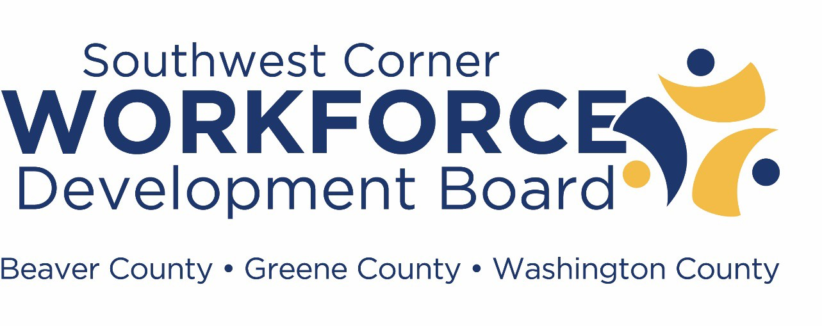

Briefing Book for Quarterly Board Meeting
Tuesday, May 25, 2021

The mission of the Southwest Corner Workforce Development Board is to develop policies, oversee public funds, and procure services that will help employers and job seekers throughout Beaver, Greene and Washington counties. Job placement assistance, education, training and counseling will be offered in order to achieve a skilled workforce and economic development throughout the region.

Mr. Terry Wiltrout, Chairman

Southwest Corner Workforce Development Board Meeting Agenda
Date: May 25, 2021 - 8:30 AM – 10:30 AM
Item | Topic | Presenter | Responsibility/Action | Briefing Book Reference
1 | Welcome | Terry Wiltrout | --- | Page 1
1A | Agenda | --- | --- | Page 2
1B | Table of Contents | --- | --- | Page 3
1C | Workforce Information | --- | --- | Pages 4-9
2 | Consent Agenda | Terry Wiltrout | Review/Approve | Pages 10-23
2A | Previous Meeting Minutes | --- | --- | Pages 10-14
2B | Monitoring Report | --- | --- | Pages 15-17
2C | Service Provider Reports | --- | --- | Pages 18-23
2C-1 | Combined 2nd Qtr. WIOA Data Report | --- | --- | Pages 18-20
2C-2 | SCWDB Combined PACL Data Report | --- | --- | Page 21
2C-3 | SCWDB BEP Data Report | --- | --- | Page 22
2C-4 | SCWDB EARN Data Report | --- | --- | Page 23
3 | Youth Council Minutes/Youth RFP | Jeff Marshall | Review/Approve | Page 24
4 | Business Development Committee  Minutes/Operator RFP | Frank Staszko | Review/Approve | Page 25
5 | WDB Bylaw Change | Terry Wiltrout | Review/Approve | Page 26
6 | Staff Reports | --- | --- | Pages 27-58
6A | Fiscal/Financial Report | Ami Gatts | Review/Approve | Pages 28-42
6B | Director’s Report | Ami Gatts | --- | Page 43-56
6B-1 | Local/Regional Plan Updates | Ami Gatts | Review/Approve | Page 44
6B-2 | Audit Updates | Ami Gatts | Awareness Only | Page 44
6B-3 | PA OEO Desk Review Update | Ami Gatts/  Ryan Russell | Review/Approve | Pages 44-45
6B-4 | PA Dept. of L&I Audit Final  Determination Letter | Ami Gatts | Awareness Only | Page 46
6B-5 | PA OEO Compliance Letter | Ami Gatts | Awareness Only | Page 47
6B-6 | BWDA SCWDB Certification Review | Ami Gatts | Awareness Only | Pages 48-51
6B-7 | Grant Updates | Ami Gatts | Awareness Only | Pages 52-54
6B-8 | SCWDB Covid-19 Response Update | Ami Gatts | Awareness Only | Pages 55-56
6B-9 | Governor’s Achievement Award  Winner | Ami Gatts | Awareness Only | Page 56
6C | PACL Operator Consortium Report | L. Neil, R. Riley,  J. Leedstrom | Awareness Only | Pages 57-59
7 | WIOA Program Historical  Performance | Ami Gatts | Awareness Only | Page 60
8 | SCWDB Officer Nominations | Terry Wiltrout | Review/Approve | Page 61
9 | Board Education Session | --- | --- | ---
10 | Other/New Business | --- | --- | ---
11 | Public Comments | Terry Wiltrout | Awareness Only | ---
12 | Adjourn | Terry Wiltrout | Chair Declaration | ---

Agenda | Page 2
Table of Contents | Page 3
SCWDB CLEO Board List | Page 4
SCWDB Membership List and Committee Membership | Pages 5-9
Consent Agenda | Pages 10-23
Minutes from SCWDB February 23, 2021 Meeting | Pages 10-14
Monitoring Report | Pages 15-17
Service Provider Reports | Pages 18-23
SCWDB Combined 4th Quarter WIOA Data Report | Pages 18-20
SCWDB Combined PA CareerLink® Data Report | Page 21
SCWDB Business & Education Partnership Report | Page 22
SCWDB EARN Report | Page 23
Youth Council Minutes/Youth RFP | Page 24
Business Development Committee Minutes/Operator RFP | Page 25
SCWDB Bylaw Change | Page 26
SCWDB Staff Reports | Pages 27-58
Fiscal Report | Pages 28-42
Director’s Report | Pages 43-56
PACL Operator Consortium Report | Pages 57-59
PA WIOA Program Performance Historical Data SCWDB Officers Appointments | Page 60  Page 61

Beaver, Greene, & Washington Counties, PA
SOUTHWEST CORNER WORKFORCE DEVELOPMENT BOARD

CHIEF ELECTED OFFICIALS

Beaver County Commissioners
Beaver County Courthouse 810 Third Street
Beaver, PA 15009
724-770-4405

Honorable Daniel Camp III* dcamp@beavercountypa.gov
Honorable Tony Amadio tamadio@beavercountypa.gov
Honorable Jack Manning jmanning@beavercountypa.gov

Greene County Commissioners
Greene County Office Building 93 East High Street Waynesburg, PA 15370
724-852-5210

Honorable Mike Belding* mbelding@co.greene.pa.us Honorable Betsy McClure bmcclure@co.greene.pa.us Honorable Blair Zimmerman bzimmerman@co.greene.pa.us

Washington County Commissioners
Courthouse Square
100 West Beau Street, Suite 702
Washington, PA 15301

Honorable Diana Irey-Vaughan* | lreyDL@co.washington.pa.us | 724-228-6721
Honorable Larry Maggi | maggil@co.washington.pa.us | 724-228-6722
Honorable Nick Sherman | nick.sherman@co.washington.pa.us | 724-228-6720

*Chairperson for respective County

Local Workforce Board Membership List

LOCAL WORKFORCE DEVELOPMENT BOARD MEMBERSHIP LIST
- DATE SUBMITTED: 02/25/2020 B. LWIA NAME: _Southwest Corner Workforce Development Area_ C. LWDA NUMBER: _165_

  - TOTAL NUMBER OF LOCAL WORKFORCE DEVELOPMENT BOARD
MEMBERS: 29
  - TOTAL NUMBER OF LOCAL WORKFORCE DEVELOPMENT
BOARD VACANCIES 0

F. MEMBER NAME

G. MEMBER TITLE

H. COMPANY/AGENCY NAME & ADDRESS

Washington Greene Central

I. TELEPHONE & FAX NUMBERS

J.
E-MAIL ADDRESS

K. NOMINATING ENTITY

L. MEMBERSHIP CATEGORY

Labor-Local
M. TERM
START AND END DATES

Linda Andrews Treasurer CLC

HR &
Labor Council
597 East Maiden Street Washington, PA 15301
Almatis, Inc.
724-228-7246 lindandrews@comcast.net Central Labor
Council

Beaver County
Workforce B-1

Business
8/1/2019-
7/31/2023

8/1/2020-

Hilary Baker
Administration
Manager
501 West Park Road
Leetsdale, PA 15056
412-297-2717 Hilary.baker@almatis.com
Chamber of
Commerce
Representative
A
7/31/2022

Mark Beichner

Darlene Bigler

Lori Como

John Feraco

James Fitzgerald

Chief Operating Officer

Chief Executive Officer

Chief Program Officeer

Senior Director, Business Operations

Manager, Major Projects

Dean of Workforce
AccuTrex Products, Inc. 112 Southpointe Blvd,
Canonsburg, PA 15317

Blueprints
150 W. Beau Street Washington, PA 15301

Literacy Pittsburgh 411 College Avenue
Beaver, PA 15009

Styropek
400 Frankfort Road
Monaca, PA 15061

First Energy Corporation 128 Ferry Hill Road Shippingport, PA 15077
Community College of Beaver

724-746-4300 x138

724-225-9550
Fax
724-228-9966

412-393-7640

724-770-2395

330-807-1036

markbeichner@accutrex.c om

dbigler@myblueprints.org

lcomo@literacypittsburgh. org

John.feraco@novachem.c om

jfitzgerald@firstenergycor p.com
Washington County Chamber of Commerce

Washington County Chamber of Commerce

Beaver County Chamber of Commerce

Beaver County Chamber of Commerce

Beaver County Chamber of Commerce

Community
Business Representative A

Community Based- Local Workforce
B-3 & C-1

Education C-1

Business Representative A

Business Representative A

5/16/2019-
7/31/2022

8/1/2019-
7/31/2021

8/1/2020-
7/31/2022

2/11/2021-
7/31/2025

8/1/2020-
7/31/2022

John Goberish
Development and
Continuing Education
County
1 Campus Drive
Monaca, PA 15061
724-480-3450 John.goberish@ccbc.edu
College of Beaver County Chancellor
Education
C
8/1/2020-
7/31/2022

Beaver, Greene, & Washington Counties, PA
SOUTHWEST CORNER WORKFORCE DEVELOPMENT BOARD
WDB MEMBERSHIP
SCWDB Briefing Book 05/25/2021
Page 5

LOCAL WORKFORCE DEVELOPMENT BOARD MEMBERSHIP LIST
  - DATE SUBMITTED: 02/25/2020 G. LWIA NAME: _Southwest Corner Workforce Development Area_ H. LWDA NUMBER: _165_

    - TOTAL NUMBER OF LOCAL WORKFORCE DEVELOPMENT
BOARD MEMBERS: 29
I.
- TOTAL NUMBER OF LOCAL WORKFORCE DEVELOPMENT
BOARD VACANCIES 0
M.

F. MEMBER NAME
G. MEMBER TITLE

Workforce
H.
COMPANY/AGENCY NAME & ADDRESS

DMI Companies
TELEPHONE & FAX NUMBERS
J.
E-MAIL ADDRESS
K.
NOMINATING ENTITY

Washington
L.
MEMBERSHIP CATEGORY

Business
TERM START
AND END DATES

Katie Hager
Development Manager
210 Fifth Street
Charleroi, PA 15022
Beaver County Office on
724-310-1244 khager@dmicompanies.com
County
Chamber of Commerce
Beaver County
Representative
9/1/2019-
7/31/2021
A
Community Based-Local | 8/1/2019-
Workforce | 7/31/2021
B-3

Linda Hall Administrator

Ben Hays Contract Manger

Gregory Hojdila Training Director

Administrative
Aging
1020 8th Avenue Beaver Falls, PA 15010 Greenbriar Treatment Center
800 Manor Drive
Washinigton PA 15301
IBEW 712
217 Sassafras Lane
Beaver, PA 15009

Greene County CTC
724-601-6014 lhall@bcoa.us

724-225-9700 bhays@greenbriar.net

724-775-6920 jatc@wcpaejatc.org

724-681-3106
Chamber of Commerce
Washington County Chamber of Commerce
Beaver County Chamber of Commerce

Joint Operating

Business Representative A

Labor- Local Workforce B-1 & B-2

Workforce B3 &

1/23/2020-
7/31/2022

8/1/2020-
7/31/2023

11/16/2017–

Mark Krupa
Director
60 Zimmerman Drive
Waynesburg, PA 15370

Corelle Brands, LLC
x202 krupam@greenectc.org
Committee
Greene CTC
Mon Valley
Education C2

Business
7/31/2021

John Lackovic Vice President, Glass
Operations

Director, Human
100 8th Street
Charleroi, PA 15022

C3Controls
724-489-2292 lackovicjl@worldkitchen.com
Regional
Chamber of Commerce
Beaver County
Representative A

Business
8/1/2018-
7/31/2021

8/1/2020-

Polly Mangan
Resources
P.O. Box 496
Beaver, PA 15009

Greene County Chief Clerk
724-775-7926 pcapots@c3controls.com
Chamber of
Commerce

Greene County
Representative
A
7/31/2022

Jeff Marshall Chief Clerk
93 East High Street Waynesburg, PA 15370
Bureau of Vocational
724-852-5210 jmarshall@co.greene.pa.us

724-223-4430
Chamber of Commerce

Department of
Governmental/ economic/comm | 8/1/2020-
Development  D-1 | 7/31/2022
Governmental/  economic/comm | 8/1/2018-
Development | 7/31/2021

Darla Openbrier District
Administrator
Rehabilitation
201 West Wheeling St. Washington, PA 15301
x251
Fax: 724-223-
4463
dopenbrier@state.pa.us
Labor and Industry

C-3 & D-3

Beaver, Greene, & Washington Counties, PA
SOUTHWEST CORNER WORKFORCE DEVELOPMENT BOARD
WDB MEMBERSHIP
SCWDB Briefing Book 05/25/2021
Page 6

LOCAL WORKFORCE DEVELOPMENT BOARD MEMBERSHIP LIST
- DATE SUBMITTED: 02/25/2020 L. LWIA NAME: _Southwest Corner Workforce Development Area_ M. LWDA NUMBER: _165_

  - TOTAL NUMBER OF LOCAL WORKFORCE DEVELOPMENT
BOARD MEMBERS: 29
I.
  - TOTAL NUMBER OF LOCAL WORKFORCE DEVELOPMENT
BOARD VACANCIES 0
M.

F. MEMBER NAME
G. MEMBER TITLE
H.
COMPANY/AGENCY NAME & ADDRESS

Impact Guard, LLC.
TELEPHONE & FAX NUMBERS
J.
E-MAIL ADDRESS
K.
NOMINATI NG ENTITY

Beaver
L.
MEMBERSHIP CATEGORY

Business
TERM START
AND END DATES

Sam Osten President

Stephanie Paluda Community Advisor

Quality/Risk
31 Leetsdale Drive
Leetsdale, PA 15053

EQT Corporation 2400 Zenith Ridge Rd, Suite 200
Canonsburg, PA 15317
Mon Valley Hospital
724-318-8800 sosten@impact-guard.com

724-746-9368 spaluda@eqt.com
County
Chamber of Commerce
Washingto n County Chamber of Commerce Washingto
Representative A

Business Representative A

Business
8/22/2019-
7/31/2022

8/1/2018-
7/31/2021

Donna Ramusivich
Management
Senior Vice President
1163 Country Club Road Monongahela, PA 15063

McCarl's, Inc
724-258-1088 dramusivich@monvalleyhospital.com
n County
Chamber of Commerce Beaver
Representative A

Business
8/1/2019-
7/31/2023

Paul Rockage Western Industrial
General Manager

Dr. Leslie Scott Human Resource
Director

Brandon Schaffer Training Manager

Assistant Regional
PO Box 191
Beaver Falls, PA 15010

SKC, Inc.
863 Valley View Road Eighty Four, PA 15330
Washington Penn Plastics 450 Race Track Road
PO Box 236
Washington, PA 15301
724-359-1831 prockage@mccarl.com

724-941-9704 lscott@skcinc.com

724-206-4423 schaffer@washpenn.com
County
Chamber of Commerce Washingto n County Chamber of Commerce Washingto n County Chamber of Commerce
Representative A

Business Representative A

Business Representative A
Governmental/
3/13/2019-
7/31/2021

8/1/2020-
7/31/2022

9/16/2019-
7/31/2022

Frank Staszko
Director PA Dept of Labor
570 Galiffa Drive
Donora, PA 15033
724-379-4750 Fstaszko@pa.gov Departmen t of L&I
economic/comm
Development D-2
8/1/2019-
7/31/2021

John Throckmorton

President
Digital Site Management LLC
48 West High St., Ste 300
Waynesburg, PA 15370 Beaver County Corporation for
724-852-2211
Fax 724-288-
9349

jthrockmorton@dsmllc.com
Greene County Chamber of Commerce

Beaver
Business Representative A

Governmental/

1/24/2019-
7/31/2021

Lew Villotti President
Economic Development 250 Insurance Street,
Suite 300
Beaver, PA 15009
724-182-8610 lvillotti@beavercountyced.org
County Chamber of Commerce
economic/comm Development
D-1
10/10/2019-
7/31/2023

Beaver, Greene, & Washington Counties, PA
SOUTHWEST CORNER WORKFORCE DEVELOPMENT BOARD
WDB MEMBERSHIP
SCWDB Briefing Book 05/25/2021
Page 7

LOCAL WORKFORCE DEVELOPMENT BOARD MEMBERSHIP LIST
- DATE SUBMITTED: 02/25/2020 Q. LWIA NAME: _Southwest Corner Workforce Development Area_ R. LWDA NUMBER: _165_

  - TOTAL NUMBER OF LOCAL WORKFORCE DEVELOPMENT
BOARD MEMBERS: 29
I.
  - TOTAL NUMBER OF LOCAL WORKFORCE DEVELOPMENT
BOARD VACANCIES 0
M.

F. MEMBER NAME
G. MEMBER TITLE
H.
COMPANY/AGENCY NAME & ADDRESS

United Steel Workers
TELEPHONE & FAX NUMBERS
J.
E-MAIL ADDRESS
K.
NOMINATI NG ENTITY

United
L.
MEMBERSHIP CATEGORY

Labor
TERM START
AND END DATES

James Watt USW Staff Representative

Terry Wiltrout President

Laural Ziemba Director, Public
Affairs
District 10
1945 Lincoln Highway North Versailles, PA 15137 Washington Health Systems Greene
350 Bonar Avenue
Waynesburg, PA 15370
Range Resources
3000 Town Center Blvd. Canonsburg PA 15317
412-824-8140 jwatt@usw.org

724-627-3101 twiltrout@whs.org

724-743-6786 lziemba@rangeresources.com
Steel
Workers District 10 Washingto n County Chamber of Commerce Washingto n County Chamber of Commerce
Organization B-1

Business Representative A

Business Representative A
8/20/2020-
7/31/2023

8/1/2017-
7/31/2021

8/1/2020-
7/31/2023

Beaver, Greene, & Washington Counties, PA
SOUTHWEST CORNER WORKFORCE DEVELOPMENT BOARD
WDB MEMBERSHIP
SCWDB Briefing Book 05/25/2021
Page 8

WDB MEMBERSHIP

SCWDB Committees

Business Development/PA CareerLink® Committee
General Tasks: Provide oversight and guidance of the PACL Operator procurement process, PACL Operator oversight, employer relations, business service teams and PACL marketing
- John Feraco
- John Goberish
- Stephanie Paluda
- Frank Staszko
- Laural Ziemba

Quality Assurance Committee
General Tasks: Focus on job seekers, contracted service providers, and training providers; Provide oversight and guidance of the Title I procurement process
- Darlene Bigler
- Polly Mangan
- Linda Hall
- Greg Hojdila
- Donna Ramusivich

Youth Council
General Tasks: Support and advise the WDB in the procurement and delivery of youth services, as well as promote career pathways and tangible opportunities for youth
- Linda Andrews
- James Fitzgerald
- Jeffrey Marshall
- Darla Openbrier
- Terry Wiltrout
- Carrie Nolan

WDB STAFF REPORTS

MINUTES
The February 23, 2021 meeting of the Southwest Corner Workforce Development Board was held virtually via the Zoom platform.

Board Members in attendance: Linda Andrews
Hilary Baker Mark Beichner Darlene Bigler Lori Como John Feraco
James Fitzgerald John Goberish Katie Hager

Linda Hall Ben Hays Greg Hojdila John Lackovic Polly Mangan Jeff Marshall
Darla Openbrier Stephanie Paluda Donna Ramusivich

Paul Rockage Brandon Schaffer Dr. Leslie Scott Frank Stazsko Lew Villotti James Watt Terry Wiltrout Laurel Ziemba

Board Members not in attendance:
Mark Krupa Sam Osten John Throckmorton

County Commissioners in attendance:
Honorable Tony Amadio, Beaver County Honorable Jack Manning, Beaver County Honorable Mike Belding, Greene County Honorable Betsy McClure, Greene County Honorable Blair Zimmerman, Greene County
Honorable Diana Irey-Vaughan, Washington County Honorable Nick Sherman, Washington County

Washington Greene County Job Training Agency, Inc. staff members:

Ami Gatts, President Ryan Russell
Bob Laick
Faith Henderson
Patti Burchfield

Title I providers and PA CareerLink® staff members: Lisa Neil, Southwest Training Services, Inc.
Cindy Derrico, Southwest Training Services, Inc. Ester Barnes, Southwest Training Services, Inc. Rick Riley, Job Training for Beaver County, Inc.
Richard Strother, Job Training for Beaver County, Inc. Harry Angelo, Job Training for Beaver County, Inc.
Jeff Leedstrom, Pittsburgh Technical College
Aimee Trunzo, PA CareerLink® Site Administrator, Washington
Terri Cooley-Taylor, PA CareerLink® Site Administrator, Greene County Dianne Funkhouser, PA CareerLink® Site Administrator, Beaver County Linda Jack, PA Department of L&I, BWDA Program Supervisor, Mon Valley
Rob Stinson, PA Department of L&I, BWDA Program Supervisor, Beaver County

WDB STAFF REPORTS

Guests:
Jennifer Nestor, PA Department of L&I
MJ Gula, Community College of Allegheny County Rachel Zilcosky, Intermediate Unit I
Carrie Nolan, Pittsburgh Job Corps Center Chester Lampman, PA Department of L&I Jill Valentine, Penn State Beaver
Natalie Olup, Rosedale Technical College Kevin Malley, Sheet Metal Workers
Joe Spanik, Consultant
John Tkach, Keystone Development Partnership Mark Critz, PA Dept. of Agriculture
Dr. Stephen Whitehead, California University of PA Kristen Szewczyk, Intermediate Unit 1
David Wytiaz, Beaver County CTC Russell Cowell, All State Career School

Chairman Terry Wiltrout called the meeting to order at 8:32 am. He began by thanking all the members for attending. Chairman Wiltrout noted that since the meeting was being held via the online platform Zoom due to the ongoing pandemic house rules would be necessary. He asked that guests refrain from speaking unless absolutely necessary until the public comment section. He requested that all guests type their name and organization into the chat section for the minutes. He also informed everyone that the chat section was being monitored by staff and asked board members to state their name when making a motion or asking a question for note taking purposes. Additionally, he reminded members that all members must submit their completed statement of financial interest forms for the calendar year 2020 by May 1, 2021.

Chairman Wiltrout referred the board to pages 10-23 of the briefing book for the items in the consent agenda. He identified that the items included in the consent agenda are the meeting minutes from the November 24, 2021 meeting, the local monitoring report, and the PY 20 2nd quarter Service Provider Data Reports. He stated that due to an error page 21 was being removed from the consent agenda. He asked for any other additions or corrections. With none, he asked for a motion to approve the consent agenda. Ms. Andrews made the motion, Ms. Bigler seconded. All in favor, no opposed or abstentions, motion carried. Mr. Wiltrout then asked Ms.
Gatts to review the changes needed for page 21. Ms. Gatts explained that the information included in the PACL data reports that were distributed to members prior to the meeting were incorrect. She stated that the PACL Beaver information entered was annual data and should have been quarterly data. She added that the information being shared was correct. Mr. Fitzgerald asked if an entire new book would be sent to members or if just the corrected page would be shared. Mr. Wiltrout responded that only the corrected page would be shared. He then asked for a motion to approve the revised PACL data reports. Ms. Ramusivich made the motion, Ms. Como seconded. All in favor, no opposed or abstentions, motion carried.

Director Ami Gatts was asked to present the fiscal information contained on pages 24-36 of briefing book. Director Gatts began by reviewing the LWDA budget reports. She explained that the report for program year 19 funds was only through December, and that the adult funds were nearly fully spent as of the day of the meeting. She anticipates meeting all of the spending requirements for PY19 funds. She then reviewed the

WDB STAFF REPORTS

program year 20 report. She explained that these funds were new as of July 1, 2020 and that there was starting to be some activity as the PY19 funds become exhausted. She added that although expenditures were a little lower than normal, she still anticipated meeting the 80% spent and obligated requirement. She added that the PY20 funds will continue until June 30, 2022. Ms. Gatts moved on to discuss the quarterly FSR for the PACL Centers. She identified that the expenditure rate was 46% through half the year, and that that was a pretty normal expenditure rate. She noted that partners were not billed for any unexpended portions of the budget and that any program income generated by the centers would be credited toward that PACL’s partner expenses. Ms. Gatts concluded her Fiscal Report by reviewing the Financial Status Report updates. She identified some specific details related to some of the grants. She noted that there was a possibility of having to return some funds from the NHE Opioid Grant and the Youth Reentry Grant. She explained that both of those grants were for specific populations that presented some difficulties to recruit during the pandemic. She added that every effort would be made to fully expend those funds prior to June 30, 2021. Commissioner Sherman asked what specific populations the grants were targeting. Ms. Gatts explained that the Opioid grant was for participants in recovery and Youth Reentry focused on participants that were 18-24 that have had contact with the justice system. Ms. Gatts moved on to highlight a few active industry specific grants. Ms.
Gatts then reviewed the population that was served through the Employment Advancement and Retention Network program. She concluded the fiscal report by reviewing the Income Statement and Balance Sheet included in the book. With no further questions, Chairman Wiltrout asked for a motion to approve the Fiscal report. Mr. Villotti made the motion as stated, Mr. Beichner seconded, no opposed or abstentions, motion carried.

Chairman Wiltrout asked Director Gatts to give the Director’s Report, and asked for everyone to move to pages 37-52 in the briefing book. Director Gatts started by providing an update on the progress of the Southwest Corner Local and Regional Plans. She stated that all plans were released for comment on February 12, 2021 and were shared with all of the members. She encouraged members to post comments and identified that the comment period would conclude on March 14, 2021. She noted that the only feedback received to this point was from the state. She explained that the state was requesting that all regions and locals include a section that identifies how the area would be conducting affirmative outreach. She went on to explain the rest of the approval process. She added that the final plans should be completed and approved before the next WDB meeting.

With no questions, Ms. Gatts moved on to review the Operator and Youth Provider request for proposals that were scheduled to be released on March 1, 2021. She reviewed the timeline and identified the committees that would be responsible for assisting with the review and selection process. She noted that very little content from the RFPs changed since the last selection process.

Ms. Gatts next identified a special program exception. She explained that it was being requested to allow the training providers to provide Work Experience opportunities to eligible participants without counting towards their training limit of $8,000 per participants. She explained that due to added participant barriers some participants need additional support. Ms. Andrews asked if the pay from the work experience opportunities were taxable. Ms. Gatts responded that they were paid through payroll and were taxable. Mr. Hojdila asked if the case-by-case evaluation could be considered discrimination. Ms. Gatts responded that by case-base-case evaluation was based on the availability of the funds and grant allowability, not based on individual participant needs. Mr. Fitzgerald asked what the timeframe limits of work experience were. Ms. Neil responded that most work experience was for 6 to 8 weeks to gain experience. Mr. Staszko asked if there were any existing policies

WDB STAFF REPORTS

that currently prevent this from happening. Ms. Gatts stated that there was not, but she preferred to make sure the board was aware of what was happening. With no further question, Mr. Wiltrout asked for a motion to accept the draft of the Southwest Corner Local and Regional Plans, to accept the time line of the Youth Provider and Operator RFPs, and to allow work experience opportunities up to 8 weeks in duration to not impact participant $8,000 training limits. Ms. Andrews made the motion as stated, Mr. Staszko seconded, no opposed or abstentions, motion carried.

Ms. Gatts moved on to update the board on the PY19 annual audit. She stated that more aspects of the audit were conducted virtually than in previous years. She stated that we are still awaiting the release of the final version and that she did not anticipate any issues. Ms. Gatts then went on to identify a few monitoring and desk revies that were conducted by BWDA and the Office of Equal Opportunity. She noted that due to the timeline of release of the prior BWDA monitoring report all of the items identified in the report were the same. She explained that all of the issues had be remedied and that no responses were required.

Ms. Gatts next provided an update on the Covid-19 NDWG that was currently on going. She stated that a portion of the funds were being used to support a frontline staff member at each of the PACLs. She stated that the additional staff member was assisting with all of the added duties brought on with the ongoing pandemic. She also explained that the grant was being used to support Covid-19 Vaccination Center staff. She reviewed some of the protocol and virtual services that were being provided. Ms. Gatts then asked the board to review the grant updates provided on page 48-51 of the briefing book. She highlighted that the regional ARC Inspire application was moved on to the second round of review process, and identified that any person in recovery for a substance abuse issue would be eligible. She also noted the amount of people served under the NHE Opioid Grant.

Chairman Wiltrout asked for Ms. Lisa Neil to provide an update from the Operator Consortium. Ms. Neil started her report by stating that she wanted to bring to the boards attention the new task of reaching out to all of the individuals that have or are approaching exhaustion of unemployment compensation benefits. She explained that every person on the list of over 6,000 people were sent a letter and a survey to gauge their needs. Mr. Staszko added that there would be a follow up contact and that BWDA was developing a report to quantify the success of the outreach efforts. He noted that there was an added emphasis on trying to engage participants during these times. Ms. Neil then moved on to highlight the RESEA program had restarted in a virtual format. This program was intended to encourage proactive activities prior to UC exhaustion.

Ms. Neil moved on to review many of the dislocations that have occurred recently. She noted that the uptick in dislocation was likely directly related to the pandemic. She concluded her report by reviewing many of the recent events held by area PACL staff and some of the planned upcoming events. She noted that recruitment for the summer youth programs were underway.

With no further questions, Chairman Wiltrout asked Ms. Gatts to report on the WIOA performance reports listed on pages 55-59 of the briefing book. Ms. Gatts stated the information included two quarters worth of data, because the first quarter data had not been received prior to the previous meeting. She further explained that the second quarter data was not included in the distributed copy of the book, because it had not been received in time. She noted that the first quarter performance was not great in some areas, but the second quarter performance data shows that all of the areas that were underperforming are trending up.
Chairman Wiltrout asked if any of the performance measures were a struggle. Ms. Gatts responded that she

WDB STAFF REPORTS

did not feel any of the measures were a struggle, but due to certain factors some areas take time to attain compliance. Ms. Neil added that a lot of the measures are calculated on data from a few quarters in the past and that the measurable skills gain measure takes time because not many credentials are awarded in the first quarter of the year. Chairman Wiltrout asked for a motion to accept the performance reports. Ms. Como made the motion, Mr. Feraco seconded. All in favor, no opposed or abstentions, motion carried.

Chairman Wiltrout asked Ms. Gatts to provide a brief update on the NDWG Covid Grant in relation to assisting the Vaccine Centers. She explained that as previously discussed this grant was used to assist frontline staff at the PACLs. She added that Washington Health Systems, Mon Valley Hospital and Cornerstone Care had reached out to her for some assistance in obtaining support staff at these centers. Ms. Gatts stated that she then reached out to the state to ensure that this type of support was allowable. The state approved, so staff have and will continue to find dislocated workers to work for the vaccine centers through a temporary employment opportunity. Mr. Wiltrout further elaborated on how the program came to fruition. He added that while the staffing had been a great help, the lack of vaccines had been inhibiting the process to some degree. Ms. Ramusivich from Mon Valley Hospital indicated that they were encountering similar issues. A discussion on the vaccination process ensued. Commissioners expressed their appreciation for all of the partners in all of the counties.

Chairman Wiltrout asked if there was any additional business or public comment. Ms. Gatts reminded the board of their member obligation to complete their financial interest form annually. Chairman Wiltrout announced that the next meeting would be May 25, 2021. With no more business he asked for a motion to adjourn the meeting. Ms. Ramusivich made the motion, Mr. Rockage seconded. All in favor, no opposed or abstentions, motion carried.

The meeting was adjourned at 9:42 am.

Respectfully submitted by Ryan Russell

MONITORING REPORT
Typically, in our local counties, when spring arrives employment picks up and things look a little brighter. While there has been nothing typical about the past year, things may be looking a little brighter.
The workforce staff have maintained Covid safety protocols and many staff have received their vaccinations. The administrative staff and operators, with guidance from the state and W.D.B., are making plans to open to the public. Some partners have resumed full-time activities in the PA CareerLinks® and more are planning to do so.
In the PA CareerLinks®, the number of job postings continue to increase, as do the contacts with employers having trouble filling job openings. Some employers have offered free training, increased wages, and sign on bonuses but hiring remains a challenge. The workforce staff has utilized video marketing, virtual job fairs, Facebook, You-Tube, and in person contact to get the word out about job openings and other services. The staff continues to write incumbent worker and on-the-job training contracts, as well as, enroll eligible customers in Individual Training Accounts and Trade Training. Trade cases seem to be increasing while R.E.S.E.A. (Reemployment services and Eligibility Assessment) numbers are holding steady, but are increasing workshop participation.
In related news, the Department of Labor and Industry announced a major update of the Pennsylvania Unemployment Compensation System. The new system will feature modern software creating easier, more intuitive usage. They are also hiring more staff (approximately 500) to serve Pennsylvania citizens. June is the target date for the new system.
Other PA CareerLink® news includes JENMMAR Services utilizing the Greene County PA CareerLink® to provide paid, 80-hour Coal Miner classes. JENNMAR plans to hire 200 miners in our local area. In our local system there were a number of hires this quarter, and Rachael Rotolo assumed her duties as Site Administrator of the Mon Valley CareerLink®.
Twenty-two cases were reviewed from the Title I providers in the third quarter. No issues were found in these cases. All cases were well documented and revealed the impact Southwest Training Services and Job Training of Beaver County can have on their respective customers. Services continue to be provided remotely and by appointment with staff working alternate weeks in their offices.
Eight of the cases reviewed were on-the-job training cases with pay ranges from $12.00 to $27.50 per hour. These cases are relatively inexpensive, but they are labor intensive. They require the workforce staff to identify high potential individuals coming in our doors and matching them with specific needs of employers. Once a placement is made, the workforce staff continues contact with the employer to assure the customers training needs and the employers’ expectations are being met. What follows are some brief descriptions of some third quarter OJT cases.

- A sixty-four-year-old woman with a long history of clerical work gets dislocated from her job in the construction industry where she was earning $19.54 per hour. Her case worker matched her with an employer who is willing to be patient as she learns a new clerical job which is now paying her $15.00 per hour.
- An 18-year-old female who demonstrated a good work ethic in high school was eager to participate in an OJT as a medical assistant with a local physician’s group. She is earning $12.00 per hour.
- A 35-year-old male veteran with a good work history as a pipefitter/welder is doing an OJT with a vocational school as a welding instructor. He can weld and is learning to teach.
- After being dislocated from his mechanics position a 29-year-old National Guardsman wanted to do a specific OJT to get his inspection license. He was doing well as his caseworker matched him with a large automotive group but his training was interrupted when his Unit was called to Active Duty during the “Capitol riots”.
As for an inspirational case, a 27-year-old pregnant woman, who is the sole financial provider for her husband and eight children, was working as a Certified Nursing Assistance and wanted to improve her earning potential. Her case worker helped her enroll in a Licensed Practical Nursing program. Her in person training was halted by the pandemic and she had to continue with online learning. With her children also now learning from home, that became more of a challenge. She has graduated, gave birth to her 9th child and continues working. She is currently earning $18.00 hr.
Another inspirational case. A 31-year-old single mother of four, having an 8th grade education level is dislocated from her job as a high platform window washer making $16.70 per hour. She enrolls with JTBC, completes her GED in two months, qualifies for and completes her CDL Class A training. She gets a local job transporting workers now earning $18.00 per hour and still is able to care for her children.

The youth staff spent much of their time this quarter preparing seniors for graduation and beyond, and enrolling as many students as possible for the Summer Programs. Deadline for enrollment – April 30, 2021.

In reviewing youth cases, one is struck by the obstacles some youths are facing. In one instance, case notes revealed that a mother of a high school senior was moving and had strongly indicated that she did no wish for her daughter to move with her. This news sent the case worker scrambling to find housing for this young lady as well as encouraging her to complete her senior year. This young woman has pledged to complete her senior year. She is maintaining her employment in a restaurant and she continues her paid work experience in a local gym. Both of her employers would like her to stay on, and she would also like to get involved in postsecondary training. She is

currently living with her boyfriend. With some guidance and help, resilience can trump obstacles. JTBC will continue to work with her.

In summary, the Title I programs are functioning as intended and meeting their required obligations.

Respectfully submitted by Bob Laick

WDB PROGRAM DATA REPORTS

COMBINED WIOA DATA REPORT
3rd Quarter: JULY 1, 2020 – June 30, 2021

WIOA Adult and DW ITA/OJT Training Participants and Costs

 | Enrolled in Training | Total Costs
Washington | 79 | $437,935.56
Greene | 21 | $138,167.00
Beaver | 93 | $483,761.62
TOTAL | 193 | $1,059,864.18
WIOA Adult and DW Incumbent Worker Participants and Costs

 | Enrolled in Training | Total Costs
Washington | 78 | $51,342.07
Greene | 0 | $0.00
Beaver | 6 | $16,996.87
TOTAL | 84 | $68,338.94
WIOA Adult Employment and Earnings
 | Total Enrolled | Exited  Program | Excluded from  Performance | Other Exit  Reason | Obtained  Employment | Average Wage
Washington | 51 | 10 | 2 | 1 | 7 | $15.25
Greene | 15 | 7 | 0 | 1 | 6 | $14.46
Beaver | 84 | 23 | 4 | 5 | 14 | $18.57
TOTAL | 150 | 40 | 6 | 7 | 27 | $16.09
WIOA Dislocated Worker Employment and Earnings
 | Total Enrolled | Exited  Program | Excluded from  Performance | Other Exit  Reason | Obtained  Employment | Average Wage
Washington | 83 | 38 | 0 | 1 | 37 | $19.32
Greene | 28 | 15 | 0 | 0 | 15 | $22.82
Beaver | 109 | 56 | 3 | 3 | 50 | $24.88
TOTAL | 220 | 109 | 3 | 4 | 102 | $22.36
NDWG Covid 19 Temporary Worker Participants

 | PACL Pandemic Safety  Officers | Vaccination Clinic Staff  Data Entry/Schedulers
Beaver | 1 | 0
Greene | 2 | 0
Washington | 3 | 7
TOTAL | 6 | 7

WDB PROGRAM DATA REPORTS

Trade Adjustment Act Participants and Costs

 | Enrolled in Training | Total Costs
Beaver | 1 | $38,697.00
Greene | 1 | $31,435.00
Washington | 15 | $482,785.00
Mon Valley | 1 | $12,200.00
TOTAL | 18 | $565,117.00

Trade Adjustment Act Employment and Earnings
 | Total Enrolled | Exited  Program | Excluded from  Performance | Other Exit  Reason | Obtained  Employment | Average Wage
Washington | 33 | 2 | 0 | 0 | 2 | $22.31
Greene | 1 | 0 | 0 | 0 | 0 | $0.00
Beaver | 7 | 1 | 0 | 0 | 1 | $42.07
TOTAL | 41 | 3 | 0 | 0 | 3 | $28.90

Opioid Crisis Health Emergency Grant Training Participants and Costs
 | Total Enrolled | ITAs for Certified Recovery Specialist  Training | ITAs for EMT or Paramedic Training | ITAs for Other Training | OJTs | Incumbent Workers Training | Total Costs
Washington | 112 | 77 | 2 | 16 | 1 | 16 | $ 231,745.04
Greene | 40 | 13 | 10 | 4 | 1 | 12 | $ 90,940.81
Beaver | 55 | 37 | 8 | 6 | 2 | 4 | $ 98,410.59
TOTAL | 207 | 127 | 20 | 26 | 4 | 32 | $ 421,096.44

Youth Reentry Cooperative Network Grant Training Participants and Costs
 | Total Enrolled | Participant ITAs | Participant OJTs | Participant Work Experience | Total Costs
Washington | 4 | 2 | 1 | 1 | $ 16,378.80
Greene | 4 | 1 | 0 | 3 | $ 24,585.82
Beaver | 5 | 1 | 0 | 3 | $ 8,135.02
Total | 13 | 4 | 1 | 7 | $ 49,099.64

Youth Reports
WIOA Youth Enrollment

 | In-School Youth  Enrolled | Out-Of-School  Youth Enrolled | Total Enrolled | Total Exited
Washington | 71 | 58 | 129 | 26
Greene | 10 | 8 | 18 | 3
Beaver | 10 | 52 | 62 | 31
TOTAL | 91 | 118 | 209 | 60

WIOA Youth Training Participants and Costs – Individual Training Account

 | Enrolled in ITA | Total Costs
Washington | 28 | $142,619.01
Greene | 3 | $6,895.00
Beaver | 4 | $8,462.00
TOTAL | 35 | $157,976.01
WIOA Youth Training Participants and Costs – Work Experience

 | Enrolled in WEX | Total Costs
Washington | 11 | $16,031.28
Greene | 0 | $0.00
Beaver | 21 | $66,625.00
TOTAL | 32 | $82,656.28
TANF Youth

 | Enrollment | Work Experience | Total Costs
Washington | 96 | 77 | $151,758.90
Greene | 25 | 25
Beaver | 60 | 39 | $74,947.00
TOTAL | 181 | 141 | $226,705.90
SLIP (State and Local Internship Program)

 | Enrolled in WEX | Total Costs
Washington | 28 | $61,368.00
Greene | 6
Beaver | 24 | $56,368.00
TOTAL | 58 | $117,736.00

Jobseeker Services
COMBINED PA CAREERLINK® DATA REPORT

 | Enrolled in System | Attended Workshop1 | Utilized Center2 | Unemployment Compensation
Beaver | 525 | 86 | 576 | 675
Greene | 191 | 2 | 65 | 136
Washington | 341 | 19 | 139 | 1,670
Mon-Valley | 193 | 12 | 369 | 1,194
TOTAL | 1,250 | 119 | 1,149 | 3,675
Business Services
 | New Employers | Job Orders | Info Phone Calls | CL Employer Orientations | Visits | LMI
Beaver | 22 | 906 | 649 | 22 | 23 | 97
Greene | 6 | 90 | 340 | 6 | 4 | 154
Washington | 8 | 803 | 431 | 1 | 8 | 168
Mon-Valley | 4 | 140 | 781 | 4 | 0 | 69
TOTAL | 40 | 1,939 | 2,201 | 33 | 29 | 488
- Workshops were provided virtually as an area
- Utilized center includes only actual onsite visitors

Business Services- Number of Contacts by Industry Cluster (Note: This is a quarterly report)
 | Energy |  | Logistics & Transportation |  | Advanced Manufacturing |  | Health |  | Construction |  | Other |  | TOTAL
 |  | % | # | % | # | % | # | % | # | % | # | %
Beaver | 68 | 13.8% | 42 | 8.5% | 64 | 13.0% | 58 | 11.7% | 94 | 19.0% | 198 | 40.1% | 494
Greene | 39 | 9.2% | 21 | 4.9% | 30 | 7.0% | 84 | 19.7% | 46 | 10.8% | 206 | 48.4% | 426
Washington | 52 | 12.0% | 82 | 19.0% | 72 | 16.7% | 62 | 14.4% | 71 | 16.4% | 93 | 21.5% | 438
Mon-Valley | 29 | 3.7% | 52 | 6.7% | 98 | 12.5% | 112 | 14.3% | 121 | 15.5% | 369 | 47.2% | 781
TOTAL | 188 | 8.7% | 197 | 9.1% | 264 | 12.2% | 316 | 14.6% | 332 | 15.3% | 866 | 40.0% | 2163

WDB PROGRAM DATA REPORTS

Southwest Corner Business & Education Partnership Grant
(Cumulative report) July 2020 to March 2021

Grant Goals | Grant Minimums | Washington | Greene | Beaver | Southwest Corner Total
Number of Students Served | 2,500 | 775 | 220 | 277 | 1,272
Number of Job Shadowing  Experiences | 250 | 90 | 55 | 42 | 187
Number of Employers Involved | 250 | 135 | 50 | 35 | 220
Number of Engagement/ Outreach Activities with the Community | 50 | 69 | 30 | 11 | 110
Number of Internships/Work Experiences (paid/unpaid) | 200 | 335 | 82 | 52 | 469
Number of Students in Post- Secondary Education | 50 | 85 | 16 | 10 | 111
Number of Teachers/Counselors Engaged in Career Awareness | 50 | 31 | 24 | 32 | 87
Student Participation in STEM Activities | 500 | 226 | 75 | 97 | 398
Number of Industry Related Career Camps | 10 | 0 | 0 | 0 | 0
Engagement/Reengagement of Out- Of-School Youth | 100 | 68 | 26 | 8 | 102
Teacher in the Workplace Activities | 10 | 14 | 2 | 0 | 16
Pre-Apprenticeship/ Apprenticeship Connections | 10 | 11 | 3 | 2 | 16
Performance Chart Legend Exclusions from Performance
- Participant exits the program due to becoming incarcerated in a correctional institution or has become a resident of an institution of facility providing 24-hour support such as a hospital or treatment center.
- Participant exits the program because of medical treatment and that treatment is expected to last longer than 90 days and precludes entry into unsubsidized employment or continued participation in the program.
- Participant is deceased.
- Participant exits the program because he or she is a member of the National Guard or other reserve military unit of the armed forces and is called to active duty for at least 90 days
Other Exit Reason
- Participant exits the program due to retirement, are no longer able to be contacted, no longer interested in services, etc.
Included in Credential Measure
- Participants who were enrolled in an education or training program (excluding those in OJT and customized training) and have ended the program.

WDB PROGRAM DATA REPORTS

EARN - Performance Requirement Report July 1, 2020 through March 31, 2020

Category | Description | Actual | Goal
Assessment | A comprehensive household assessment must be  conducted within 7 days of participant’s enrollment | 97% | 85%
IEP | A detailed IEP must be documented and include plans to address participants challenges and agreed upon plans for resolution with 14 business days after the  assessment is completed. | 98% | 85%
Licensed Counselor or Social Worker | A network of professionals must be established so that eligible participants have an introductory meeting and are able to meet with an appropriate professional at  least once a month. | 83% | 80%
Secondary Equivalency and Credentialing (including referrals to outside programs) | Coordination of educational activities through referrals to ELECT service providers and the KEYS program  OR  For participants in a credentialing or secondary equivalency program, a participant must receive a diploma or certification that will provide the participant with an industry-recognized certificate or certification and marketable skill directly related to their  employment goals listed on their AMR and IEP | 30% | 50%
Job Placement | Placement of participants in employment where participant is meeting 20 hours per week (80 hours per month) in Unsubsidized Employment and is paid at least two dollars above the higher of the federal or state minimum wage as of July 1st of the program year. Placement can be met at any time once employment  begins until the end of the retention period. | 78% | 70%
Job Retention | Retention begins when an individual obtains unsubsidized employment (Activity 33) and is placed in CWDS Extended Hold indicating the initial TANF services have ended.  The program is to continue to serve the individual during the retention period, up to twelve months. A participant may meet the retention goal up to two times, at six (6) months and twelve (12) months after  the project ends. | N/A | 50%
Earned Income | Applies to participants who have achieved Placement. At the conclusion of the 12-month retention period, the  participant has increased their earned income. | N/A | 75%

WDB STAFF REPORTS

SCWDB Youth Council Meeting April 19, 2021 at 2 PM Zoom Virtual Platform
In attendance:
Members- Terry Wiltrout, Jeff Marshall, Carrie Nolan, Darla Openbrier, Linda Andrews and Jamie Fitzgerald Staff- Ami Gatts, Ryan Russell

The youth council met on April 19th at 2:00 PM. There were only two proposals received and they were from Southwest Training Services, Inc. and Job Training for Beaver County. They are the current youth providers for the Southwest Corner.

The meeting began with discussion about the RFP, score sheets, and a summary that were sent to the council members prior to the meeting, describing the goals and required 14 elements under WIOA youth. The key provisions were also discussed for the benefit of the council. The Council asked if they can accept the proposals and still make recommendations to the providers for this current contract period. The WDB staff explained that is the role of the council. The council discussed out of school youth population and how to create opportunity for more engagement with them. Linda Andrews asked if it is possible to do a bonus to get kids to come in to participate. The WDB staff will ask the state if that is an allowable expense. The council also asked what the WDB staff thought the outlook for the ability of the providers to get kids as well as the availability to provide opportunities for them. WDB staffed stated they see no issues with either.

The Council decided they will turn in one document that is scored with all the members in agreement, and broke into a committee meeting without WDB staff. Jeff Marshall volunteered to be the spokesperson for this council. The council then went into session without the WDB staff.

Recommendations/Considerations:

Youth Council rated both proposals positively reflecting on the product both organizations have accomplished over the years. The Youth Council did offer the following recommendations/areas for improvements:
- Beaver County – Innovative Solutions to Increase Out of School Youth Programs for 16-24 year olds.
- Beaver County - Performance concerns for youth programs during the pandemic drop drastically compared with Washington and Greene Counties
- Southwest - Innovative Solutions to Increase Out of School Youth Programs for 16-24 year olds.

The Youth Council plans to recommend to the WDB that they accept both JTBC, Inc. and SWTS, Inc. as the Youth Services Providers for PY21.

Minutes respectfully submitted by Ami Gatts

PY 2021 Youth RFP Scoring Results
Proposal Submitter | JTBC, Inc. | SWTS, Inc.
Technical Factors (20) | 18 | 20
Demonstrated Effectiveness (25) | 20 | 25
Program Requirements (35) | 27 | 32
Cost (20) | 20 | 20
Total (100) | 85 | 97

SCWDB Business Development/PACL April 19, 2021 at 1PM
Zoom Virtual Planform In attendance
Members- Terry Wiltrout, Frank Staszko, John Feraco, Laural Ziemba, John Goberish Staff- Ami Gatts, Ryan Russell

The business development committee met on April 19th at 1:00 PM. There were only two proposals received and they were from Southwest Training Services, Inc. Consortium and the IU Consortium.

The meeting began with discussion about the RFP, score sheets, and a summary that were sent to the committee members prior to the meeting. The key provisions were discussed briefly, including the requirements to be a consortium, which is the model the WDB chose to release in the RFP. Then the staff, as per the RFP the requirements, reviewed the duties and responsibilities of a one stop operator. John Goberish talked about collaboration and how it should always be mutually beneficial. Terry Wiltrout asked about performance in the state, around Title II, if it is similar to our performance. Laural Ziemba asked the committee if they could discuss and score the RFPs together as a group for each proposal, the committee all agreed this was the best way to move forward. The Council decided they will turn in one document that is scored with all the members in agreement, and broke into a committee meeting without WDB staff. Frank Staszko volunteered to be the spokesperson for this council.
The council then went into session without the WDB staff.

Recommendations/Considerations
- Increase Partnerships with Washington, Greene and Beaver County Employers to educate\train and recruit employers’ greatest need. Example Phlebotomist Program, Medical Assistant Program, EMT’s, etc.

The Business Development/PACL Committee plans to recommend to the WDB that they accept the Southwest Training Services, Inc. led consortium that includes Job Training for Beaver County, Inc. and Pittsburgh Technical College as the PACL Operator for PY21.
Minutes respectfully submitted by Ami Gatts

PY 2021 Operator RFP Scoring Results
Proposal Submitter | SWTS/JTBC/PTC | IU1/BVIU27/CPE
Experience with Workforce Programs (15) | 15 | 8
Experience with PA CareerLink® (15) | 15 | 5
Experience as an Operator of a PACL Center (5) | 5 | 0
Demonstrated connection to local job seekers,  educational and employer communities (20) | 15 | 10
Proposed delivery and innovative methods (30) | 15 | 10
Cost (10) | 10 | 0
Small and/or Minority owned business (5) | 0 | 0
Total (100) | 69 | 33

WDB BYLAW CHANGE

BWDA has recommended a Bylaw Change in relation to member meeting attendance. The current Bylaws state the following:

- WDB members must be removed by the Chief Local Elected Officials should there be evidence or documentation of:
  - Engagement in any activity which may be, or has the appearance of, a conflict of interest;
  - Failure to meet WDB member representation requirements defined in WIOA and the PA Department of Labor and Industry’s policy; or
  - Documented evidence of fraud or abuse.

WDB Staff recommends adding bullet four to this section of the Bylaws:

- WDB members must be removed by the Chief Local Elected Officials should there be evidence or documentation of:
  - Engagement in any activity which may be, or has the appearance of, a conflict of interest;
  - Failure to meet WDB member representation requirements defined in WIOA and the PA Department of Labor and Industry’s policy;
  - Documented evidence of fraud or abuse; or iv.
Failure to attend 4 consecutive Board meetings, unless a reasonable explanation can be provided. CLEO Board members must vote to retain member if the explanation is deemed reasonable.

FISCAL REPORTS

- SCWDB PY 2019 Q7 Cumulative Report
- SCWDB PY 2020 Q3 Cumulative Report
- PY21 Preliminary WIOA Allocations
- PACL PY20 Q3 Operating Budget-FSR
- PACL Operating Budget PY21
- Financial Status Reports - Information through 3/31/2021
- Washington-Greene County Job Training Agency Inc. Income Statement
- Washington-Greene County Job Training Agency Inc. Balance Sheet

SCWDB PY 2019 CUMULATIVE REPORT

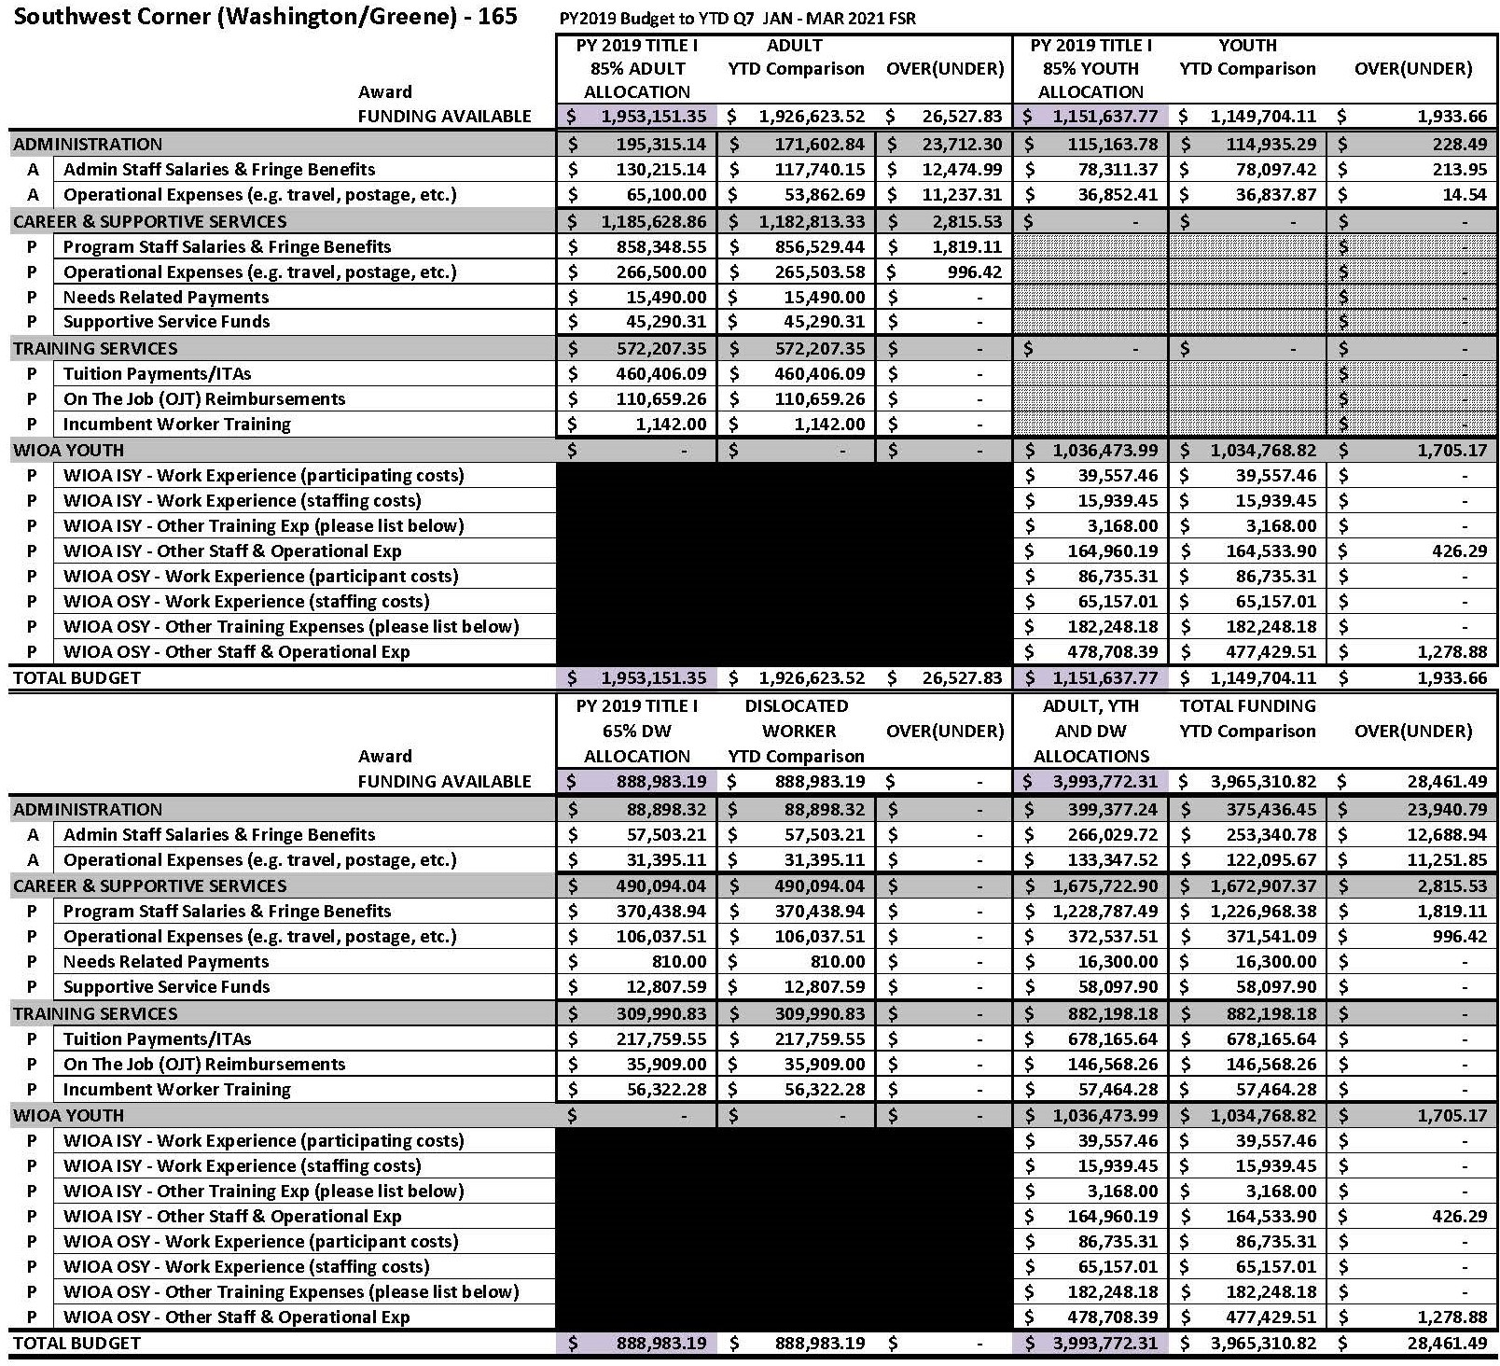

SCWDB PY 2020 CUMULATIVE REPORT

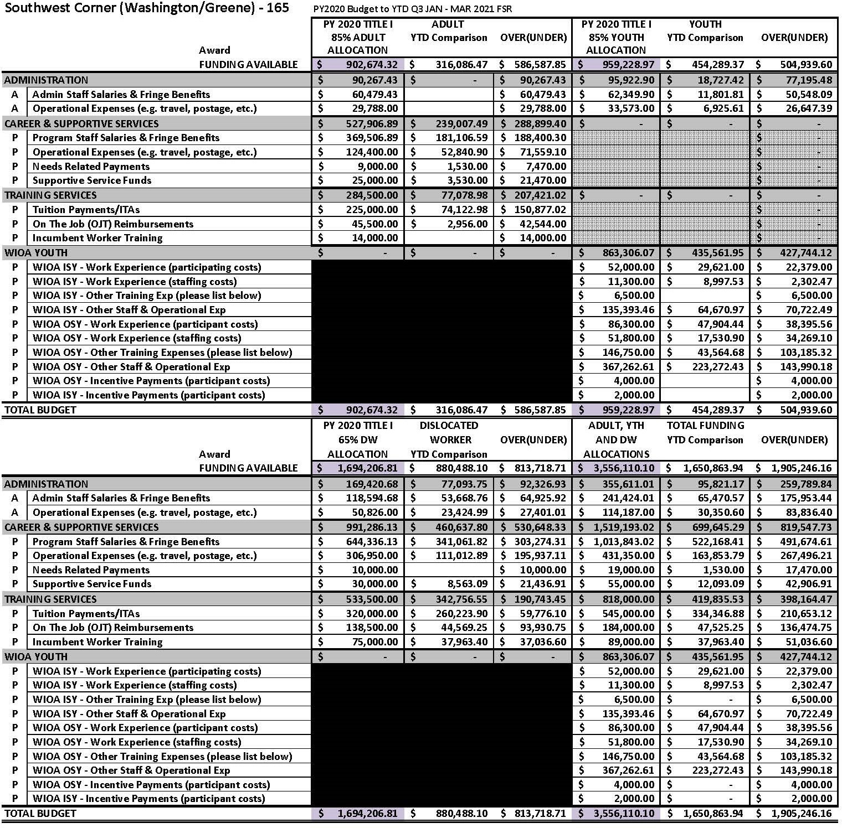

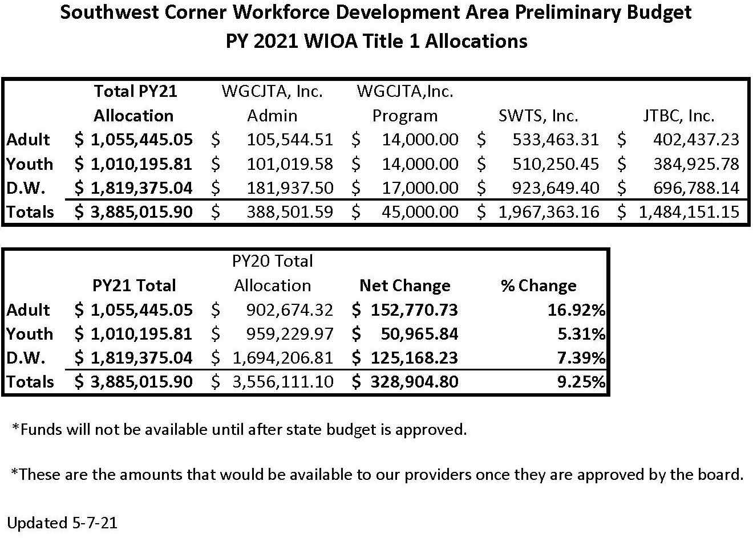

PACL 3rd Quarter Operating Budget FSR Report
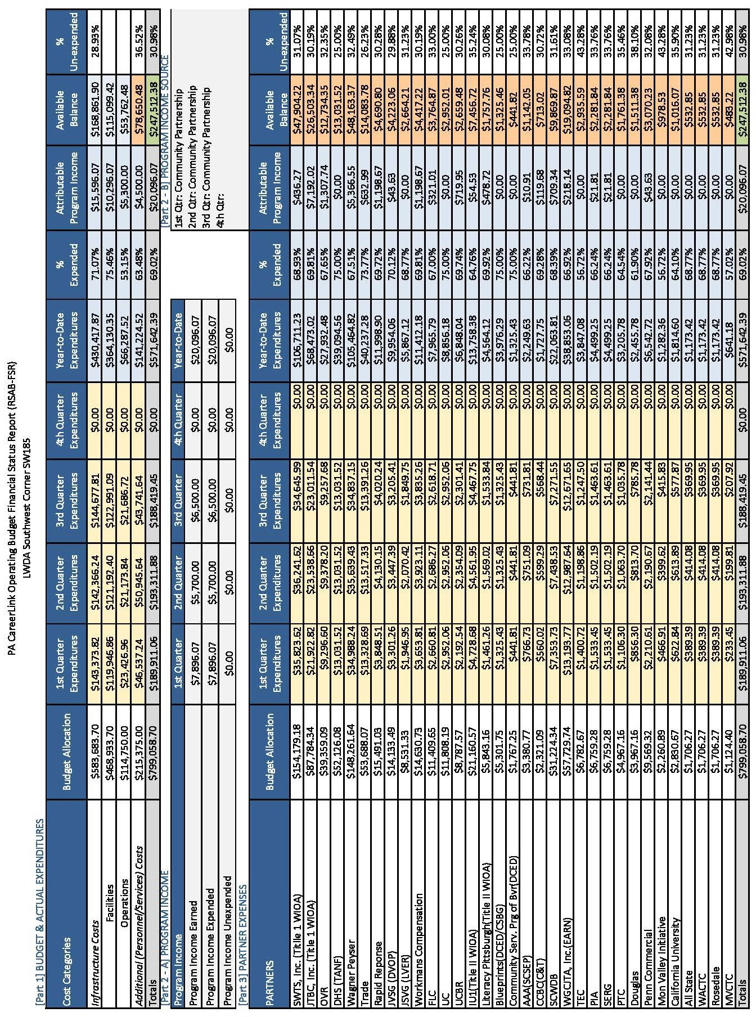

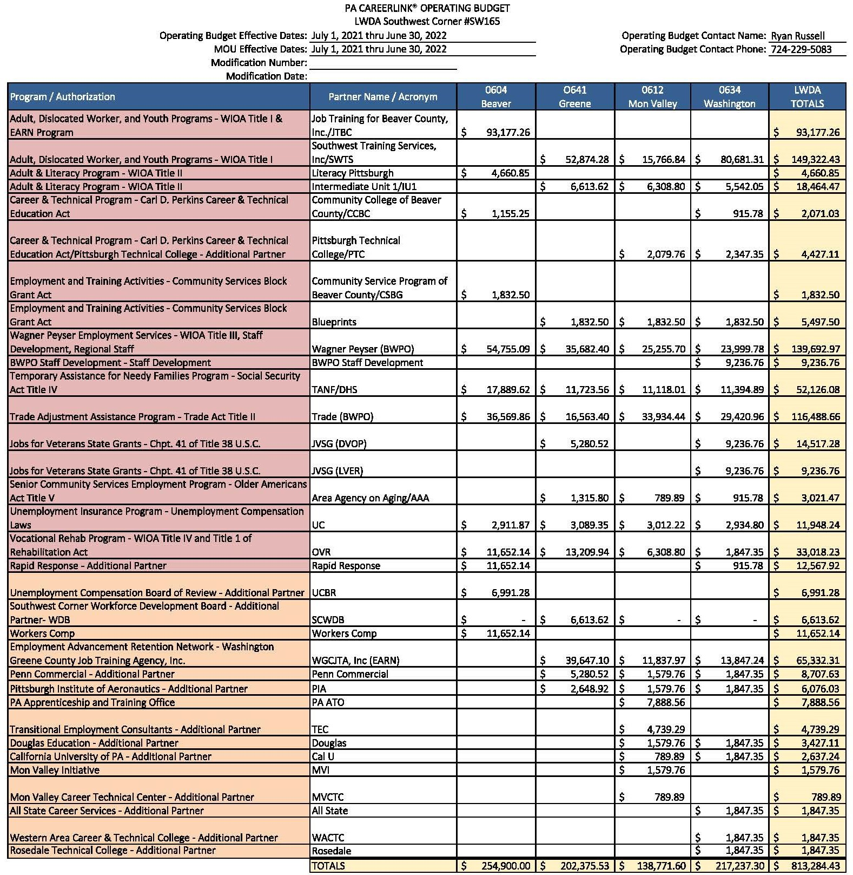

Financial Status Reports - Information through 3/31/2021
Adult PY19
(Term: 7/1/19-6/30/21) | Allocation | Expenses | % Expended
Admin | $195,315.14 | $171,692.84 | 87.91%
Program-Oversight | $15,709.90 | $12,894.37 | 82.08%
Program-Subrecipient | $1,742,126.31 | $1,742,126.31 | 100.00%
Totals | $1,953,151.35 | $1,926,713.52 | 98.65%
Youth PY19 | *Awarded additional $55,000
(Term: 7/1/19-6/30/21) | Allocation | Expenses | % Expended
Admin | $115,163.78 | $114,935.29 | 99.80%
Program-Oversight | $12,085.67 | $10,380.59 | 85.89%
Program-Subrecipient | $1,024,388.32 | $1,024,388.32 | 100.00%
Totals | $1,151,637.77 | $1,149,704.20 | 99.83%
Dislocated Worker PY19
(Term: 7/1/19-6/30/21) | Allocation | Expenses | % Expended
Admin | $88,898.33 | $88,898.33 | 100.00%
Program-Oversight | $11,492.39 | $11,492.39 | 100.00%
Program-Subrecipient | $788,592.48 | $788,592.39 | 100.00%
Totals | $888,983.20 | $888,983.20 | 100.00%
Adult PY20
(Term: 7/1/20-6/30/22) | Allocation | Expenses | % Expended
Admin | $90,267.43 | $- | 0.00%
Program-Oversight | $12,500.00 | $- | 0.00%
Program-Subrecipient | $799,906.89 | $316,086.47 | 39.52%
Totals | $902,674.32 | $316,086.47 | 35.02%
Youth PY20
(Term: 7/1/20-6/30/22) | Allocation | Expenses | % Expended
Admin | $95,923.00 | $18,727.42 | 19.52%
Program-Oversight | $13,500.00 | $- | 0.00%
Program-Subrecipient | $849,806.97 | $435,561.95 | 51.25%
Totals | $959,229.97 | $454,289.37 | 47.36%
Dislocated Worker PY20
(Term: 7/1/20-6/30/22) | Allocation | Expenses | % Expended
Admin | $169,420.68 | $77,093.75 | 45.50%
Program-Oversight | $19,000.00 | $2,262.29 | 11.91%
Program-Subrecipient | $1,505,786.13 | $801,132.06 | 53.20%
Totals | $1,694,206.81 | $880,488.10 | 51.97%

Youth TANF PY20 | *Extension waiver pending
(Term: 7/1/20-6/30/21) | Allocation | Expenses | % Expended
Admin | $50,049.00 | $27,548.60 | 55.04%
Program-Subrecipient | $450,441.00 | $359,358.73 | 79.78%
Totals | $500,490.00 | $386,907.33 | 77.31%
NDWG COVID PACL Grant | *To be extended through 06/30/22
(Term: 7/1/20-6/30/21) | Allocation | Expenses | % Expended
Admin | $15,654.16 | $6,730.98 | 43.00%
Program-Subrecipient | $294,821.61 | $99,786.30 | 33.85%
Totals | $310,475.77 | $106,517.28 | 34.31%
Business Ed. Partnership PY19 | *To be extended through 06/30/22
(Term: 1/1/20-6/30/21) | Allocation | Expenses | %Expended
Program-Oversight | $10,000.00 | $6,965.00 | 69.65%
Program-Subrecipient | $90,000.00 | $52,519.59 | 58.36%
Totals | $100,000.00 | $59,494.59 | 59.48%
NEG Health – OPIOID Grant
(Term: 7/1/18-6/30/21) | Allocation | Expenses | % Expended
Admin | $60,589.67 | $54,956.06 | 90.70%
Program-Oversight/Coord. | $209,172.13 | $162,091.94 | 77.49%
Program-Subrecipient | $434,769.20 | $334,016.56 | 76.83%
Totals | $704,531.00 | $551,064.56 | 78.22%
NDWG-Economic Transition (P4W)
(Term: 10/1/18-3/31/21) | Allocation | Expenses | % Expended
Program-Subrecipient | $247,000.00 | $247,000.00 | 100.00%
Totals | $247,000.00 | $247,000.00 | 100.00%
Rapid Response PY18
(Term: 7/1/18-6/30/21) | Allocation | Expenses | % Expended
Program-Subrecipient | $355,262.21 | $209,180.18 | 58.88%
Totals | $355,262.21 | $209,180.18 | 58.88%
Rapid Response PY19
(Term: 7/1/19-6/30/22) | Allocation | Expenses | % Expended
Program-Subrecipient | $50,000.00 | $- | 0.00%
Totals | $50,000.00 | $- | 0.00%

Next Generation Industry Partnership PY17
(Term: 7/1/17-6/30/21) | Allocation | Expenses | % Expended
Program-Oversight | $5,000.00 | $5,000.00 | 100.00%
Program-Subrecipient | $45,000.00 | $44,712.28 | 99.36%
Totals | $50,000.00 | $49,712.28 | 99.42%
Next Generation IP AM PY17 2nd Increment
(Term: 7/1/17-6/30/21) | Allocation | Expenses | % Expended
Program-Oversight | $3,750.00 | $3,750.00 | 100.00%
Program-Subrecipient | $71,250.00 | $37,101.31 | 52.07%
Totals | $75,000.00 | $40,851.31 | 54.47%
Next Generation IP FL PY17 2nd Increment
(Term: 7/1/17-6/30/21) | Allocation | Expenses | % Expended
Program-Oversight | $1,875.00 | $1.216.96 | 64.90%
Program-Subrecipient | $37,625.00 | $- | 0.00%
Totals | $37,625.00 | $1,216.96 | 3.25%
Youth Reentry PY19 *$217,500 extends through 6/30/22
(Term: 11/18/2019-6/30/21) | Allocation | Expenses | % Expended
Admin | $50,000.00 | $23,142.83 | 46.29%
Program-Oversight/Coord. | $88,375.00 | $45,759.25 | 51.78%
Program-Subrecipient | $361,625.00 | $104,179.83 | 28.81%
Totals | $500,000.00 | $173,081.91 | 34.62%
Nat Gas Apprenticeship Grant | *To be extended through 10/31/21
(Term: 6/1/19-6/30/21) | Allocation | Expenses | % Expended
Admin | $13,750.00 | $13,750.00 | 100.00%
Program-Subrecipient | $261,250.00 | $115,392.57 | 44.17%
Totals | $275,000.00 | $129,142.57 | 46.96%
PA SMART Expanding Diverse Industry *Extension waiver pending
(Term: 3/1/20-6/30/21) | Allocation | Expenses | % Expended
Admin | $40,000.00 | $- | 0.00%
Program-Subrecipient | $360,000.00 | $- | 0.00%
Totals | $400,000.00 | $- | 0.00%
PA SMART Building a Diverse Pipeline |  | *Extension waiver pending
(Term: 3/1/20-6/30/21) | Allocation | Expenses | % Expended
Admin | $25,000.00 | $- | 0.00%
Program-Subrecipient | $225,000.00 | $25,830.28 | 11.48%
Totals | $250,000.00 | $25,830.28 | 10.33%

EARN TANF PY 20
(Term: 7/1/20-6/30/21) | Allocation | Expenses | % Expended
Admin | $99,744.00 | $60,201.54 | 60.36%
Program | $897,700.00 | $489,290.92 | 54.50%
Totals | $997,444.00 | $549,492.46 | 55.09%
EARN SNAP PY 20
(Term: 7/1/20-6/30/21) | Allocation | Expenses | % Expended
Admin | $5,857.00 | $3,212.39 | 54.85%
Program | $52,727.00 | $21,897.18 | 41.53%
Totals | $58,584.00 | $25,109.57 | 42.86%
EARN Performance
(Term: No Term) | Allocation | Expenses | % Expended
Program | $391,129.18 | $395.10 | 0.10%
Totals | $391,129.18 | $395.10 | 0.10%

Washington-Greene County Job Training Agency Inc.
Income Statement
July 2020 - March 2021

Revenues Actual
01-4015-01 | SPC Revenue | $4,389.00
01-4019-01 | ATO-APPRENTICESHIP | $5,373.44
01-4019-02 | ATO-APPRENTICESHIP | $61,154.61
01-4023-01 | TEACHER IN THE WORKPLACE | $1,396.11
01-4023-02 | TEACHER IN THE WORKPLACE | $5,495.30
01-4031-01 | EQT Revenue | $10,000.00
01-4033-01 | Youth Re-entry | $18,225.14
01-4033-02 | Youth Re-entry | $111,278.01
01-4037-01 | Opioid Grant | $4,766.09
01-4037-02 | Opioid Grant | $157,724.34
01-4044-02 | BLD & CONST MATCH MONEY REVENUE | $22.08
01-4045-02 | LOGISTICS & TRANSP MATCH MONEY REVENUE | $15.94
01-4047-02 | OIL AND GAS MATCH REVENUE | $0.59
01-4084-01 | 19 8523 COVID PACL | $6,732.39
01-4084-02 | 19 8523 COVID PACL | $99,786.30
01-4091-01 | Snap-Earn | $3,212.39
01-4091-02 | Snap-Earn | $21,897.18
01-4101-02 | 19 8892 PASMART GACC | $25,830.28
01-4102-02 | 18 8323 Economic Transition- TCWIB | $45,623.00
01-4144-01 | 8141 SPOC REVENUE | $60,201.54
01-4144-02 | 8141 SPOC REVENUE | $489,290.92
01-4164-02 | Welfare Performance Based Payments | $33.26
01-4178-01 | INDUSTRY PARTNERSHIP REVENUE | $1,219.64
01-4238-02 | Q101 Revenue | $551,647.35
01-4239-02 | Q101 CONTRIBUTIONS | $19,573.92
01-4308-02 | 6231 INDUSTRY PARTNERSHIP REV | $2,975.51
01-4310-02 | ADV .MFG. | $8.89
01-4315-01 | 6233 IP 2ND INC REV | $260.10
01-4315-02 | 6233 IP 2ND INC REV | $1,611.00
01-4316-02 | P4W NATIONAL DW GRANT | $109,434.86
01-4536-01 | 3361 YTH. TANF REVENUE | $53,179.27
01-4536-02 | 3361 YTH. TANF REVENUE | $365,654.25
01-4575-01 | SLIP INTERNSHIP | $10,150.03
01-4575-02 | SLIP INTERNSHIP | $98,201.86
01-4578-02 | RAPID RESPONSE REV. | $71,228.54
01-4912-01 | 300 ADULT REVENUE | $83,762.89

01-4912-02 | 300 ADULT REVENUE | $787,083.48
01-4913-01 | 330 YOUTH REVENUE | $63,270.73
01-4913-02 | 330 YOUTH REVENUE | $149,580.63
01-4913-03 | 330 YOUTH REVENUE | $481,515.89
01-4914-01 | 400 DIS. WKR. REVENUE | $93,484.22
01-4914-02 | 400 DIS. WKR. REVENUE | $996,351.39
01-4921-01 | BUSINESS EDUC PARTNERSHIP | $7,255.73
01-4921-02 | BUISINESS EDUC PARTNERSHIP | $63,849.52
01-4950-00 | OTHER INCOME | ($71.31)
 | Total Revenues | $5,143,676.30
Expenses
01-5000-01 | SALARIES | $187,228.90
01-5000-02 | SALARIES | $225,091.16
01-5000-03 | SALARIES | $2,173.72
01-5001-02 | SALARIES-WK EXP | $696.00
01-5100-01 | FRINGES | $81,690.25
01-5100-02 | FRINGES | $92,048.79
01-5100-03 | FRINGES | $187.16
01-5101-02 | FRINGES-WK EXP | $53.24
01-6000-01 | ADVERTISING | $4,701.42
01-6000-02 | ADVERTISING | $369.00
01-6015-02 | TESTING SERVICES-Client's | $625.00
01-6030-01 | BANK SERVICE CHARGE | $747.07
01-6030-02 | BANK SERVICE CHARGE | $3.67
01-6035-02 | BEAVER COUNTY EXPENSES--PROGRAM | $1,386,260.84
01-6035-03 | BEAVER COUNTY EXPENSES-OSY | $240,981.00
01-6036-02 | SOUTHWEST TRAINING EXPENSES | $1,773,739.23
01-6036-03 | SOUTHWEST TRAINING EXPENSES | $235,196.07
01-6060-01 | COMPUTER EXPENSES | $4,892.17
01-6060-02 | COMPUTER EXPENSES | $4,720.76
01-6060-03 | COMPUTER EXPENSES | $419.79
01-6080-01 | CONTRACTED SERVICES | $35,825.69
01-6183-02 | PETERS TWP SCHOOL DISTRICT | $3,079.75
01-6184-02 | PENNA FLAME INDUSTRIES, INC. | $537.00
01-6219-02 | SKC, Inc. | $537.00
01-6254-02 | KEYSTONE DEVELOPMENT PARTNERSHIP | $31,492.17
01-6269-02 | WESTMORELAND-FAYETTE WORKFORCE INVESTMENT BOARD | $31,161.62
01-6281-02 | GERMAN AMERICAN CHAMBER | $38,830.28
01-6282-02 | TRINITY SCHOOL DISTRICT | $2,415.55
01-6284-02 | Accuttrex Product, Inc. | $537.00
01-6285-02 | MEDCERTS | $6,000.00

01-6300-01 | COPYING | $2,017.84
01-6300-02 | COPYING | $16,338.74
01-6300-03 | COPYING | $33.84
01-6320-01 | DUES & SUBSCRIPTIONS | $7,446.48
01-6320-02 | DUES & SUBSCRIPTIONS | $1,302.72
01-6320-03 | DUES & SUBSCRIPTIONS | $4.55
01-6380-01 | INSURANCE | $21,572.80
01-6380-02 | INSURANCE | $2,527.17
01-6380-03 | INSURANCE | $79.03
01-6390-01 | COUNSELING SERVICES | $1,590.00
01-6390-02 | COUNSELING SERVICES | $31,407.00
01-6440-01 | MATERIALS & SUPPLIES | $7,399.57
01-6440-02 | MATERIALS & SUPPLIES--For Client's Only | $4,168.24
01-6441-02 | MATERIALS AND SUPPLIES (OPERATIONAL) | $7,200.02
01-6441-03 | MATERIALS AND SUPPLIES (OPERATIONAL) | $1,209.77
01-6470-02 | TRAINING -PARTICIPANTS | $690.00
01-6478-01 | OFFICE SUPPLIES | $7,596.89
01-6478-02 | OFFICE SUPPLIES | $9,739.65
01-6478-03 | OFFICE SUPPLIES | $127.49
01-6480-01 | POSTAGE | $3,461.71
01-6480-02 | POSTAGE | $2,165.48
01-6480-03 | POSTAGE | $61.34
01-6482-01 | PENSION EXPENSE | $890.00
01-6484-01 | FSA EXPENSES | $185.82
01-6520-02 | PUBLICATION & PRINTING | $28.50
01-6540-01 | RENT | $25,958.66
01-6540-02 | RENT | $356,462.67
01-6540-03 | RENT | $508.85
01-6560-01 | STAFF TRAINING & EDUCATION | $1,989.00
01-6560-02 | STAFF TRAINING & EDUCATION | $6,161.61
01-6563-02 | SUBSIDIZED EMPLOYMENT | $2,840.89
01-6580-01 | TELEPHONE | $2,629.53
01-6580-02 | TELEPHONE | $37,300.42
01-6580-03 | TELEPHONE | $43.33
01-6600-01 | TRAVEL | $2,030.90
01-6600-02 | TRAVEL | $8,416.15
01-6600-03 | TRAVEL | $74.51
01-6620-01 | UTILITIES | $7,580.88
01-6620-02 | UTILITIES | $73,886.33
01-6620-03 | UTILITIES | $415.44
01-6640-02 | CAREERLINK SITE ADMIN EXPENSE | $50,399.51
01-6700-01 | JOB TRAINING SHARE OF CDM-GREENE | $5,054.13

01-6700-02 | JOB TRAINING SHARE OF CDM-GREENE | $25,270.68
01-6701-02 | JTA SHARE OF CDM-WASH | $11,734.26
01-6702-02 | JTA SHARE OF CDM-DONORA | $12,823.59
01-6703-02 | JTA SHARE OF CDM-BEAVER | $5,106.75
 | Total Expenses | $5,158,174.04
 | BEGINNING NET ASSETS | $632,176.34
 | NET SURPLUS/(DEFICIT) | ($14,497.74)
 | ENDING NET ASSETS | $617,678.60
Report name: Combined Inc Stmt -USE FOR WDB MTG
Include all Account Codes
Include all Accounts
Include all Projects
Include all Project Attributes
Include all Transaction Attributes
Include all Classes
Include all Journals
Include these Not Yet Posted Transactions: <None>
Include all Project Types
Include all Project Statuses
Include all Project Divisions
Include all Project Departments
Include all Project Locations
Include all Department(s)
Include these dates: <Specific fiscal periods> (7/1/2020 to 3/31/2021)

Washington-Greene County Job Training Agency Inc.
Balance Sheet
Mar-21

Assets Actual
01-1010-00 | CASH-CHECKING | $169,889.19
01-1011-00 | CASH-CHECKING NORTHWEST | $134.91
01-1020-00 | CASH-PAYROLL | $31,510.27
01-1030-00 | CASH-IP -Original | $122,926.11
01-1040-00 | CASH-DONATION | $0.00
01-1050-00 | ARC-Black to Blue/ARCODE | $1,006.02
01-1060-00 | CASH-DHS | $78,579.55
01-1070-00 | CASH-15/16 B&C MATCH-Sustainability | $74,737.33
01-1110-00 | GRANTS RECEIVABLE | $173,768.73
01-1111-00 | RECEIVABLES FEE FOR SERVICE | $0.00
01-1120-00 | DUE FROM RAPID ATTACHMENT | $0.00
01-1121-00 | DUE FROM WCCED | $0.00
01-1124-00 | RECEIVABLE FROM WGCJTA GEN. ACCT. | $0.00
01-1125-00 | RECEIVABLE FROM SOUTHWEST TRAINING | $25,848.69
01-1126-00 | RECV FROM SWTS-PAYROLL & TAXES | $0.00
01-1127-00 | RECVB FROM SWTS-PENSION EMPLR CONTRIB | $0.00
01-1128-00 | RECEIVABLE FROM BEAVER COUNTY | ($65,047.89)
01-1129-00 | RECEIVABLES FOR JTBC GRANTS | $0.00
01-1200-00 | ESCROW ACCT-PENSIONS | $273.91
01-1210-00 | PREPAID EXPENSES | $0.00
01-1500-00 | DUE FROM OTHER CONTRACTS | $0.00
01-1600-00 | DUE TO OTHER CONTRACTS | $0.00
01-1710-00 | DEPOSITS | $0.00
Total Assets $613,626.82

Liabilities and Fund Balance Liabilities
01-2010-00 | ACCOUNTS PAYABLE | $14,369.10
01-2020-00 | NOTES PAYABLE | $0.00
01-2025-00 | ACCRUED PAYROLL & TAXES | $0.74
01-2027-00 | ACCRUED TIME OFF | $0.00
01-2030-00 | ADP TAXES ACCRUED & WITHHELD | $0.01
01-2035-00 | PENSIONS WITHHELD | ($0.01)
01-2037-00 | LOCAL TAXES WITHHELD | ($0.05)
01-2039-00 | MISCELLANEOUS WITHHELD | $3,805.43
01-2040-00 | DEFERRED REVENUES | $0.00
01-2045-00 | DUE TO BEAVER COUNTY JTA | ($22,227.00)
01-2047-00 | DUE TO SOUTHWEST TRAINING SERVICES INC. | $0.00
01-2060-00 | ACCRUED STORAGE COSTS-CLOSEOUT | $0.00
01-2065-00 | ACCRUED AUDIT EXPENSES-CLOSEOUT | $0.00

01-2066-00 | ACCRUED W/C LIABILITY | $0.00
01-2070-00 | PNC CREDIT CARD | $0.00
01-2100-00 | PRIOR YEAR PAYABLE | $0.00
 | Total Liabilities | ($4,051.78)
Fund Balance
01-3100-00 | NET ASSETS-BEG OF YR-UNRESTR | $0.00
01-3200-00 | NET ASSETS-UNRESTRICTED | $617,678.60
 | Total Fund Balance | $617,678.60
 | Total Liabilities and Fund Balance | $613,626.82
Report name: Monthly Balance Sheet
Chart template: Default
Include account levels 1 to 4
Include accounts with zero balances
Include inactive accounts
Include these Funds: 01
Include all Account Codes
Include all Accounts
Include all Account Attributes
Include all Projects
Include all Project Attributes
Include all Transaction Attributes
Include all Classes
Include all Journals
Include these Not Yet Posted Transactions: <None>
Include all Cash Flow Codes
Include all Working Capital Codes
Include all Project Types
Include all Project Statuses
Include all Project Divisions
Include all Project Departments
Include all Project Locations
Include all Department(s)
Column 1 criteria:
Heading:
Definition: Account Number
Column 2 criteria:
Heading:
Definition: Account Description
Column 3 criteria:
Heading: Actual
Include these dates: <Specific fiscal period> (3/31/2021)
Definition: {Actual}

DIRECTOR’S REPORT

- Local/Regional Plan Update
- Audit Update
- EEO Compliance Review
- BWDA Monitoring Reports
- Grant Updates
- SCWDB Covid-19 Planned Responses/Action
- Governor’s Achievement Award Winner

Southwest Corner Local and Regional Plan Update
  - A locally approved Southwest Regional Plan and Southwest Corner Local Plan were submitted to the PA Bureau of Workforce Development (BWDA) on April 1, 2021.
  - BWDA has conducted regional and local plan feedback meetings. A feedback meeting for the Regional Plan occurred May 10, 2021 at 12 pm. A Local Plan feedback meeting occurred May 14, 2021 at 10AM.
  - Majority of the feedback for both plans was structural in nature. In a few instances, content needs to be elaborated on.
  - The Southwest Corner Local Plan had 7 instances of best practices. This was the most in the state.
  - The board accepted the Regional and Local Plans at the last WDB meeting, which was still during the comment period. There were no comments received for either plan, but the board will still need to accept the plans again in order to meet compliance.
  - The staff are requesting approval of the Southwest Regional Plan and Southwest Corner Local Plan.
  - The final versions of both plans will be posted to the WDB website and shared with both the CLEO Board and WDB members.

Washington Greene County Job Training Agency, Inc. PY19 Audit
  - Maher Duessel conducted the audit (2nd year of a 3-year agreement).
  - Audit conducted November 23, 2020 through December 4, 2020.
  - More portions of the audit were conducted remotely than usual.
  - Final Audit was released and will be posted to WDB and WGCJTA, Inc. websites.
  - No findings or deficiencies were cited.
  - PA Dept. of L&I reviewed and accepted the audit. (see letter dated 4/5/21)

PA Department of Department of Labor and Industry Office of Equal Opportunity (PA OEO) desk review update
  - Due to changes made to the PA Office of Equal Opportunity review process, PA OEO initiated a new review of the entire Southwest Corner Workforce Area on September 22, 2020. All documentation was requested by November 9, 2020.
  - All requested documentation was submitted prior to the deadline.
  - Draft monitoring survey received February 1, 2021.
  - Local responses to draft monitoring survey were submitted 3/18/21.
  - Responses to survey were accepted by the PA OEO. (see letter dated 4/27/21)
  - In order to maintain compliance moving forward, the SCWDB must make the following changes to the SCWDB NDEO policy:
    - The current SCWDB NDEO Policy (Section I) states the following sentence in regards to the EO Officer communicating with OEO.
“EO Officer will be the main conduit of NDEO information between SCWDB and the Commonwealth”.
The SCWDB will revise this sentence to state:

“EO Officer will be the main conduit of NDEO information between SCWDB and the Commonwealth, specifically the PA Office of Equal Opportunity.”
    - The current NDEO policy outlines the complaint processing procedures in sections VII. Local Office Complaint Acceptance Procedures, IX. Complaint Procedures and X. Complaint Resolution. PA OEO has stated that the process needs to be broken into a step-by-step process, to allow for a clearer understanding of the procedures. WDB staff recommend removing the previously stated section and replacing them with sections VII. Discrimination Complaints and IX. Discrimination Complaint procedures. Changes were outlined in the revised copy of the policy that was shared with the members prior to the meeting and was approved by PA OEO.
  - WDB staff are requesting approval of these changes to the policy.
  - If changes are approved, an updated version will be posted to the WDB website.
*Report prepared by EO Officer, Ryan Russell

PA Bureau or Workforce Development Oversight Services SCWDB Certification (Reports included)
  - Oversight Services conducted a LWDB certification analysis on January 8, 2021.
  - Oversight Services cited issues related to board member appointment time lines and signature dates of required documents.
  - No responses were required.
  - The SCWDB is certified until January of 2023.

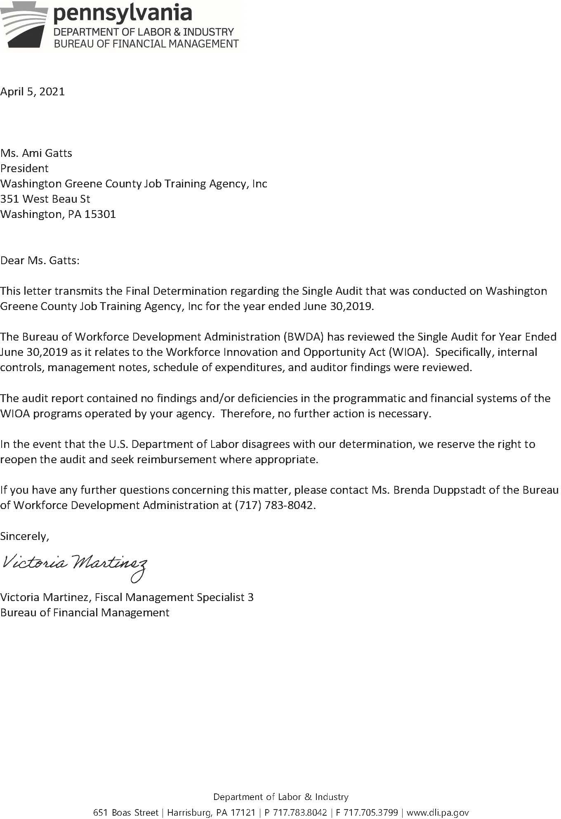

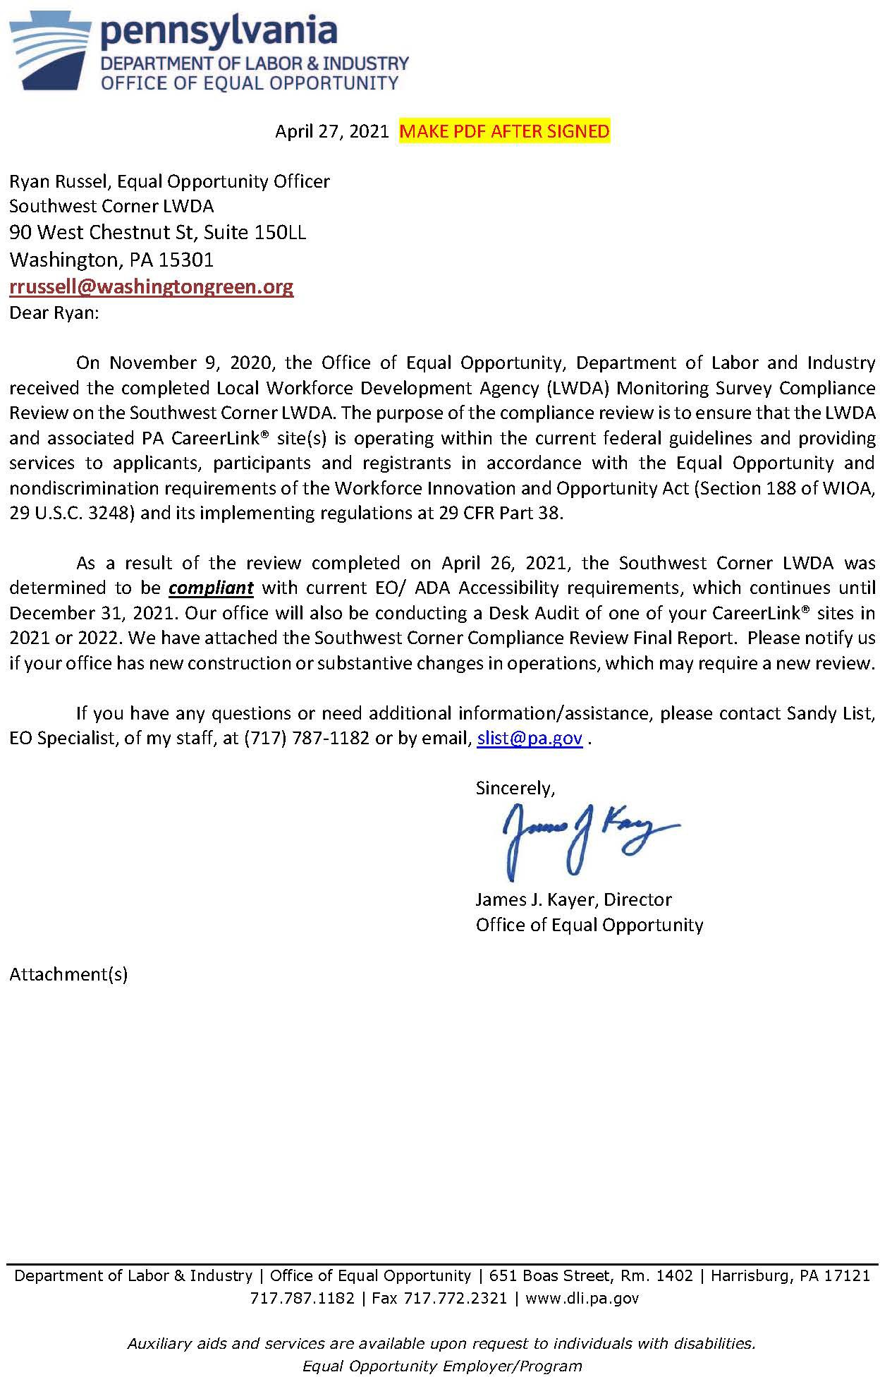

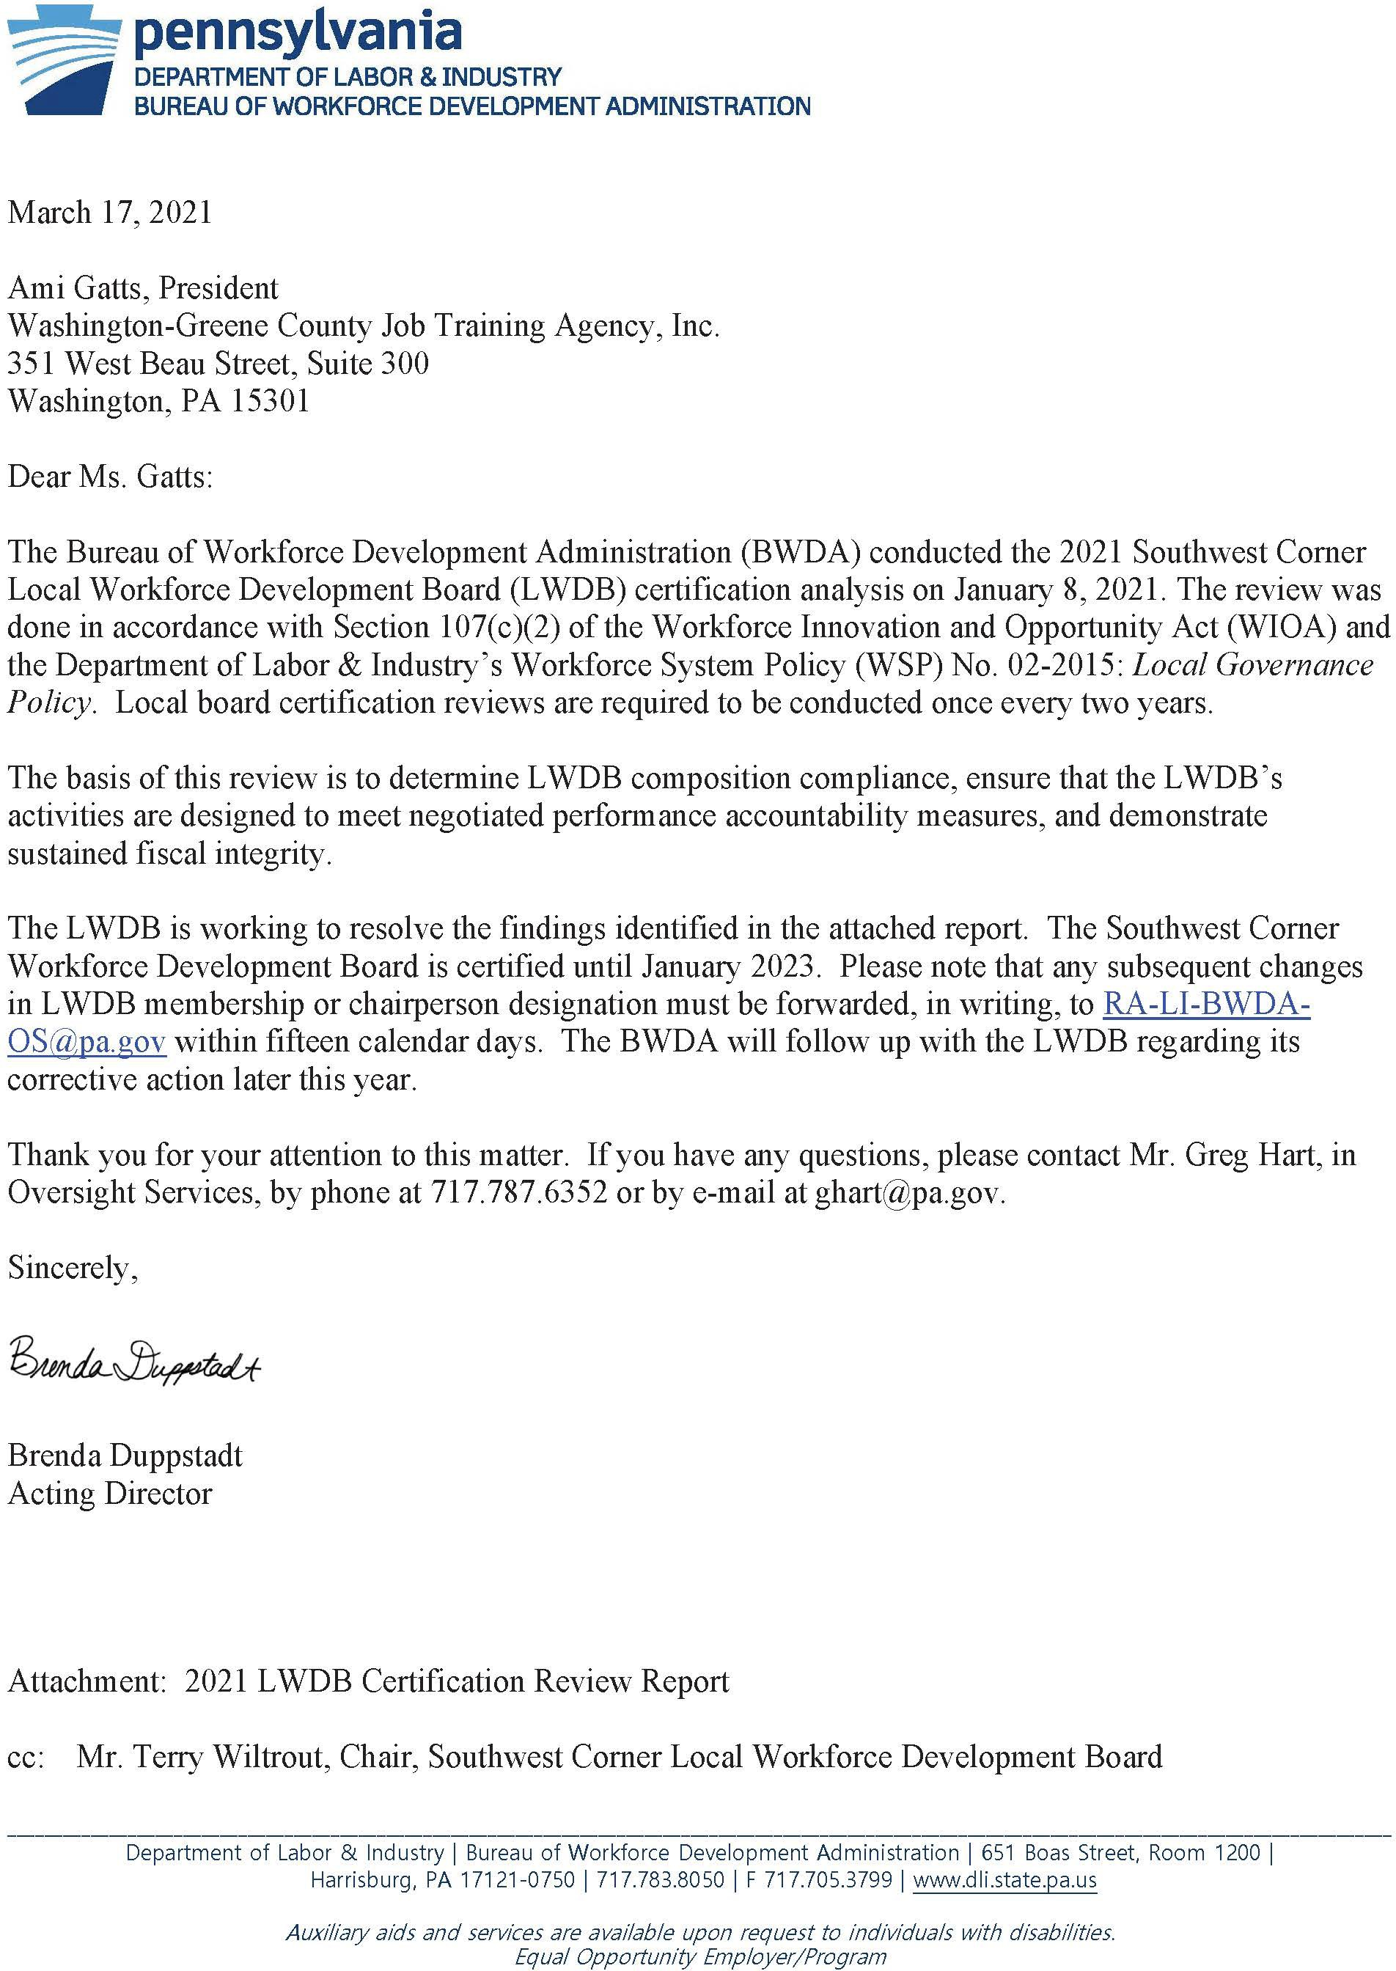

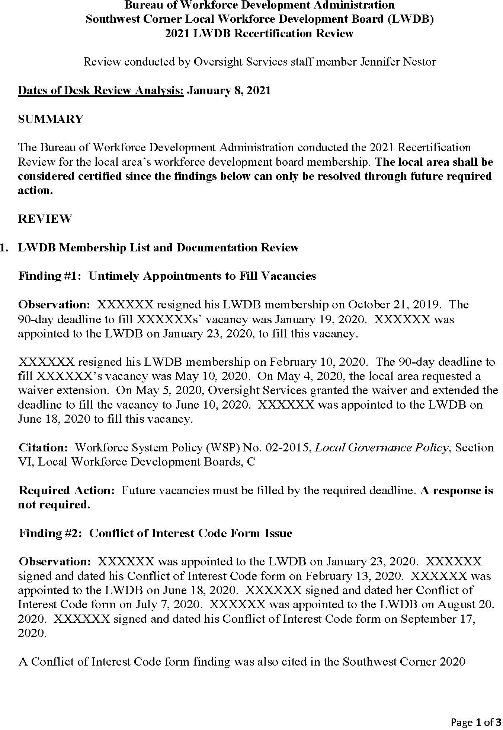

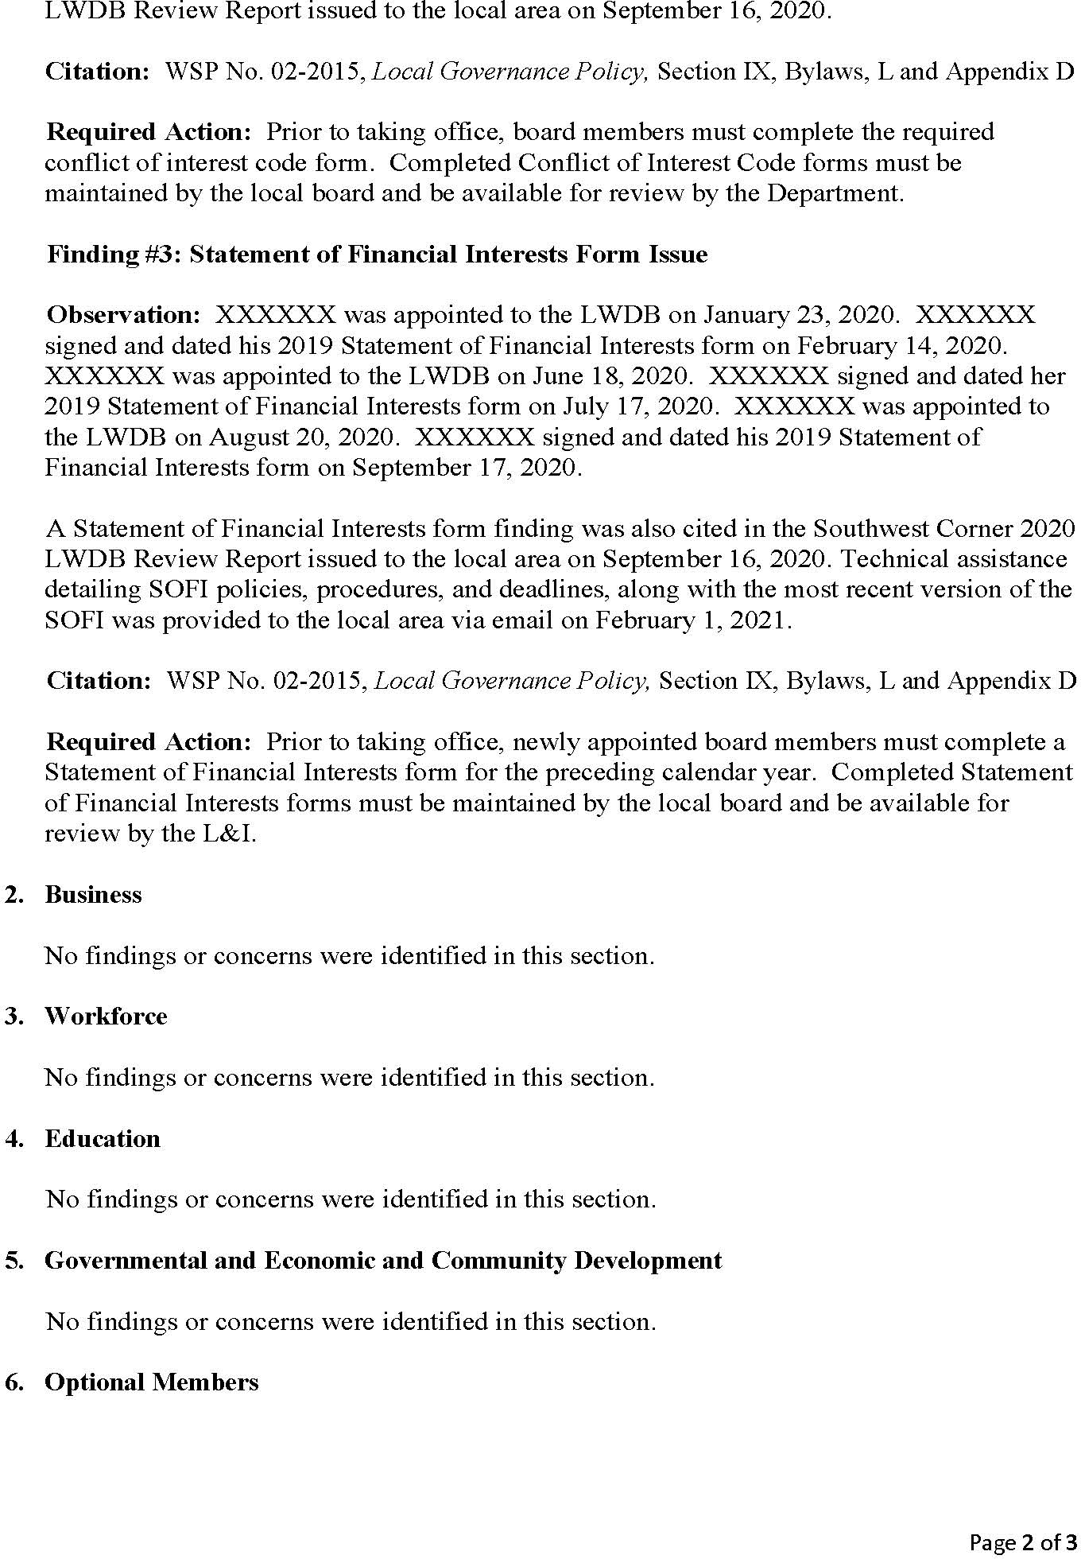

Grant Updates
Funding Awarded:
  - Partner 4 Work, NDWG
This grant is a multi-State National Dislocated Worker Grant, that will serve dislocated workers in our region. We became a regional partner through P4W. We initially asked for and spent $143,000 and then were awarded an additional $102,000. This funding was fully spent by the grant end date of March 31, 2021. These funds proved very valuable and allowed us to support training for 45 dislocated workers that were laid off during COVID 19. Total grant award was $245,000.

Economic Transition
We were awarded $375,000 in Economic Transition funding through Tri-County Workforce Investment Board. These funds were awarded in place of a request for Rapid Response funds to support training of the over 1500 workers in our area affected by COVID 19 layoffs. The funds must be spent by September 30, 2021

Rapid Response
We were awarded $50,000 in Rapid Response funding to help support the needs of the over 1500 workers in our area affected by COVID 19 layoffs. These funds will primarily be used to support staffing and operational needs related to this population.

PA Smart Dual Apprenticeship Program
In collaboration with the Pittsburgh Chapter of the German American Chamber of Commerce (GACC), the SCWDB was awarded $250,000 in funding to support GACC’s regional Dual Apprenticeship and Pre-Apprenticeship Program. This program addresses skills gaps in the regional advanced manufacturing workforce through the German dual training model, in which young people split time between traditional classroom education, related technical instruction (RTI), and on-the-job training (OJT). The Dual Apprenticeship Program has been registered by the Pennsylvania Department of Labor and Industry (L&I), and has earned approval from the Pennsylvania Apprenticeship and Training Office (ATO) and the Federal Committee on Apprenticeship.

PA Steel Alliance Industry Partnership
The SCWDB was awarded $145,000 to convene and Implement a PA Steel Alliance Next-Gen Sector Partnership in Beaver, Greene, and Washington counties. The partnership will focus on supporting costs related to coordinating and funding electrical and mechanical maintenance worker training.

Building & Construction Industry Partnership
The SCWDB was awarded $250,000 to convene and Implement a Building and Construction Next- Gen Sector Partnership in Beaver, Greene, and Washington counties. SCWDB has built a strong connection and continues a growing relationship between workforce and the regional joint apprenticeship programs as related to prevailing wage job opportunities at the Shell Cracker Plant and other power plants. Also, there are many building and construction companies with long histories working throughout the regional area. These employers face many obstacles in their work, including but not limited to recruitment of minorities, women, and veterans, and replacing an aging workforce.

EQT Foundation
The Compass Program of Greene County works to give at-risk youth (grades 6-12) the tools necessary to lead a productive life and stay out of the criminal justice system by addressing the six life domains of work, education, relationships, community, health and creativity. Through academic and counseling support, as well as job and soft-skill training, we hope to reduce recidivism and high school drop-out rates among our participants. The Compass Program meets twice weekly after

WDB STAFF REPORTS

school at the PA CareerLink® Greene County office. Optional Saturday mornings and/or summer sessions for students may also be assigned by Children and Youth Services, juvenile probation, school principals or local judges. In addition, Compass assists students who wish to attend voluntarily or at their parent’s request. The SCWDB applied for $20,000, but was awarded $10,000. Program activities are being planned and additional funding opportunities are being explored.

New Applications Awarded:
  - Appalachian Regional Commission
SCWDB applied for a Substance Abuse Grant through ARC. This grant will include our regional partners and cover 9 Counties, Allegheny, Armstrong, Beaver, Butler, Greene, Fayette, Indiana, Washington and Westmoreland. The INSPIRE Initiative makes funding available for projects that address the substance abuse crisis by creating or expanding a recovery ecosystem that will lead to workforce entry or reentry for individuals in recovery from substance abuse disorder (SUD). Projects are encouraged to support the post-treatment-to-employment continuum, which could include investments in healthcare networks that support substance abuse recovery professionals; recovery- focused job training programs; and initiatives designed to coordinate or link recovery services and training, among others. This grant will continue and expand our existing work from the Opioid grant. We will have a kick off meeting on May 18th with our regional partners.
Grant request- $500,000 for a 2-year period.

Program Updates

  - Business-Education Partnership (BEP)
PY20 BEP program will conclude on June 30, 2021, it appears that all grant goals will be met or exceeded and it will be fully expended. Because of COVID we have instituted some initiatives to offer some programs virtually and that has been successful.

Southwest Corner Beaver County Non-Traditional Pre-Apprenticeship Ecosystem
This grant that was developed to recruit and prepare nontraditional and diverse populations for building trades careers in Beaver County. This is a partnership between the SCWDB, Beaver County Building Trades, Beaver County CTC, and Community College of Beaver County, along with a number of community and social service groups. The initial focus has been on putting place the recruitment team and developing the MC3 class schedule and location. The Pandemic has impacted the location and schedule. However, the first class is scheduled for June 28th, 2021 and we expect a full class.

Youth Re-Entry
The Youth Reentry Cooperative Network (YRCN) is a collaborative project between the Southwest Corner Workforce Development Board and the Westmoreland-Fayette Workforce Development Board. Though COVID 19 has required some creativity for recruiting both WDBs began outreach and recruitment of eligible Individuals in need of additional training and/or employment assistance including those interested in other High Priority Occupations for ITAs continues. The SCWDB has enrolled eleven (15) out-of-school-youth offenders: 3 in Greene County, 5 in Beaver County, 5 Washington County and 2 in West-Fay workforce area. The participants have enrolled in work experiences (7), On-the-Job Training (2), and post-secondary education (4). The other 2 participants are receiving assessment, work readiness, and case management.

Opioid Project
This program has had many successes. Trainings are done through incumbent worker training and traditional Individual Training Accounts through the opioid program funds and leveraged with WIOA

WDB STAFF REPORTS

formula dollars through co-enrollment. Though the area planned to serve 50 individuals in this grant, we have served over 200 individuals in training to this point. SCWDB has requested and been awarded a total of $704,531 in funding under this grant to continue training and programs. The Commonwealth’s request to extend the funding through June 30, 2021 has been approved. Current activity for the projects, which includes Incumbent Worker Training (IWT) and Individual Training Accounts (ITA) is as follows:
- 118 enrolled in Certified Recovery Specialist training
- 2 On-The-Job Training contracts with local employers – Job Title: Certified Recovery Specialist
– One participant was given a raise because she completed the CRS training.
- 32 Incumbent Worker Trainings
- 20 ITAs for Paramedics, Advanced EMTs and EMTs
- 30 HPO ITAs
- 2 Transitional Jobs
COVID 19 has proved to be very detrimental to this population. We have had numerous overdose deaths, many relapses and every day that we remain under restrictions it increases the chances of more. This population has not thrived on the virtual platforms for connectivity, meetings and support. We continue to work as closely as we can with our clients to help them navigate these uncertain times.

WDB STAFF REPORTS

Covid-19 Response Update
Pennsylvania CareerLink ® offices opened on June 15, 2020 for all staff. On July 1, 2020 we started seeing individuals by appointment only. This is currently still in effect. We have also implemented and A Team and B Team rotation, so if there is a COVID exposure, the site can be reopened to the other team, after cleaning. This is for all of our PA CareerLink® sites. We are currently planning to have all supervisors return to in person work full-time (with no team rotations) on May 17, 2021. If there are no issues, the PACLs will allow all staff to return to full-time in-person work starting June 7th, 2021. Individual partners may decide not to return, but all will be permitted to return when ready starting June 7th, 2021. All health recommendations from the Governor’s office will be followed.
  - Created a Pandemic Response Team that included our Workforce Board Director, Fiscal Staff, PA CareerLink® Operator Consortium and PA Career® Site Administrators. Our team virtually met on a weekly basis to discuss programming needs and updates, opportunities for improvement and the development of a “post-pandemic” plan for the safe reopening of our One Stop Centers.
  - Provided virtual case management and career counseling services to both new and existing customers. They have been able to meet with our staff on a regular basis to ensure they are receiving the services they need and staying on track for program success;
  - Created a full menu of online workshops addressing a variety of topics regarding Professional Development; Soft Skills Training; Orientation to One Stop Services; Financial Literacy and Labor Market Information to name a few;
  - Provided Unemployment Compensation claim guidance information and support in alignment with our State Agency;
  - Developed Resource Email Accounts for each of our PA CareerLink® locations so the needs of our communities can be responded to expeditiously and referrals to appropriate partnering agencies can be made virtually.
Washington County: PACLWASH@washingtongreene.org 724-223-4500 Mon Valley: PACLMV@washingtongreene.org 724-379-4750 Greene County: PACLGREENE@washingtongreene.org 724-852-2234 Beaver County: PACLBEAVER@washingtongreene.org 724-728-4860
  - Worked with our training providers to develop online approved programs quickly;
  - Assisted our employers with Incumbent Worker Training opportunities and funds to support online training initiatives; thus, enhancing the skills of their existing workforce and;
  - Hired Pandemic Safety Officers in each of our One Stop locations. The positions are funded through a National Dislocated Worker Grant; therefore, the individuals hired are dislocated workers. We are proud to report that the positions we have created have enabled them to get back into workforce.
  - Our virtual services include, but are not limited to:
Adult Education Services All Employer Services Career Counseling
Job Search
On-the-job training programs
Eligibility determination for Workforce Innovation programs and services Resume assistance

WDB STAFF REPORTS

Virtual Workshops
Youth Programming and Work Readiness services EARN program operations and services
Opioid and Youth Re-entry grant programs

Southwest Corner PACL January-March 2021 Participant Data
Participant Data | PACL Beaver | PACL Greene | PACL Mon Valley | PACL Washington
Customer Engagements | 9,689 | 1,789 | 2,015 | 7,228
UC Assistance | 456 | 140 | 1,255 | 1,031

Governor’s Achievement Award Winner – Success Story
According to Rich Lynham, growing up in “Southie”, Boston’s working-class Irish community, often required him to fight his way back home at night. At the early age of 12, his behavior and drug use had prompted his parents to file a Child in Need of Services petition requesting he be placed in a juvenile care facility (from which he later escaped).
At age 16, Rich hit the road as drum tech for a local rock band, which led him deeper into a culture of drugs and violence. Within a few years, he was traveling the country as a rigger for bands including Bon Jovi, Aerosmith, and the Rolling Stones. At age 23, he came off tour and served 5 ½ years in prison on a felony conviction. Rich’s hardcore lifestyle resulted in a critical automobile accident, a fall from a stage roof, and an addiction to the opioid pain medications he was prescribed. Although Rich’s life had been spiraling out of control for years, it took becoming homeless on the streets of Pittsburgh for him to seek treatment.
Despite a few relapses, Rich finally took control of his addiction in 2017 with the help of Light of Life Rescue Mission, Cove Forge Rehabilitation Center, and a series of halfway and three-quarter houses. He began working part time while staying at Gateway Rehabilitation Center’s Moffet House in Beaver Falls, PA. A presentation by one of Gateway’s Certified Recovery Specialist motivated Rich to want to use his own addiction and recovery experience to help other individuals in recovery. He also learned about Penn State Beaver’s Certified Recovery Specialist (CRS) training program and Opioid grant funding available through Job Training for Beaver County, Inc. (JTBC) to cover the cost.
Rich was referred to PA CareerLink Beaver County where he met with a JTBC case manager. His case manager coordinated his enrollment into Penn State’s CRS program and referred him to OVR for additional support. Rich successfully completed the CRS program and obtained his CRS certification in December. He then continued to work with JTBC’s case manager and job search specialist to develop a resume, practice interviewing skills, and increase his computer skills. Rich’s OVR counselor told him about a CRS position at Resources for Human Development (RHD), a local drug and alcohol addiction treatment center. Rich applied for the position and worked with JTBC to develop a short-term on-the-job training (OJT) opportunity to help him successfully transition into his new career.
Rich now works full time at RHD and is regarded as a favorite among residents and staff. His co-workers nominated him for a Values Day 2020 award “as an extraordinary professional whose dedication makes a tremendous difference and favorably impacts the lives of the people he supports.” Rich will reach his 3- years in recovery date next month and strongly believes in the power of “one addict helping another”. He is excited about the opportunity to refer individuals in recovery to the services he received through JTBC, PA CareerLink Beaver County, and OVR.

WDB STAFF REPORTS

SOUTHWEST CORNER OPERATOR CONSORTIUM UPDATE

JANUARY - FEBRUARY - MARCH 2021

SOUTHWEST CORNER OPERATOR CONSORTIUM:
− Operator meetings: February 5; May 21
  - PA CareerLink® offices remain open to the public on an appointment only basis. No UC Phone.
  - Alternate Work Schedules are continuing. Projected return date for management staff is May 17th and all staff are tentatively to return on June 7th.
]
  - Unemployment Compensation (UC) Exhaustee Outreach Project - 2nd UC Exhaustee Lists received and contacted for services
  - Reemployment Services and Eligibility Assessment (RESEA) program relaunched on January 19th with virtual orientations and referrals to services including training and virtual workshops. The RESEA Program is designed to identify claimants who are most likely to exhaust benefits and may need help in finding a new job.
  - New Unemployment Compensation Website Launch –Launching in June 2021- the system will be down for 2 weeks. Programs that will transition to the new system are:
    - Unemployment Compensation (UC)
    - Pandemic Emergency Unemployment Compensation (PEUC)
    - Extended Benefits (EB)
    - Shared Work or Short-Time Compensation (STC)
    - Trade Readjustment Allowances (TRA)

PA CareerLink® quarterly Partner Meetings held:

- PACL Beaver Co: 2/26
- PACL Greene Co: 1/28
- PACL Mon Valley: 3/26
- PACL Washington Co: 3/11

NEW Southwest Corner WORKSHOPS for Job Seekers developed:
- “The Greatest Industry in the World - Construction” workshop, facilitated by CCBC, with guest speaker John Mascaro, President of Mascaro Construction.
- Rebranding Yourself for the Job Market
- “A Day in the Life of an EMT”, facilitated by CCBC
- Transportation & Trades workshop (held 3rd Thursday of each month)

STAFF TRAININGS for all Southwest Corner PA CareerLink® Staff
  - 2/12: Office of Equal Opportunity (OEO) Training: Disability Inclusion & Mental Health webinar, presented by Diana Gulick, Assoc. Director of Benefits & Wellbeing for Merck
  - 3/11: (OEO) Training: "Mental Health and Wellness in the Workplace" – presented by Employer Assistance and Resource Network on Disability Inclusion
  - 3/26: “Situational Awareness Training: Free Tactical Survival Mindset” Training presented by Penn State Fayette instructor, Brian Ruck

WDB STAFF REPORTS

- SITE SPECIFIC INFORMATION
  - PA CareerLink® Beaver County
    - New Hires: John Elsman, Eligibility/Case Manager, Job Training for Beaver County
Alexis Sheffield, Records/Retention Specialist, Job Training for Beaver County
    - “Regional Resilience in Beaver County During COVID-19” session- held March 24.
  - PA CareerLink® Greene County
    - New Hire: Johnna Walsh, EARN Assistant Case Manager, Washington Greene County Job Training Agency, Inc., start date Feb. 1
    - On-Site Employer Recruitment: JennMar Services, Hiring for positions including: Under-ground Coal Miner, Manufacturing, Construction (Appt. Only) – Every Monday 10am-2pm
  - PA CareerLink® Mon Valley
    - New Hire: Phyllis Nicholson, Pandemic Safety Officer PA CareerLink® Mon Valley, start date: Feb. 15 (Full-time Temporary under COVID Grant – SWTS, Inc.)
    - Resignation: Sam Finotti, Pandemic Safety Officer, last date of employment – Feb. 12
    - PA CareerLink® Mon Valley Site Administrator–Interviews held March 11. Rachel Rotolo was selected to be the Site Administrator. She is also a job developer for Southwest Training Services, Inc. THANK YOU to Linda Jack, BWPO Supervisor, for serving as the Interim Administrator for the past several months.
    - New Hire: Matthew Ebert, BWPO Career Advisor/Trade Coordinator, start date Feb. 21
  - PA CareerLink® Washington County
    - New Hire: Bill Merriman, BWPO Career Advisor, start date March 22
    - Intermediate Unit #1 (IU1) is now onsite: Tues-Wed- Thurs each week to provide clients with Adult GED/Remediation services onsite, as well as, virtually.
    - New document drop box installed outside to give participants/customers the ability to drop paperwork off without entering the office or doing so after operating hours.
    - Veteran’s Representative (LVER), Sam Jocuns, has returned to the office following his remote assignment of assisting with Unemployment Compensation for the past year.

RAPID RESPONSE / WARN / TRADE INFORMATION
COMPANY | LOCATION | EFFECTIVE LAYOFF/CLOSURE DATE(S) | # AFFECTED
GNC | Leetsdale, PA | 1/31/2021 (closure) | 75
Damascus Steel | Monaca, PA | TRADE Approved | 25
Allegheny and Tsingshan Stainless (ATI) | Midland, PA | TRADE Approved | 56
Beaver Falls Tubular | Beaver Falls, PA | TRADE Approved | 59
Harsco Environmental | Koppel, PA | TRADE Approved | Not  confirmed
Viatris (formally Mylan) | Morgantown, WV* | 7/31/2021 | 1500
Black Box Corp | Lawrence, PA | TRADE APPROVED - Benefit Rights  Interview (BRI) March 25 | 12
TMK IPSCO Koppel  Tubulars | Ambridge, PA | 3/17/21 Trade petition decision  appealed | 254
*Company located in a contiguous county with individuals from our workforce area employed there.

WDB STAFF REPORTS

EVENTS HELD
- March 17: “Mechanics of Starting Your Own Business” – provided by SBDC
- March 25: “Racial Equity Summit” and “Bridging the Racial Divide: Courageous Conversation Leadership Series”
  - March 30: Employer Roundtable – “Diversity in the Workplace” – provided by SBDC

UPCOMING EVENTS
  - April 8 – PA CareerLink® Virtual Career Day - Facebook platform- Presentations from our PA CareerLink® training provider partners including: California University of PA; Community College of Beaver County; Douglas Education Center; JENNMAR Services; Penn Commercial; Penn State Beaver; Pittsburgh Technical College; Rosedale Technical College; Triangle Tech
  - April 29 - OEO Training: "Developing the Capacity to Serve Others by Increasing Under-standing of Cultural Competency" - presenter: Donald Sheffield, EdD
  - May 5-7 - PA Workforce Dev. Assoc. Annual Employment & Training Conference -virtual
  - May 6 – WQED Future Jobs: Building the Future – Construction (Virtual Event) - The panelists include representatives from the Builders Guild of Western PA; multiple skilled trade unions including Carpenters, Ironworkers, Laborers, and Electrical Workers; and two major construction companies. https://ovee.itvs.org/screenings/yt0xg
  - Apprenticeship Readiness Program (ARP) begins May 10. This is a hybrid program with both a virtual and hands-on classroom component. Held at Beaver County Career & Technology Center. Classes explore opportunities in the Building & Construction Industry, with a commitment from the Laborers Union to employ individuals who successfully complete the 140-hour program. Program targets non- traditional populations including: women, minorities, re-entrants, and individuals with disabilities. **A class is also slated for Washington County in August.
  - May 13 - Southwest Corner Virtual Manufacturing Job Fair 9:00am-12:00pm
Employers registered to date include:

- Almatis
- ARDEX
- EATON
- Hussey Copper
- Impact Guard
- JENNMAR
- Keystone Profiles
- O'Neal Manufacturing Services
- Pennatronics
- PTC Alliance
- Rose Plastics
- Tamco Tools
- Valmont
- VEKA

  - May 20 – Employer Workshop – “UC Appeals/Hearings workshop” 10:00am – virtual – presented by PA Department of Labor & Industry

Beaver, Greene, & Washington Counties, PA
SOUTHWEST CORNER WORKFORCE DEVELOPMENT BOARD

WDB PROGRAM DATA REPORTS

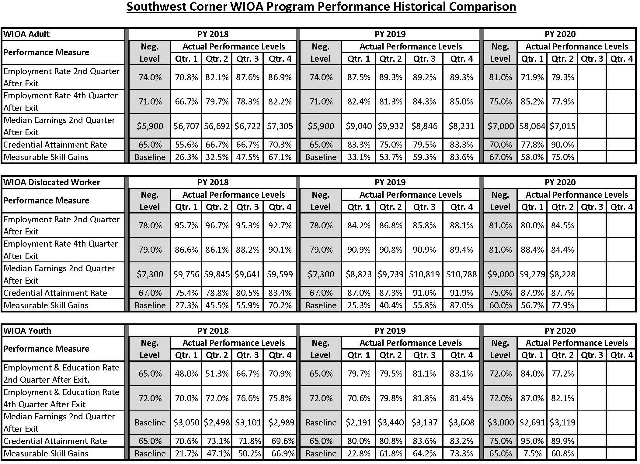

SCWDB Officer Nominations
As stated in the WDB Bylaws, it is required to nominate and appoint/re-appoint SCWDB Officers on every odd numbered year. Current officers can be reappointed or new offices can be nominated for appointment.
Term: July, 1 2021 through June 30, 2023 Candidate Slate
- Chair: Terry Wiltrout, Washington Health Systems
- Vice-Chair: Jon Feraco, Styropek
- Vice-Chair: Laurel Ziemba, Range Resources
- Treasurer: Linda Andrews, Washington Greene Central Labor Council
- Secretary: Stephanie Paluda, EQT Corporation

Thank you for attending.

Our next quarterly meeting will be

Tuesday, August 24, 2021 at
Hilton Garden Inn Southpointe, Canonsburg, PA at 8:30 AM
Note: a call in option will be available

Always visit

www.southwestcornerwdb.com
for all SCWDB information and event listings.

Follow us on Twitter @scwdb15
Follow us on Facebook @SouthwestCornerWDB

