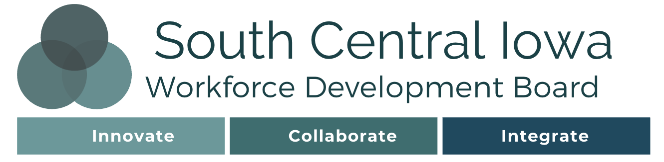

Memorandum of Understanding

IowaWORKS System Operations
This Memorandum of Understanding (MOU) is executed between the South Central Iowa Local Workforce Development Board (LWDB), the IowaWORKS system partners (Partners), and the Chief Lead Elected Official (CLEO). They are collectively referred to as the “Parties” to this MOU.

This MOU confirms the understanding of the Parties regarding the operation and management of the IowaWORKS centers in the Local Workforce Development Area. The South Central Iowa LWDB, along with the CLEO, provides oversight of workforce services in the Local Workforce Development Area (LWDA).

The LWDA includes the following counties: Appanoose, Davis, Hardin, Jefferson, Keokuk, Lucas, Mahaska, Marshall, Monroe, Poweshiek, Tama, Van Buren, Wapello, and Wayne.
The CLEO for the LWDA is Donald Seams who is a member of the Wayne County Board of Supervisors.

The one-stop system brings together workforce development, education, and human service-focused organizations into a seamless customer-focused network. The goal of the one-stop system is to enhance access to programs and improve long-term employment outcomes for individual customers.

Introduction
Congress enacted The Workforce Innovation and Opportunity Act (WIOA) to strengthen our country's workforce development system by aligning its employment, training, and education programs. This alignment of program services will combine with a metrics-based assessment of performance to improve our workforce development system. WIOA prioritizes a forward­ looking one-stop system that provides integrated employment, training, and education programs responsive to the employment needs of the system's customers: job seekers, employees, and businesses. This focus will result in a one-stop system that will lead to economic growth for the individual, State, and nation.
Iowa has previously taken steps to integrate and streamline its workforce services, but WIOA requires further integration between agencies and programs. The Parties to this memorandum of understanding (MOU) will come together to develop a partnership for workforce services delivery that fosters cooperation, collaboration, communication, and accessibility. This MOU sets forth the framework for local - level collaboration in pursuit of attaining the goals and meeting the requirements set forth by WIOA.
Iowa's one-stop delivery system is a locally driven system that provides the programs and services to achieve the goals set forth in the Iowa Unified State Plan:

Iowa Unified State Plan Goals
Goal 1 | Iowa’s employers will have access to skilled, diverse, and Future Ready workers.
Goal 2 | All Iowans will be provided access to a continuum of high-quality education, training, and career opportunities.
Goal 3 | Iowa’s workforce delivery system will align all programs and services in an accessible, seamless, and integrated manner.

These goals will be accomplished by providing all customers in each local area across the state access to a high-quality one-stop system with the full range of services available in their communities.

Purpose
The purposes of this MOU are to:
- Establish a cooperative working relationship among partners.
- Define respective Party roles and responsibilities.
- Coordinate resources to avoid duplication of services.
- Develop a one stop system that creates a seamless customer experience.
- Ensure the effective and efficient delivery of workforce services.
- Establish joint processes and procedures that will enable partners to align and integrate programs and activities across the local area one stop system.
- Increase and maximize access to workforce services for individuals with barriers to employment.
- Coordinate to implement state workforce development initiatives.
- Ensure an accessible workforce system for all.

Vision and Mission
VISION
We envision an Iowa where every business has access to a qualified, job-ready workforce and every Iowan has the skills needed to connect with meaningful employment and advance in a career.

MISSION
We drive Iowa’s economic growth by implementing an effective and efficient workforce system that delivers innovative, fully integrated, data-driven products and services that meet the needs of businesses and job seekers. We hold ourselves accountable to the system’s goals and support high-impact outcomes.

IowaWORKS System Structure
The Local Workforce Development Area is made up of two comprehensive centers and currently has no affiliate centers.
IowaWORKS System locations are listed in Attachment A: IowaWORKS Office Locations.
Partners/ Parties to this Agreement are listed in Attachment C: Partners and Parties to MOU Agreement.
The South Central Iowa Workforce Area LWDB will select the One Stop Operator through a competitive process in accordance with the Uniform Guidance, WIOA and its implementing regulations, and local procurement standards, laws, and regulations. All documentation for the competitive One Stop Operator procurement and selected process may be viewed on the IWDB website at https://www.iowawdb.gov/.
By signing this Agreement, Parties attest that the centers identified as Comprehensive meet the definition as outlined in the Core Partner Agency jointly issued policy “Characteristics of the One Stop Delivery System.”

Service Design
WIOA Section 121 identifies the Federal programs and requires that the services and activities under each of those programs must be made available through each local area’s One Stop Delivery System. The entities that receive the Federal funds for each of these programs and/ or have the responsibility to administer the respective programs in the local area are required partners under WIOA. One stop centers provide services to individual customers based on individual needs, including the seamless delivery of multiple services to individual customers. There is no required sequence of service.

Roles and Responsibilities

Chief Lead Elected Official (CLEO)
While not an exhaustive list of duties, the CLEO will, at a minimum:
- In partnership with the LWDB and Partners develop and submit a Local Plan that includes a description of the activities that shall be undertaken within the local system.
- Approve all significant actions of the LWDB including, but not limited to,
  - Competitive selection of a One Stop Operator and other providers
  - Termination of One Stop Operator and other providers, if necessary
  - LWDB Budget
  - Memorandum of Understanding and Infrastructure Funding Agreement(s)
- In partnership with the LWDB, conduct ongoing oversight of workforce development activities to assure appropriate management and use of funds and to maximize performance outcomes.

Local Workforce Development Board
The primary role of the Local Board is to serve as a strategic convener to promote and broker effective relationships throughout the Local Workforce Development Area. The Local Board must develop strategies to continuously improve and strengthen the workforce system through innovation in, and alignment and improvement of, employment, training, and education programs to promote economic growth. While not an exhaustive list of duties, the Local WDB will, at a minimum:
- In partnership with the CLEO and Partners develop and submit a Local Plan that includes a description of the activities that shall be undertaken within the local system
- Conduct workforce research and regional labor market analysis.
- Convene, broker, and leverage workforce system stakeholders.
- Lead efforts in the local area to:
  - engage with a diverse range of employers and other entities.
  - develop and implement career pathways opportunities.
- In partnership with the CLEO, conduct ongoing oversight of workforce development activities to assure appropriate management and use of funds and to maximize performance outcomes.

One Stop Operator
The primary role of the One Stop Operator is to coordinate service delivery among partners of the IowaWORKS system. South Central Iowa has not procured a one stop operator at this time.

IowaWORKS Partners
The management of the one-stop system is the shared responsibility of the LWDB, CLEO, WIOA core program Partners, required one-stop Partners, one-stop operators, service providers, and any non-mandatory Partners added to the local system by the LWDB and CLEO. In other words, the system is a total collaborative for the planning, operations, and management of local workforce services.
All Partners should be aware of their responsibility under the law. All Partners must:
- Provide access to their programs through the IowaWORKS system.
- Use their program’s funds to:
  - Provide career services.
  - Maintain the one-stop system and jointly fund it.
- Sign the Memorandum of Understanding (MOU) with the LWDB.
- Participate in the operation of the system.
- Provide representation on the LWDB, as required, and participate on committees of the LWDB, as needed.

Required Partner Services
The Parties to this Agreement will collaborate to ensure all required and needed services are available to Iowans and Iowa businesses and will work to ensure each IowaWORKS location offers integrated services and have staff who work to ensure quality service delivery.

Acceptable methods and options for providing access to each of the required services:
- Having a program staff member physically present at the American Job Center.
- Having a staff member from a different partner program physically present at the American Job Center and appropriately trained to provide information to customers about the programs, services, and activities available through all partner programs.
- Making available a direct linkage through technology to a program staff member who can provide meaningful information or services.
Services delivered within the system are outlined in the Partners Services section in Attachment D: Matrix of MOU Partners Shared Service and Delivery Methods.

Basic Career Services
Basic Career Services are universally accessible and must be made available to all individuals seeking employment and training services in at least one comprehensive IowaWORKS center per local workforce development area.

Individualized Career Services
Individualized career services must be provided after IowaWORKS Center staff determine that such services are required to retain or obtain employment, consistent with any applicable statutory priorities.

Training Services
Training services can be critical to the employment success of many adults and dislocated workers. IowaWORKS Center staff may determine training services are appropriate regardless of whether the individual has received basic or individualized career services first, and there is no sequence of service requirements.

Follow up Services
Local areas must provide follow up services for Adult and Dislocated Worker participants who are placed in unsubsidized employment, for up to 12 months after the first day of employment.

Youth Services
Services for youth, ages 16-24, can be critical to credential attainment and obtaining meaningful work experience.

Business Services
Business services must be made available to local employers. Local areas must establish and develop relationships and networks to support these efforts. Business Services, offered by the IowaWORKS system, should be collaborative across Partners.

Referrals
The purpose of the referral system is to provide integrated and seamless delivery of services to workers, job seekers, and employers.
All referrals and outcomes of referrals must be documented and tracked. Documentation and tracking may occur via a paper process or utilizing the IowaWORKS case management system, if applicable. If a paper process is utilized, all papers must be in accessible formats.
In order to facilitate and promote such a system, each Party agrees to the Referral Process outlined in Attachment F: Referral Process.

Accessibility
Accessibility to the services provided by the IowaWORKS Centers and all Partner agencies is essential to meeting the requirements and goals of the IowaWORKS network. Job seekers and businesses must be able to access all information relevant to them via visits to physical locations as well as in virtual spaces, regardless of gender, age, race, religion, national origin, disability, veteran’s status, or on the basis of any other classification protected under state or Federal law.

- Physical Accessibility – IowaWORKS centers will maintain a culture of inclusiveness and the physical characteristics of the facility, both indoor and outdoor, will meet the latest standards of accessible design. Services will be available in a convenient, high traffic, and accessible location, taking into account reasonable distance from public transportation and adequate parking (including parking clearly marked for individuals with disabilities). Indoor space will be designed in an “equal and meaningful” manner providing access for individuals with disabilities.
- Virtual Accessibility – The Local WDB will work with the State Workforce Development Board (SWDB) to ensure that job seekers and businesses have access to the same information online as they do in a physical facility. Information will be compliant with Section 508 of the U.S. Department of Health and Human Services code. Partners will comply with the Plain Writing Act of 2010; the law that requires that Federal agencies use "clear Government communication that the public can understand and use" and all information kept virtually will be updated regularly to ensure dissemination of correct information.
- Communication Accessibility – Communications access, for purposes of this MOU, means that individuals with sensory disabilities can communicate (and be communicated with) on an equal footing with those who do not have such disabilities. All Partners agree that accommodations for individuals who have communication challenges, including but not limited to individuals who are deaf and hard of hearing, individuals with vision impairments, and individuals with speech-language impairments and barriers will be provided based on individual needs.
- Programmatic Accessibility – All Partners agree that they will not discriminate in their employment practices or services on the basis of gender, gender identity and/or expression, age, race, religion, national origin, disability, veteran’s status, or on the basis of any other classification protected under state or Federal law. Partners will assure that policies and procedures are put in place to address these issues, and that such policies and procedures are disseminated to employees and otherwise posted as required by law. All Partners will cooperate with compliance monitoring that is conducted at the Local level to ensure that all IowaWORKS Center programs, services, technology, and materials are physically and programmatically accessible and available to all. Partners will comply with all applicable state and Federal laws and regulations regarding these issues. Additionally, staff members will be trained to provide services to all, regardless of range of abilities, mobility, age, language, learning style, or comprehension or education level. An interpreter will be provided in real time or, if not available, within a reasonable timeframe to any customer with a language barrier. Assistive devices options will be discussed with individuals based on their needs to ensure physical and programmatic accessibility within the IowaWORKS Center network.

The Parties to this MOU agree to participate on and with the Disability Access Committee(s) within their Local Workforce Development Area and agree to ongoing and regular communication and training with and / or by partners regarding accessibility. The Parties agree to the Accessibility Plan outlined in Attachment G: Accessibility Plan.

Outreach
The Parties recognize the value in joint outreach of the IowaWORKS system and agree to collaboratively conduct outreach activities to customers, employers and job seekers of the system. The Parties agree to the Outreach Plan in Attachment H: Outreach Plan.
The Local WDB and its Partners will develop and implement a strategic outreach plan that will include, at a minimum:
- Specific steps to be taken by each partner.
- Development of a unified business services team
- Alignment with sector strategies and career pathways.
- Connections to Registered Apprenticeship.
- Focus on outreach to human resource professionals.
- Focus on local area’s job seekers, including targeted efforts for populations most at risk or most in need.
- Regular use of social media.
- An outreach toolkit available for all partners
- Clear objectives and expected outcomes
- Leveraging of any statewide outreach materials relevant to the local area

Data Sharing
Partners agree that the use of high-quality data is essential to inform decisions made by policymakers, employers, and job seekers. Partners further agree that the collection, use, and disclosure of customer’ personally identifiable information (PII) is subject to various requirements set forth in Federal and State privacy laws. Partners acknowledge that the execution of this MOU, by itself, does not function to satisfy all these requirements.
All data, including customer PII, collected, used, and disclosed by Partners will be subject to the following:
- Customer PII will be properly secured in accordance with the LWDB’s policy and procedure regarding the safeguarding of PII.
- The collection, use, and disclosure of customer education records, and the PII contained therein, as defined under FERPA, shall comply with FERPA and applicable State privacy laws.
- All confidential data contained in the UI wage records must be protected in accordance with the requirements set forth in 20 CFR 603.
- All personal information contained in VR records must be protected in accordance with the requirements set forth in 34 CFR 361.38.
- Customer data may be shared with other programs, for those programs’ purposes, within the IowaWORKS Center network only after written consent of the individual has been obtained, where required.
- Customer data will be kept confidential, consistent with Federal and State privacy laws and regulations.
- All data exchange activity will be conducted in machine readable format, such as HTML or PDF, for example, and in compliance with Section 508 of the Rehabilitation Act of 1973, as amended. 29 CFR 794(d).

All Partner staff will be trained in the protection, use, and disclosure requirements governing PII and any other confidential data for all applicable programs, including FERPA- protected education records, confidential information in UI records, and personal information in VR records. The Parties to this MOU agree to the Data Sharing Training Plan outlined in Attachment I: Data Sharing Plan.

Monitoring
The Local WDB, or its designated staff, officials from state and local administrative entities, the US Departments of Education, Health and Human Services, and Labor have the authority to conduct fiscal and programmatic monitoring to ensure that:
- Federal awards are used for authorized purposes in compliance with law, regulations, and State policies.
- Those laws, regulations, and policies are enforced properly.
- Performance data is recorded, tracked, and reviewed for quality to ensure accuracy and completeness.
- Outcomes are assessed and analyzed periodically to ensure that performance goals are met.
- Appropriate procedures and internal controls are maintained, and record retention policies are followed.
- All MOU terms and conditions are fulfilled.
All Parties to this MOU should expect regular fiscal and programmatic monitoring to be conducted by each of the above entities, as appropriate.

Dispute Resolution
For purposes of this MOU and for IowaWORKS system related issues, each Party expressly agrees to participate in good faith negotiations to reach a consensus. However, should a dispute arise among any Parties to this MOU regarding the contents of this MOU and including the process to develop, amend or renew or in matters pertinent to IowaWORKS operations or activities not addressed in this MOU, all Parties agree to utilize the process included in the attachment cited below. The administrators of applicable state agencies will designate an individual to negotiate and resolve any impasses involving state level partners.

Any local Dispute Resolution Process should include thorough attempts to resolve the issues locally. After reasonable attempts have been made to resolve the dispute locally and in adherence to the Dispute Resolution Process, then and only then can the dispute be elevated to a state level for action.

This MOU is legally binding. Therefore, if all reasonable attempts to resolve any impasse are unsuccessful, it may be remedied in court.

Dispute Resolution Process in Attachment J: Dispute Resolution Process.

Terms and Conditions
The Parties to this MOU agree to the following Terms and Conditions:

Confidentiality
All Parties expressly agree to abide by all applicable Federal, State, and local laws and regulations regarding confidential information, including PII from education records, such as but not limited to 20 CFR 603, 45 CFR 205.50,20 USC 1232g, and 34CFR 99, and 34 CFR 361.38, as well as any applicable State and local laws and regulations. In addition, in carrying out their respective responsibilities, each Party shall respect and abide by the confidentiality policies and legal requirements of all the other Parties.

Each Party will ensure that the collection and use of any information, systems, or records that contain PII and other personal or confidential information will be limited to purposes that support the programs and activities described in this MOU and will comply with applicable law.

Each Party will ensure that access to software systems and files under its control that contain PII or other personal or confidential information will be limited to authorized staff members who are assigned responsibilities in support of the services and activities described herein and will comply with applicable law. Each Party expressly agrees to take measures to ensure that no PII or other personal or confidential information is accessible by unauthorized individuals.

To the extent that confidential, private, or otherwise protected information needs to be shared amongst the Parties for the Parties’ performance of their obligation under this MOU, and to the extent that such sharing is permitted by applicable law, the appropriate data sharing agreements will be created and required confidentiality and ethical certifications will be signed by authorized individuals. With respect to confidential unemployment insurance information, any such data sharing must comply with all the requirements in 20 CRF 603, including but not limited to requirements for an agreement consistent with 20CFR 603.10, payments of costs, and permissible disclosures.

With respect to the use and disclosure of FERPA-protected customer education records and the PII contained therein, any such data sharing agreement must comply with all of the requirements set forth in 20 U.S.C. $ 1232g and 34 CFR Part 99.

With respect to the use and disclosure of personal information contained in VR records, any such data sharing agreement must comply with all of the requirements set forth in 34 CFR 361.38.

By signing this MOU, the Parties attest that their respective agency’s Confidentiality Policies have been reviewed and are not in conflict with the confidentiality section of this MOU.

Non-Discrimination and Equal Opportunity
All Parties to this MOU certify that they prohibit, and will continue to prohibit, discrimination, and they certify that no person, otherwise qualified, is denied employment, services, or other benefits on the basis of: (i) political or religious opinion or affiliation, marital status, sexual orientation, gender, gender identification and/or expression, race, color, creed, or national origin; (ii) sex or age, except when age or sex constitutes a bona fide occupational qualification; or (iii) the physical or mental disability of a qualified individual with a disability.

The Parties specifically agree that they will comply with Section 188 of the WIOA Nondiscrimination and Equal Opportunity Regulations (29 CFR Part 38; Final Rule December 2, 2016), the Americans with Disabilities Act (42 U.S.C. 12101 et seq.), the Non-traditional Employment for Women Act of 1991, titles VI and VII of the Civil Rights of 1964, as amended, Section 504 of the Rehabilitation Act of 1973, as amended, the Age Discrimination Act of 1967, as amended, title IX of the Education Amendments of 1972, as amended, and with all applicable requirements imposed by or pursuant to regulations implementing those laws, including but not limited to 29 CFR Part 37 and 38. The Parties agree to fully comply with the Iowa Civil Rights Act of 1965 as amended, Iowa Executive Order 15 (1973), as amended by Iowa Executive Order 1934 (1988).

Indemnification
All Parties to this MOU recognize the partnership consists of various levels of government, not-for-profit entities, and for-profit entities. Each Party to this agreement shall be responsible for injury to persons or damage to property resulting from negligence on the part of itself, its employees, its agents, or its officers. No Partner assumes any responsibility for any other Party, State or non-State, for the consequences of any act or omission of any third Party. The Parties acknowledge the South Central Iowa Local WDB and the South Central Iowa one-stop operator have no responsibility and/or liability for any actions of the IowaWORKS center employees, agents, and/or assignees. Likewise, the Parties have no responsibility and/or liability for any actions of the South Central Iowa Local WDB or the South Central Iowa one-stop operator.

Severability
If any part of this MOU is found to be null and void or is otherwise stricken, the rest of this MOU shall remain in force.

Drug and Alcohol-Free Workplace
All Parties to this MOU certify they will comply with the Drug-Free Workplace Act of 1988, 41 U.S.C. 702 et seq., and 2 CFR part 182 which require that all organizations receiving grants from any Federal agency maintain a drug-free workplace. The recipient must notify the awarding office if an employee of the recipient is convicted of violating a criminal drug statute. Failure to comply with these requirements may be cause for suspension or debarment under 2 CFR part 180, as adopted by the U.S. Department of Education at 2 CFR 3485, and the U.S. Department of Labor regulations at 29 CFR part 94.

Certification Regarding Lobbying
All Parties shall comply with the Byrd Anti-Lobbying Amendment (31 U.S.C. §1352), 29 C.F.R. Part 93, and 34 CFR part 82, as well as the requirements in the Uniform Guidance at 2 CFR 200.450. The Parties shall not lobby Federal entities using Federal funds and will disclose lobbying activities as required by law and regulations.

Debarment and Suspension
All Parties shall comply with the debarment and suspension requirements (E.0.12549 and12689) and 2 CFR part 180 and as adopted by the U.S. Department of Labor at 29 CFR part 2998 and by the U.S. Department of Education at 2 CFR 3485.

Priority of Service
All Parties certify that they will adhere to all statutes, regulations, policies, and plans regarding priority of service, including, but not limited to, priority of service for veterans and their eligible spouses, and priority of service for the WIOA title I Adult program, as required by 38 U.S.C. §4215 and its implementing regulations and guidance, and WIOA sec. 134(c)(3)(E) and its implementing regulations and guidance. Partners will target recruitment of special populations that receive a focus for services under WIOA, such as individuals with disabilities, low-income individuals, basic skills deficient youth, and English language learners.

Buy American Provision
Each Party that receives funds made available under title I or II of WIOA or under the Wagner-Peyser Act (29 U.S.C. §49, et. seq.) certifies that it will comply with Sections 8301 through 8303 of title 41 of the United States Code (commonly known as the “Buy American Act.”) and as referenced in WIOA Section 502 and 20 CFR 683.200(f).

Salary, Compensation, and Bonus Limitations
Each Party certifies that, when operating grants funded by the U.S. Department of Labor, it complies with TEGL 05-06, Implementing the Salary and Bonus Limitations in Public Law 109-234, restricting the use of Federal grant funds for compensation and bonuses of an individual, whether charged to either direct or indirect, at a rate in excess of the Federal Office of Personnel Management Executive Level II.

Non- Assignment
Except as otherwise indicated herein, no Party may, during the term of this MOU or any renewals or extensions of this MOU, assign or subcontract all or any part of the MOU without prior written consent of all other Parties.

Governing Law
This MOU will be construed, interpreted, and enforced according to the laws of the State of Iowa. All Parties shall comply with all applicable Federal and State laws and regulations, and Local laws to the extent that they are not in conflict with State or Federal requirements.

Amendment/ Modification
This MOU may be amended at any time upon mutual agreement of the Parties. Any amendment to this MOU must be consistent with Federal, state, and local laws, regulations, rules, plans and policies. Any amendment must adhere to the process outlined and referenced below. Amendments or modifications may only be proposed by partner program signatories.
All Parties to this MOU agree to the MOU Amendment/ Modification Process provided in Attachment K: Amendment/Modification Process.

Termination
The Parties understand that implementation of the one stop system is dependent upon good faith effort to work together to improve services to the community. It is understood and agreed that there are situations which may cause a Party to cease being a Party to this MOU. Termination of this agreement may only be proposed by partner program signatories.
This MOU will remain in effect until the end date specified in the Effective Period section below, unless:
- All Parties mutually agree to terminate this MOU prior to the end date.
- Federal oversight agencies charged with the administration of WIOA are unable to appropriate funds or if funds are not otherwise made available for continued performance for any fiscal period of this MOU succeeding the first fiscal period. Any Party unable to perform pursuant due to lack of funding shall notify the other Parties as soon as the Party has knowledge that funds may be unavailable for the continuation of activities under this MOU.
- WIOA is repealed or superseded by subsequent Federal law.
- Local Workforce Development Area designation is changed under WIOA or by action of the Iowa State Workforce Development Board.
All Parties to this MOU agree to the Termination Process provided in Attachment L: Termination Process.

Effective Period
This MOU is entered into on July 1, 2021. This MOU will become effective as of the date of signing by the final signatory below unless any of the reasons in the Termination section above apply. Regardless of the effective period of this agreement, the Parties agree to review the contents of this agreement at least one time annually. This agreement shall be in effect until:

_____ June 30, 2022
_____ June 30, 2023
_X___ June 30, 2024

MOU Attachments
A: IowaWORKS Office Locations
B: Partner's Other Locations
C: Partners and Parties to MOU Agreement
D: Matrix of MOU Partners Shared Service and Delivery Methods
E: Other Services
F: Referral Process and Form
G: Accessibility Plan
H: Outreach Plan
I: Data Sharing Plan
J: Dispute Resolution Process
K: Amendment/Modification Process
L: Termination Process
M: Negotiations/Meeting Summary
Signature Pages
Definitions

Attachment A: IowaWORKS Office Locations
Ottumwa IowaWORKS
Center Manager Name | Micheal Cockrum
Mailing Address | 15260 Truman Street, Ottumwa, Iowa 52501
Operating Hours | M-T-TH-F 8:30 am - 4:30 pm W: 9:00am –4:30pm
Phone | 641-684-5401
Email | OttumwaIowaWORKS@iwd.iowa.gov
Website | https://www.iowaworkforcedevelopment.gov/ottumwa
Marshalltown IowaWORKS
Center Manager Name | Melanie Guilbeaux
Mailing Address | Southgate Plaza, 101 Iowa Ave W STE 200, Marshalltown, IA 50158
Operating Hours | M-T-TH-F 8:30 am - 4:30 pm W: 9:00am –4:30pm
Phone | 641-754-1400
Email | MarshalltownIowaWORKS@iwd.iowa.gov
Website | https://www.iowaworkforcedevelopment.gov/marshalltown

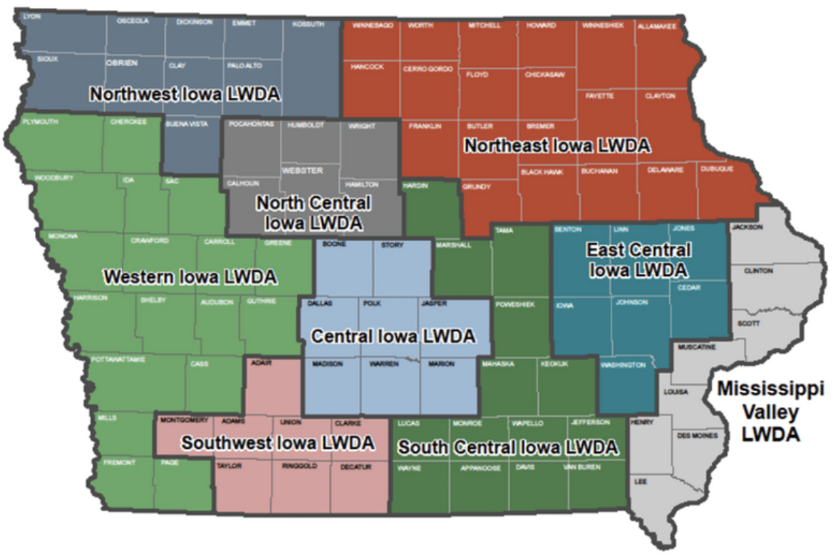

Attachment B: Partner's Other Locations
Partner | Location | Address
IHCC-CTE | Albia High School | 503 B Ave E, Albia, IA 52531
IHCC-CTE | Cardinal High School | 4045 Ashland Rd, Eldon, IA 52554
IHCC-CTE | Chariton High School | 501 N Grand St, Chariton, IA 50049
IHCC-CTE | Fairfield High School | 605 E Broadway Ave, Fairfield, IA 52556
IHCC-CTE | Ottumwa High School | 501 2nd St E, Ottumwa, IA 52501
IHCC-CTE | Sigourney High School | 907 E Pleasant Valley St, Sigourney, IA 52591
IHCC-CTE | Oskaloosa High School | 1816 N 3rd St, Oskaloosa, IA 52577
IHCC-CTE | North Mahaska High School | 2163 135th St, New Sharon, IA 50207
IHCC-CTE | Centerville High School | 600 CHS Dr, Centerville, IA 52544
IHCC-CTE | Wayne High School | 102 N Dekalb St, Corydon, IA 50060
IHCC-AEL | Ottumwa North Campus | 14383 College Ave, Ottumwa, IA 52501
IHCC-AEL | Centerville | 721 N 1st St, Centerville, IA 52544
IHCC-AEL | Mahaska Co. Service Center | 114 N Market St, Oskaloosa, IA 52577
IHCC-AEL | Jefferson Co. Service Center | 201 S 23rd St, Fairfield, IA 52556
IHCC-AEL | Ottumwa Main Campus | 525 Grandview Ave, Ottumwa, IA 52501
IHCC-AEL | JBS | 600 S Iowa Ave, Ottumwa, IA 52501
IHCC-AEL | St. Mary of the Visitation | 216 N Court St, Ottumwa, IA 52501
IHCC-AEL | Hy-vee Distribution Center | 1801 Osceola Ave, Chariton, IA 50049
IVCC-AEL | Tama County Education & Training Center | 215 West 9th St, Tama, IA 52339
IVCC-AEL | Poweshiek County Education & Training Center | 123 6th Ave West, Grinnell, IA 50112
IVCC-AEL | Hardin County Education & Training Center | 1100 College Ave, Iowa Falls, IA 50126
IVCC-AEL | Marshall County Education & Training Center | 206 E Church Street, Marshalltown, IA 50158

Attachment C: Partners and Parties to MOU Agreement
Partner | Program | Signatory Name | Address | Phone
SCIWA LWDB | CLEO | Donald Seams | 100 N Lafayette St, Corydon, IA 50060 | 641-895-8585
SCIWA LWDB | Chair | Natalie McGee | 1801 Osceola Ave, Chariton, IA 50049 | 641-774-2121
Indian Hills CC | Title I Adult | Jennifer Erdmann | 525 Grandview Ave, Ottumwa, IA 52501 | 641-684-5401
Indian Hills CC | Title I Dislocated Worker
Indian Hills CC | Title I Youth
Iowa DOE | Title II AEL – Indian Hills Community College | Alex Harris | 400 East 14th Street, Des Moines, IA 50319-0146 | 515-281-3640
Iowa DOE | Title II AEL - Iowa Valley Community College
IWD | Title III Wager-Peyser | Michael Witt | 1000 E. Grand Ave., Des Moines, IA 50319 | 563-468-3110
IDB | Title IV Rehabilitation Act 1973 | Keri Osterhaus | 524 4th St., Des Moines, IA 50309 | 515-205-8583
IVRS | Title IV Rehabilitation Act 1973 | David Mitchell | 510 East 12th Street, Des Moines, IA 50319 | 515-326-1785
Iowa DOE CTE | Career and Technical Education – Indian Hills CC | Dennis Harden | 400 East 14th Street, Des Moines, IA 50319-0146 | 515-281-4716
Iowa DOE CTE | Career and Technical Education - Iowa Valley CC
IWD | Trade Adjustment Assistance | Michelle McNertney | 1000 E. Grand Ave., Des Moines, IA 50319 | 515-805-7320
AARP Foundation | Senior Community Services Employment Program (SCSEP) | Demetrios Antzoulatos | 601 E Street, NW, Washington, DC 20049 | 202-434-2272
National Able | Senior Community Services Employment Program (SCSEP) | Bridget Altenburg | 567 W. Lake Street, Suite 1150, Chicago, IL 60661 | 312-994-4213
Career Systems Development | Job Corps | Taren Ferguson | 15229 Truman St, Ottumwa, IA 52501 | 641-683-0203
American Indian Council | Native American Programs | Christine Campbell | 310 Armour Road, Suite 205 North Kansas City, MO 64116 | 816-471-4898
Proteus | National Farmworker Jobs Program (NFJG) | Daniel Hoffman-Zinnel | 1548 S Gilbert St, Iowa City, IA 52240 | 319-248-0178
IWD | Temporary Assistance for needy Families (TANF) - PROMISE Jobs | Michael Witt | 1000 E. Grand Ave, Des Moines, IA 50319 | 563-468-3110
IWD | Unemployment Compensation | Christina Steen | 1000 E. Grand Ave, Des Moines, IA 50319 | 515-725-3748
IWD | Jobs for Veterans State Grant (JVSG) | Michael Witt | 1000 E. Grand Ave, Des Moines, IA 50319 | 563-468-3110
IWD | Reentry Employment Opportunities (REO)
IWD | Ticket to Work

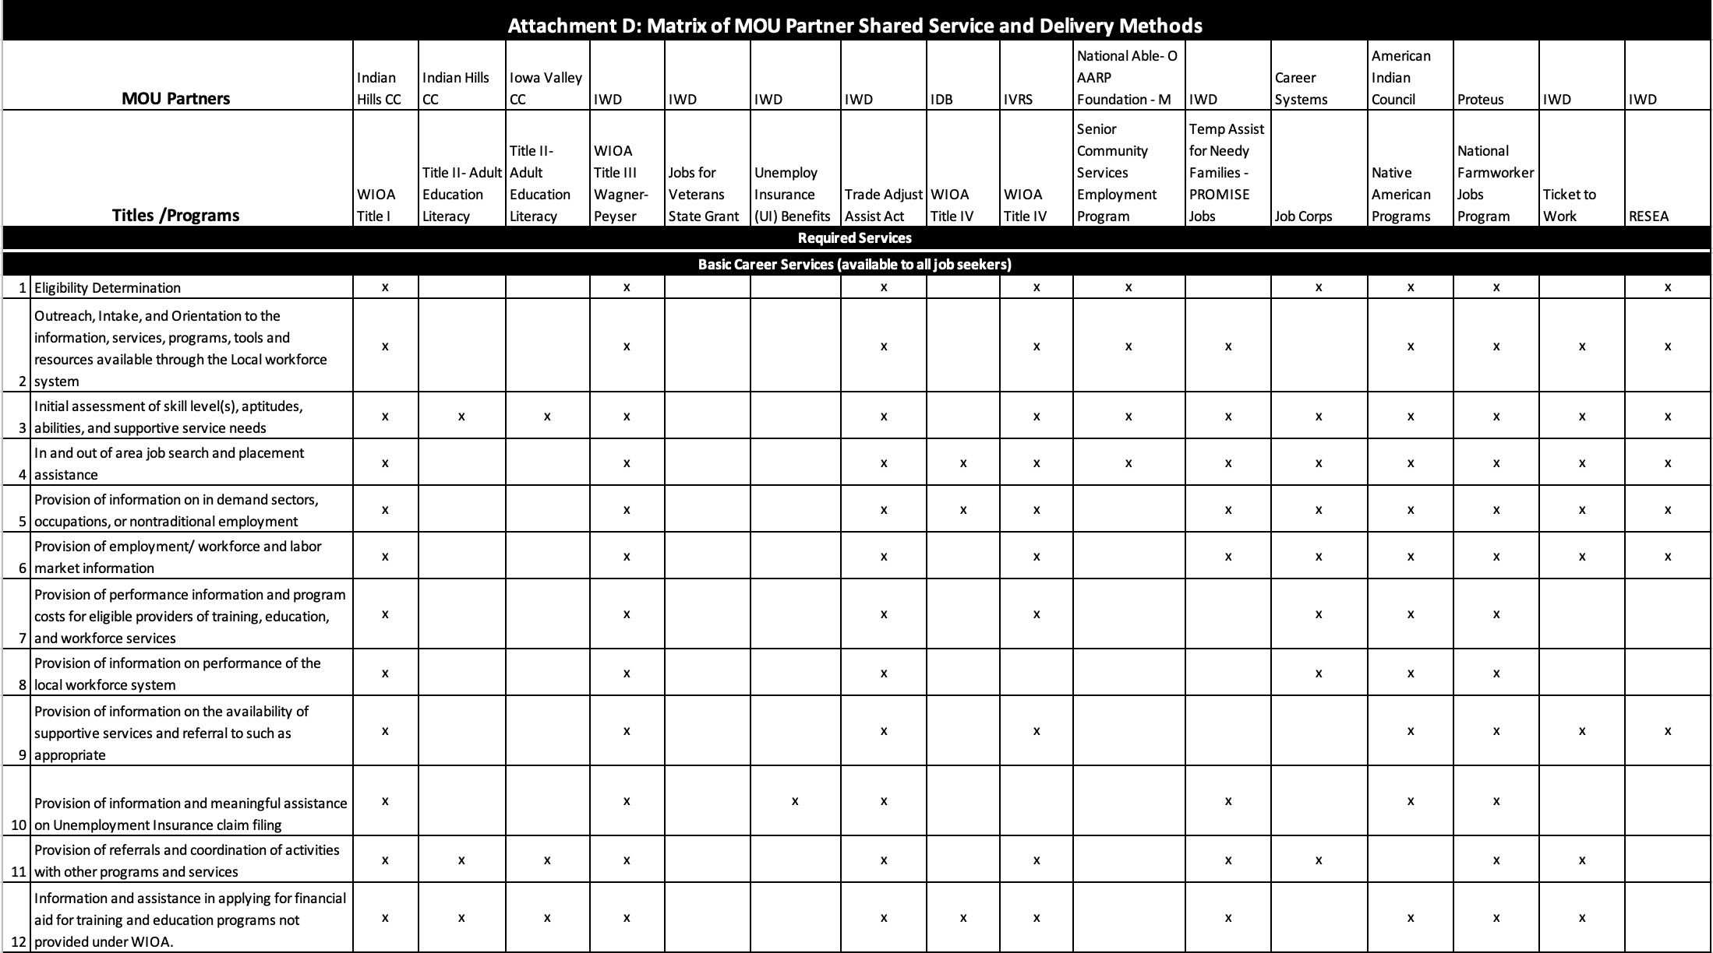

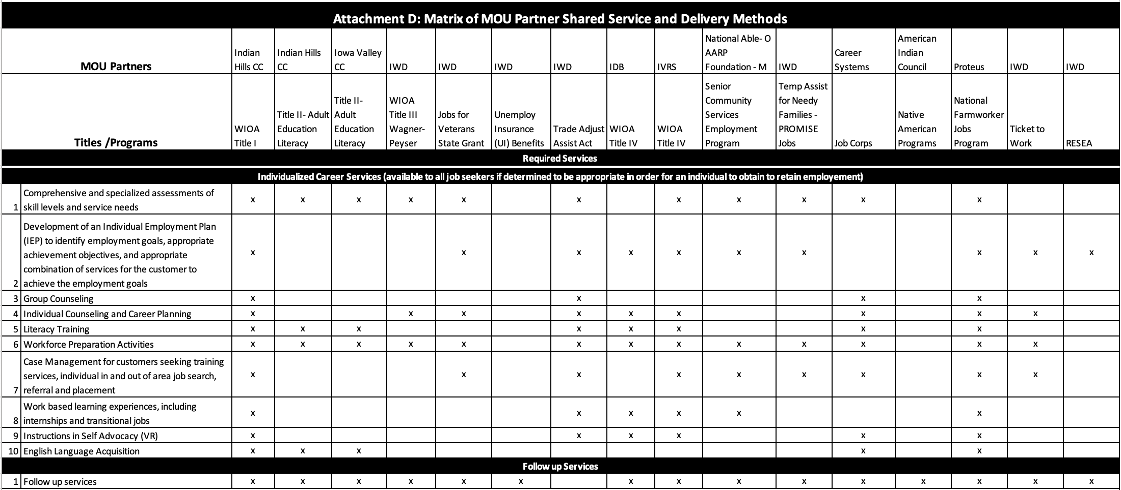

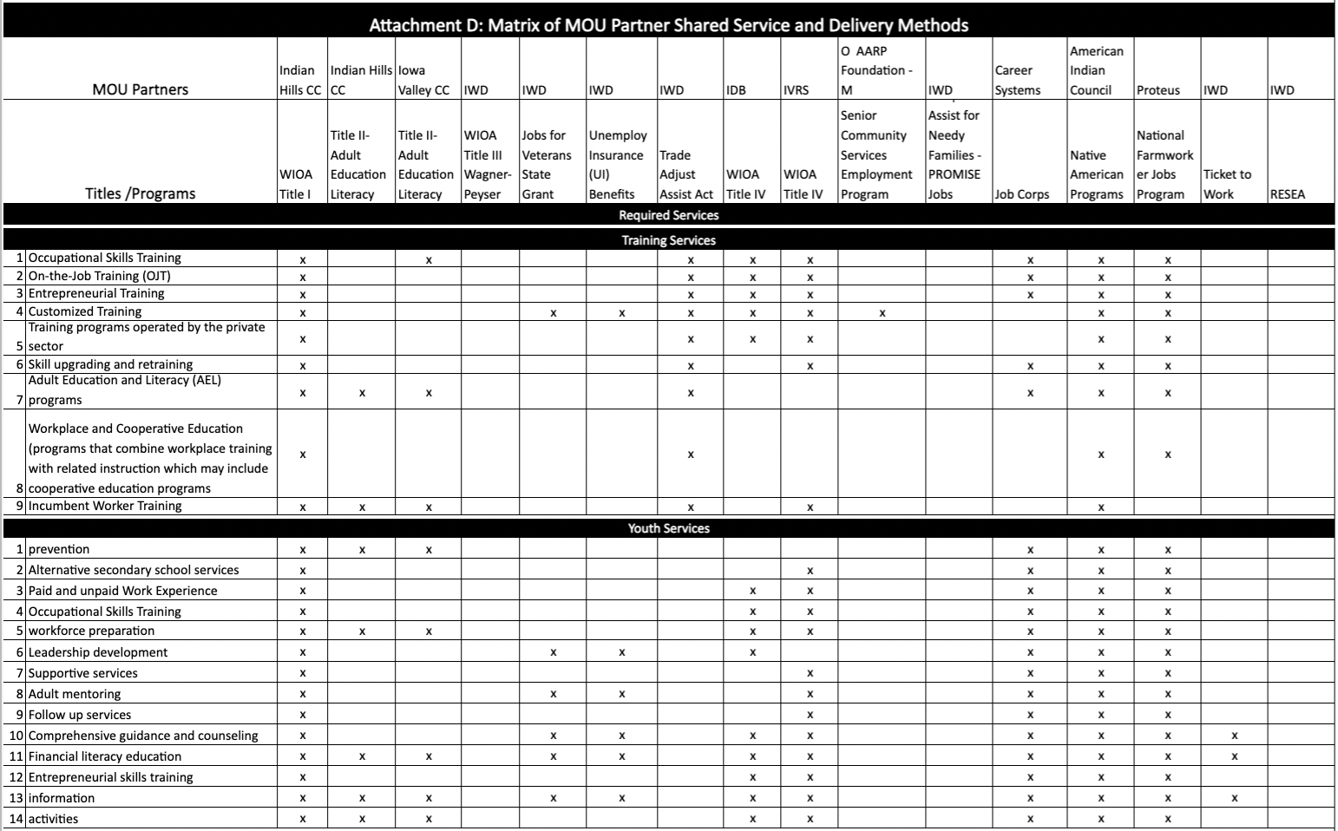

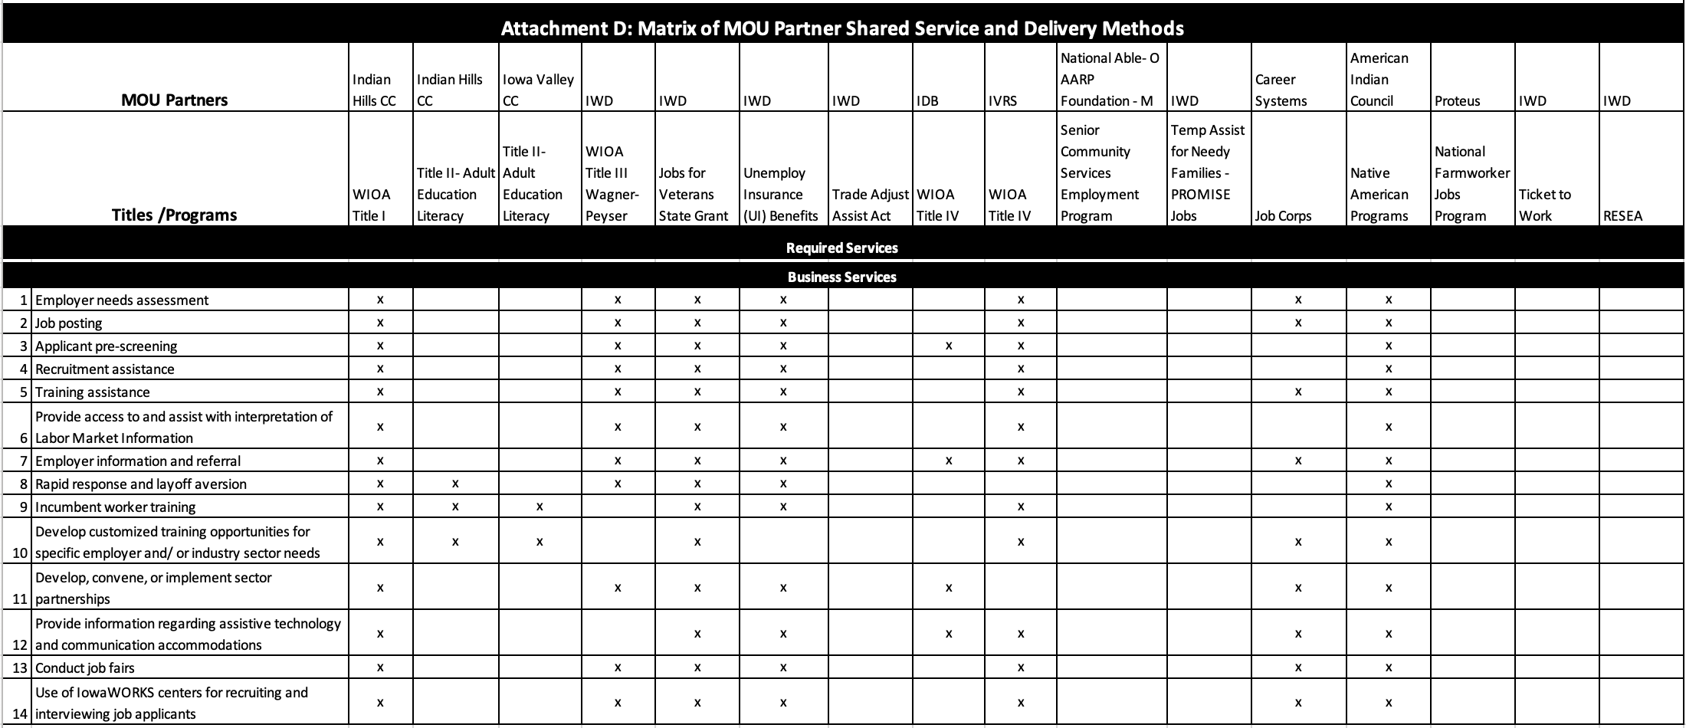

Attachment E: Other Services
Partner | Service
Title II AEL | AEL classes are held on site at IHCC and Iowa Valley locations throughout SCIWA.
CTE | CTE classes are offered at IHCC and Iowa Valley Locations throughout SCIWA.
Iowa Dept for the Blind | Counselors see individuals in their homes and community settings, and their orientation center is located In Des Moines.
Job Corps | Other Job Corps services are offered at the centers not located in SCIWA.

Attachment F: Referral Process
Step 1
Provide training to all staff and partners on the referral process and use of the referral form. Staff will ensure that referrals are customer-centered and that the referral provides the customer needed services. Ensuring that general information regarding IowaWORKS programs, services, activities, and resources shall be made available to all customers as appropriate.
Step 2
Staff will complete the form by completing the top portion with customer information. Staff will assign a tracking number as follows:
First two identifiers will be the One-Stop Location:
OT for Ottumwa and MR for Marshalltown
Next Four identifiers will be the last 4 of their SSN or the 4 digit year of their birth
Last two identifiers will be the Individuals Initials.
Example: MR2215BS
Step 3
Staff will obtain a digital signature from the customer by the individual typing their full name. Staff will click the Refer button on the programs requesting referral to which will send an email to the designated staff person. Final step is the staff member will click the submit button which will transfer the data to the Excel spreadsheet for tracking.
Methods for Documenting and Tracking Referrals
Referrals will be documented utilizing the South Central WIOA Partner Network Referral form.
Method for Tracking Status of Referrals: Referrals will be tracked on an Excel Spreadsheet. Partners will ensure the individual is registered in IowaWORKS data management system by going to www.iowaworks.gov. Partners who have access to the system will provide the referral service. Partners who receive the referral will provide follow-up status on the Excel spreadsheet within 30 days of the referral.
The referral form will be posted to www.iowawdb.gov website under South Central as a link on the Contact us page.
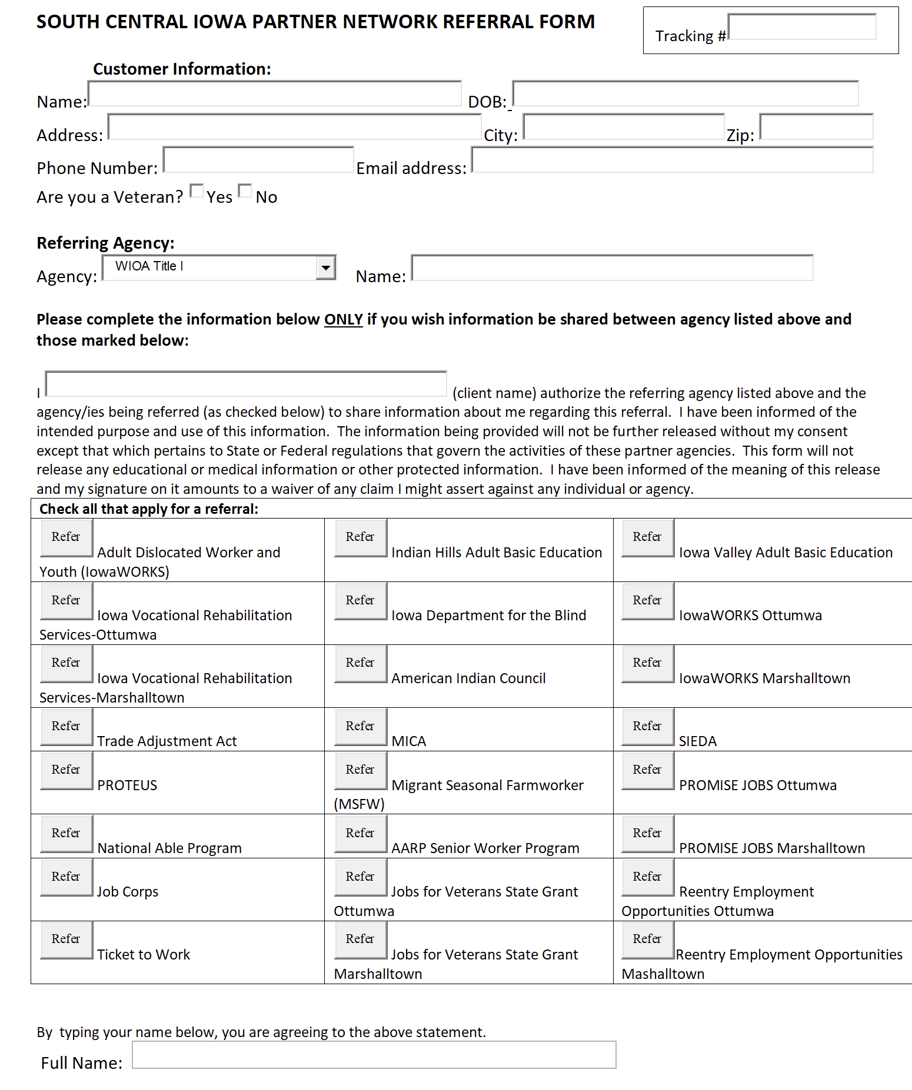

Attachment G: Accessibility Plan
Physical
South Central Iowa IowaWORKS centers will maintain a culture of inclusiveness and the physical characteristics of the facility, both indoor and outdoor, will meet the latest standards of accessible design. Services will be available in convenient, high traffic, and accessible locations, taking into consideration the reasonable distance from public transportation and adequate parking (including parking clearly marked for individuals with disabilities). Indoor space will be designed to ensure access for individuals with disabilities.
Virtual
South Central Iowa LWDB will comply with any/all mandates of the Iowa Workforce Development Board to ensure that job seekers and businesses have access to the same information online as they do in a physical facility including usage of the workforce system. The one-stop site will maintain a website that details all programs and series.
Communication
All Partners agree that they will provide accommodations for individuals who have communication challenges including, but not necessarily limited to, those individuals who are deaf or hard of hearing, individuals with vision impairments, and individuals with speech-language impairments.
Programmatic
All partners agree that they will not discriminate in their employment practices or services on the basis of gender, gender identity and/or expression, age, race, religion, national origin, disability, veteran’s status, or on the basis of any other classification protected under state and federal law. Partners must assure that they have policies and procedures in place to address these issues and that such policies and procedures have been disseminated to their employees and otherwise posted as required by law.
Partners further assure that they are currently in compliance with applicable state and federal laws and regulations regarding these issues. All Partners will cooperate with compliance monitoring that is conducted at the local level to ensure that all IowaWORKS Center programs, services, technology, and materials are physically and programmatically accessible and available to all. Additionally, staff members will be trained to provide services to all, regardless of the range of abilities, mobility, age, language, learning style, or comprehension, or educational level.
An interpreter will be provided in real-time or, if not available, within a reasonable timeframe to any customer with a language barrier. Assistive devices, such as screen-reading software programs and assistive listening devices will be available to ensure physical and programmatic accessibility within the local one-stop.

Attachment H: Outreach Plan
The South Central Iowa Workforce Area LWDB and partners recognize the value in joint outreach of the IowaWORKS system and agree to collaboratively conduct outreach activities to customers, employers and job seekers, of the system.
Development of a unified business services team
- Each one-stop will have an integrated Business Services Team and the Core Partners will be the unified Business Services Team for the South Central Iowa Workforce Area.
- The integrated Business Service teams will develop the following:
  - Develop partnerships with businesses and partners to increase innovative ideas in the utilization of the Employer Innovation Fund;
  - Educate, promote, design, and collaborate with local area employers to facilitate work-based learning activities.
Alignment with sector strategies and career pathways
- Facilitate the training of Business Marketing Specialists or partner staff as trained
- Sector Partnership Facilitators;
- Development of at least one sector partnership in Advanced Manufacturing and Healthcare in the Ottumwa and Marshalltown Office Area
- Promote the use of the Iowa Department of Education’s Career Pathways guides;
- Develop a Career Pathway Guide based on Local Employers and local area-specific Labor Market Information
Promote Connections to Registered Apprenticeship
- Promote Registered Apprenticeship to Businesses and Job Seekers utilizing the www.earnandlearniowa.gov website and marketing materials.
- Develop Registered Apprenticeship opportunities available in the South Central Iowa Workforce area.
Focus on outreach to human resource professionals
Have designated Integrated Business Service Team members as representatives at area SHRM Meetings
Focus on local area’s job seekers, including targeted efforts for populations most at risk or most in need
The South Central Iowa targeted population includes the following:
- Veterans and their Spouses
- Recipients of Public Assistance
- Displaced homemakers
- Indians, Alaska Natives, and Native Hawaiians
- Individuals with disabilities, including youth who are individuals with disabilities
- Older individuals (age 55 and older)
- Ex-offenders
- Youth who are in or have aged out of the foster care system
- Individuals who are:
  - English language learners
  - Individuals who have low levels of literacy (an individual is unable to compute or solve problems, or read, write, or speak English at a level necessary to function on the job, or in the individual’s family, or in society); and
  - Individuals facing substantial cultural barriers
  - Eligible migrant and seasonal farmworkers
  - Individuals within two years of exhausting lifetime TANF eligibility
Single parents (including single pregnant women)
  - Long-term unemployed individuals (unemployed for 27 or more consecutive weeks)
  - Underemployed individuals. Underemployed individuals may include:
  - Individuals employed less than full-time who are seeking full-time employment
  - Individuals who are employed in a position that is inadequate with respect to their skills and training
  - Individuals who are employed who meet the definition of a low-income individual
  - Individuals who are employed, but whose current job’s earnings are not sufficient compared to their previous job’s earnings from their previous employment, per state and/or local policy

Attachment I: Data Sharing Training Plan
All Partner staff in the South Central Iowa Workforce Area will be trained in the protection, use, and disclosure requirements governing PII and any other confidential data for all applicable programs, including FERPA- protected education records, confidential information in UI records, and personal information in VR records. The Parties to this MOU agree to the Data Sharing Training Plan outlined below. The One-Stop Operator will hold quarterly partner meetings and will cover data sharing and confidentiality at each meeting on a continuous basis. A tentative initial training schedule is below. All training will be recorded and provided to all partners to share with their staff.
The South Central Iowa Local Workforce Development Board (LWDB) will develop a policy on PII, as required by WIOA. All customer PII will be properly secured in accordance with the LWDB’s policy and procedure regarding the safeguarding of PII once established and shared and reviewed with all partners.
Proposed Training Schedule
- Confidentiality and PII
- FERPA
- Confidential information in UI record
- Personal information in VR records

Attachment J: Dispute Resolution Process
Step 1
All Parties are advised to actively participate in Local negotiations in a good faith effort to reach agreement. Any disputes shall first be attempted to be resolved informally.
Should informal resolution efforts fail, the dispute resolution process must be formally initiated by the petitioner seeking resolution. The petitioner must send a notification to the Board Chair (or designee) and all Parties to the MOU regarding the conflict within 10 business days.
The Board Chair (or designee) shall place the dispute on the agenda of a special meeting of the Board Executive Committee within 20 business days. The Executive Committee shall attempt to mediate and resolve the dispute. Disputes shall be resolved by a majority consent of the Executive Committee members present.
The Executive Committee must provide a written response and dated summary of the proposed resolution to all Parties to the MOU within 10 days of the decision.
The Board Chair (or designee) will contact the petitioner and the appropriate Parties to verify that all agree with the proposed resolution.
The decision of the Executive Committee shall be final unless the petitioner pursues further action through the state dispute process.
Step 2
If local attempts to resolve the dispute have been unsuccessful, the agency with the dispute shall notify Iowa Workforce Development (IWD). In this manner, IWD serves as a gatekeeper and convener of the Core Partner Team who will seek resolution to the dispute. The agency with the dispute must send an email to WIOAgovernance@iwd.iowa.gov and follow these steps:
Subject line of email: MOU Dispute Resolution: insert name of LWDA.
In the body of the email or in a clearly identifiable attachment, clearly state the issue in dispute. Provide as much detail as possible.
Attach to the email, the local Dispute Resolution Process as well as documentation that the local Dispute Resolution Process has been followed.
Step 3
Upon receipt of the Dispute Resolution email, IWD will:
Acknowledge the receipt of the email.
Provide all documentation to the WIOA Core Partner Working Group.
Step 4
Core Partner Team will review the dispute and notify the appropriate Parties of its decision within 14 days of receipt of the dispute.
Step 5
If the Core Partner Team decision is not satisfactory to the agency with the dispute, the agency may appeal to the State Workforce Development Board. No local dispute may go directly to the SWDB without first being addressed by the Core Partner Team.

Attachment K: Amendment/Modification Process
Any alterations, additions, or deletions to the terms of this agreement which are required by changes in the state law, federal law, or by regulations are automatically incorporated in this agreement without written amendment and shall become effective on the date designated by such law or regulation.
When a System Partner wishes to modify the MOU, the System Partner must first provide written notification to all signatories of the existing MOU and outline the proposed modification(s). The SCIWA LWDB Chair (or designee) must ensure that discussions and negotiations related to the proposed modification take place with System Partners in a timely manner and as appropriate. Depending upon the type of modification, this can be accomplished through email communications of all the Parties. If the proposed modification is extensive and is met with opposition, the SCIWA LWDB Chair (or designee) may need to call a meeting of the Parties to resolve the issue. Upon agreement of all Parties, a modification will be processed.
If the modification involves substitution of a party that will not impact any of the terms of the agreement, it can be accomplished by the original party and the new party entering into an MOU that includes the SCIWA LWDB wherein the new party assumes all of the rights and obligations of the original party. Upon execution, the SCIWA LWDB Chair (or designee) presents the agreement as a proposed modification to the MOU, and the remaining steps are followed. If determined that a Partner is unwilling to agree to the MOU modification, the SCIWA LWDB Chair (or designee) must ensure that the process in the Dispute Resolution section of the MOU is followed.
The SCIWA LWDB Chair (or designee) must immediately circulate the MOU modification and secure Partner signatures. The modified MOU will be considered fully executed once all signatories have reviewed and signed. The modification may be signed in counterparts, meaning each signatory can sign a separate document as long as the SCIWA LWDB Chair (or designee) acquires signatures of each party and provides a complete copy of the modification with each partner’s signature to all the other Parties.

Attachment L: Termination Process
In the event that it becomes necessary for one or more party to cease being a party to this MOU, said party shall notify the other parties and the SCIWA LWDB, in writing, ninety (90) days in advance of that intention. A party’s termination in whole or in part of its participation in this MOU will not affect its duties and obligations under any applicable federal or state law, including but not limited to WIOA.
This MOU will remain in effect until the end date specified in the Effective Period section below, unless:
- All Parties mutually agree to terminate this MOU prior to the end date;
- Federal oversight agencies charged with the administration of WIOA are unable to appropriate funds or if funds are not otherwise made available for continued performance for any fiscal period of this MOU succeeding the first fiscal period. Any party unable to perform pursuant to MOU due to lack of funding shall notify the other Parties as soon as the party has knowledge that funds may be unavailable for the continuation of activities under this MOU.
- WIOA is repealed or superseded by subsequent federal law.
- Local area designation is changed under WIOA.
- A party breaches any provision of this MOU and such breach is not cured within thirty (30) days after receiving written notice from the MVWDB Chair (or designee) specifying such breach in reasonable detail. In such event, the nonbreaching party(s) shall have the right to terminate this MOU by giving written notice thereof to the party in breach, upon which termination will go into effect immediately.
- In the event of termination, the Parties to the MOU must convene within thirty (30) days after the breach of the MOU to discuss the formation of the successor MOU. At that time, allocated costs must be addressed.
- Any party may request to terminate its inclusion in this MOU by following the modification process identified in the Modification Process section.
- All Parties agree that this MOU shall be reviewed every year and renewed not less than once every 3-year period to ensure appropriate funding and delivery of services.
Effective Period This MOU is entered into on July 1, 2021.

Attachment M: Negotiations/Meeting Summary
Initial Meeting
Date of Virtual Meeting: April 7, 2021, 8 AM via Zoom
Attendees: Core Partners
Notes: Draft Dispute Process, Amendment/Modification Process and Termination Process reviewed, and no changes requested. Accessibility and Data Sharing Training Plan - Discussed what this should look like and will wait until after MOU TA session to proceed. Referral Process - Discussed using an electronic form, having one point of contact for each partner for referrals, and One Stop Operator would oversee this process.
Questionnaire
A questionnaire was sent to all partners gathering information on the services they provide, input on MOU attachments, preferred method to provide services, and other locations.
Email Draft MOU
Based on input from questionnaires all required attachments were drafted and emailed to all partners for input and changes. All partners had at least one week to provide input to each required attachment.
Final MOU review
Meeting held June 9, 2021 to discuss final inputs for MOU.

Signatures

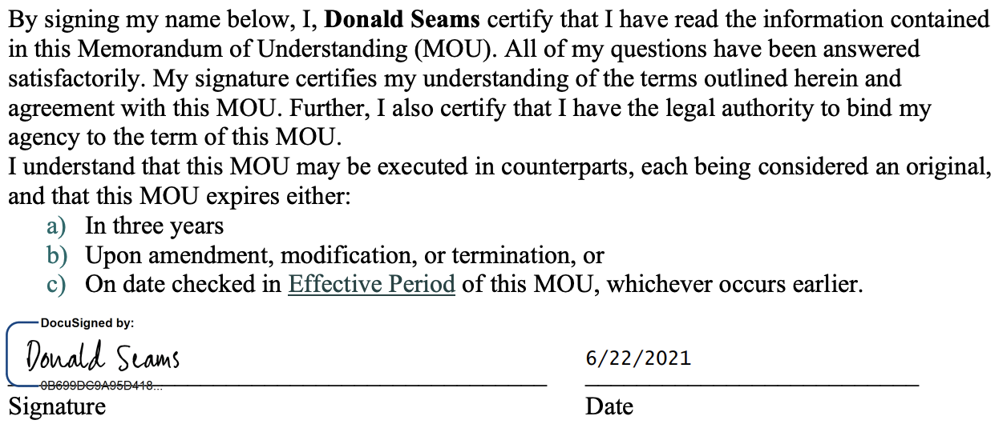

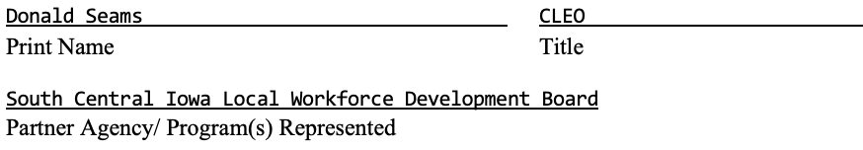

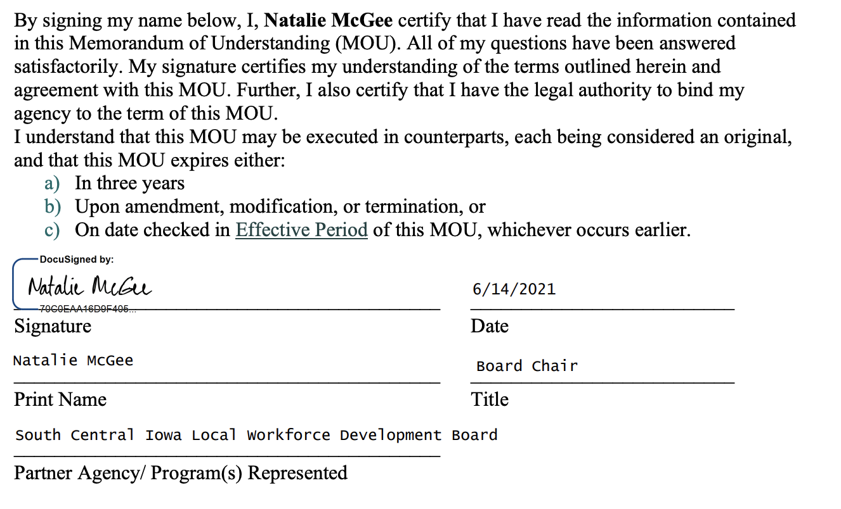

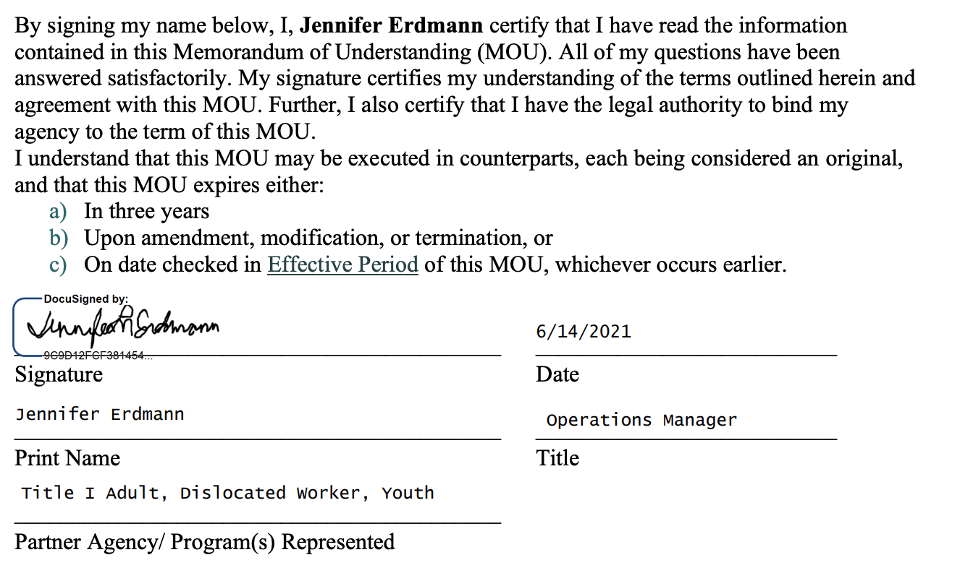

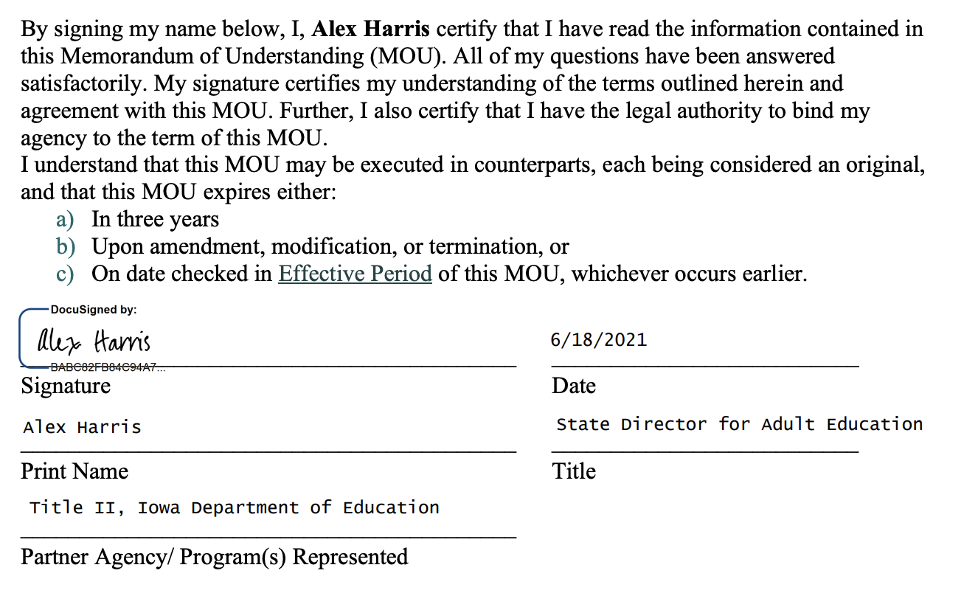

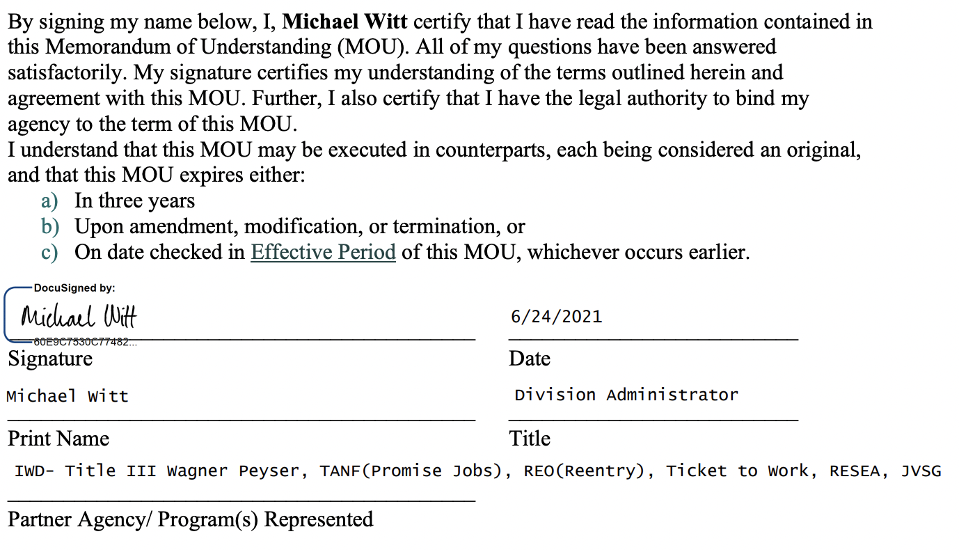

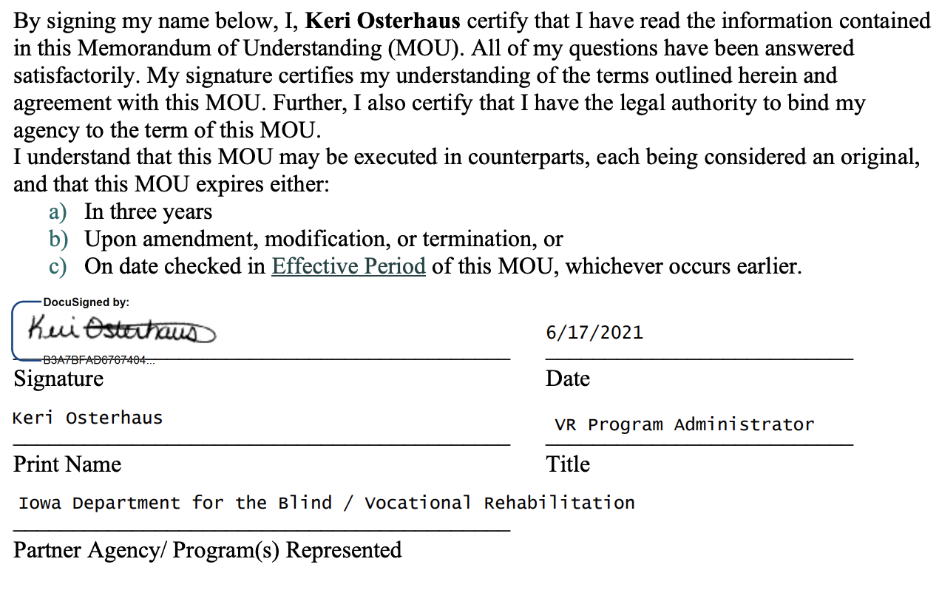

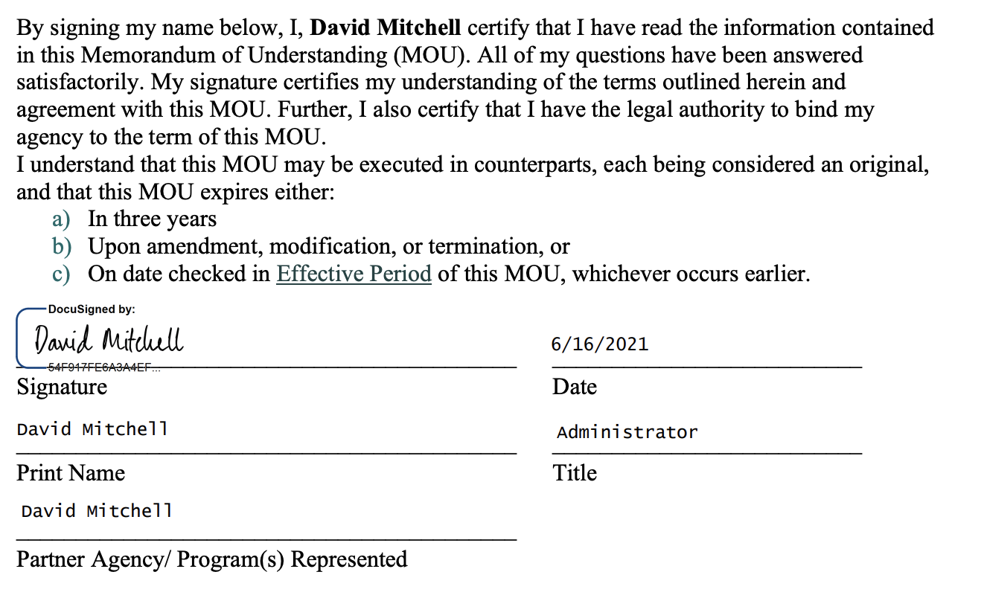

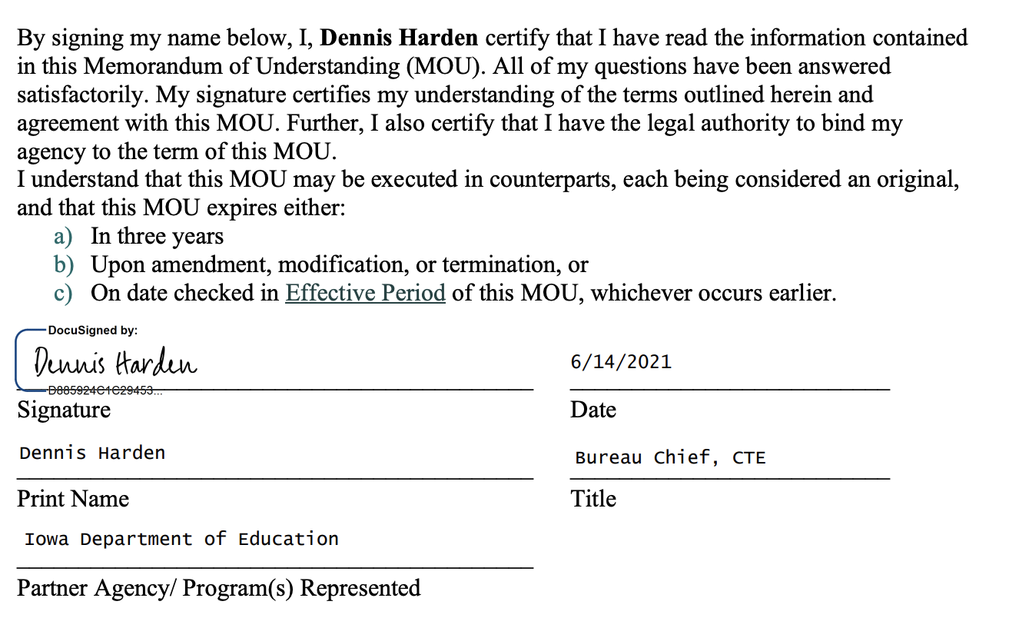

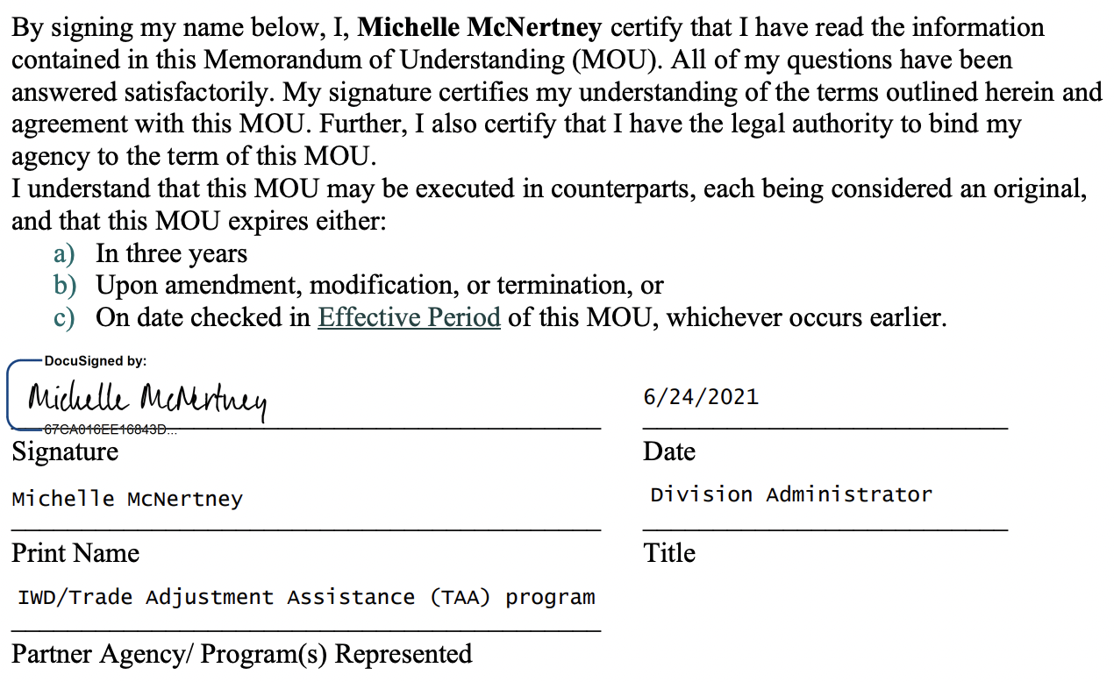

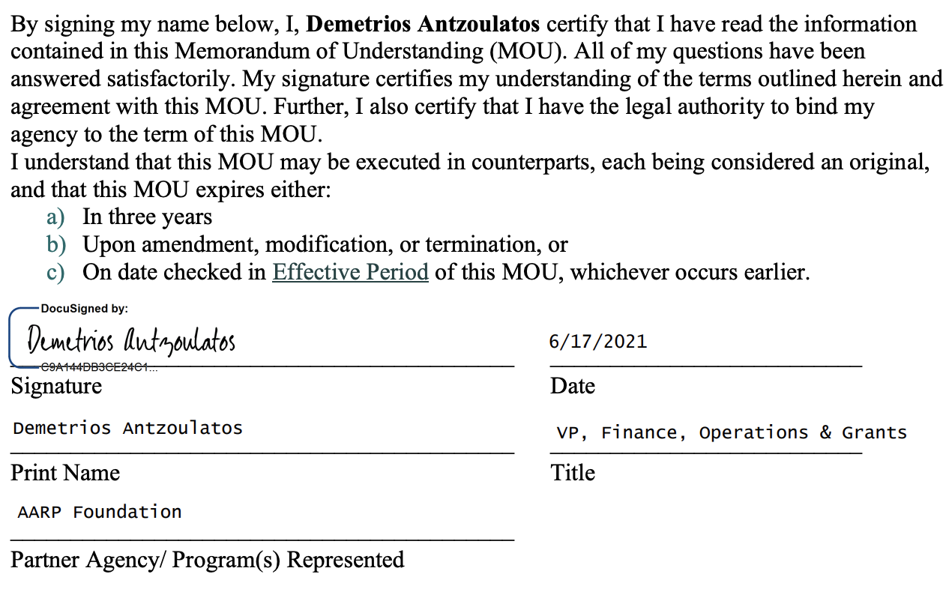

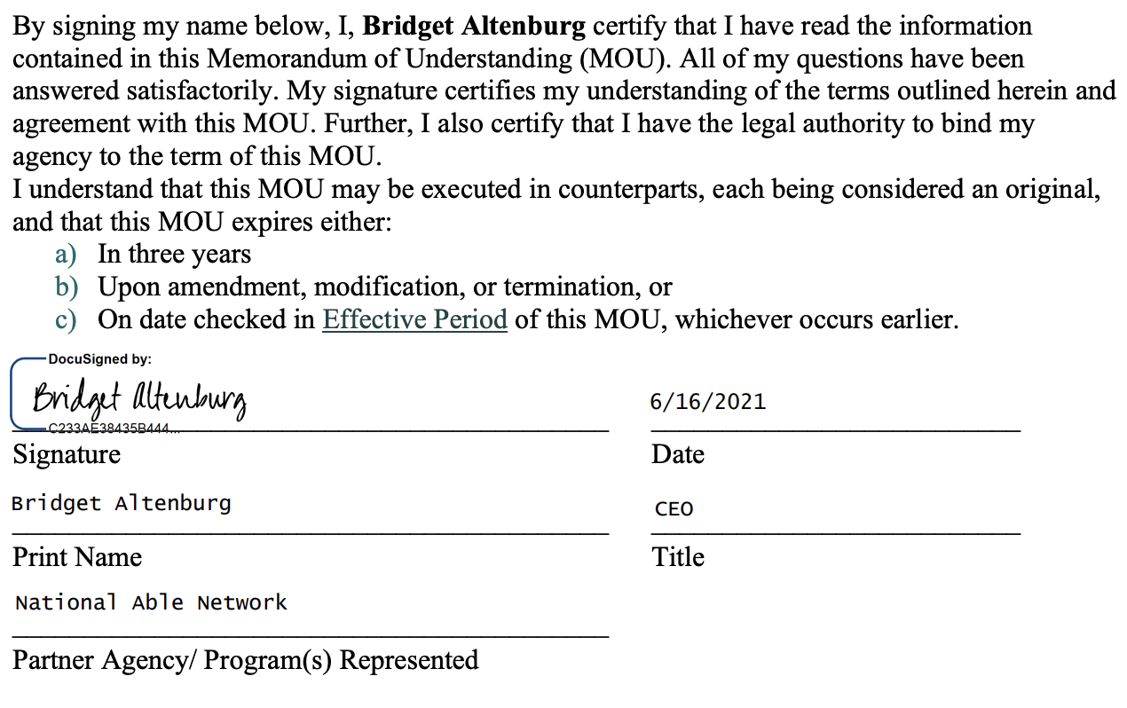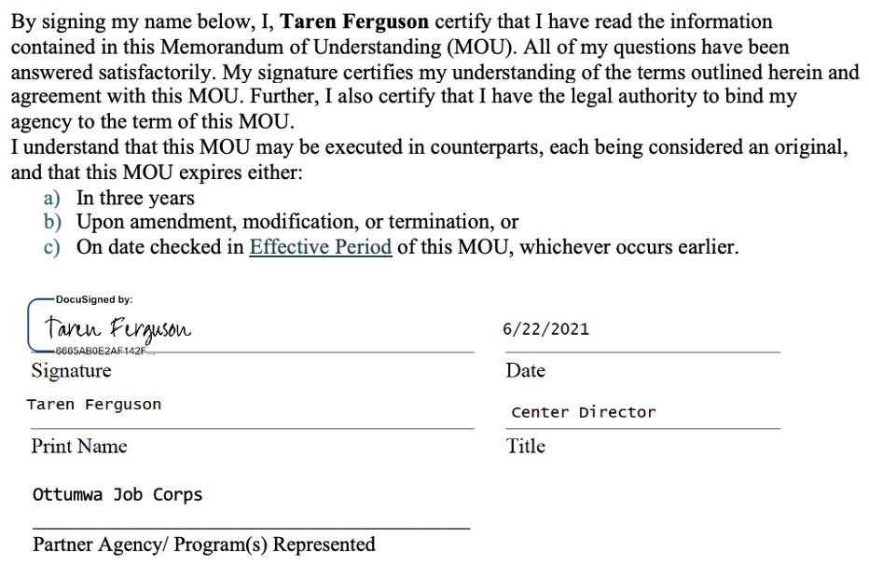

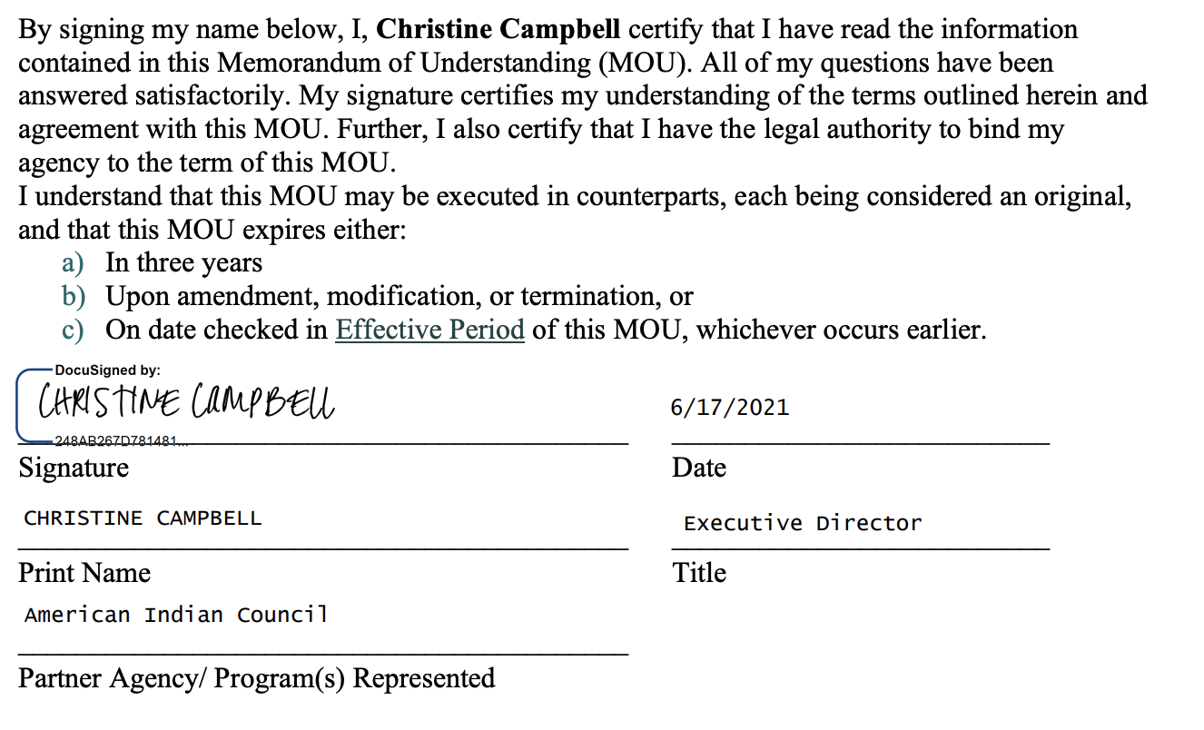

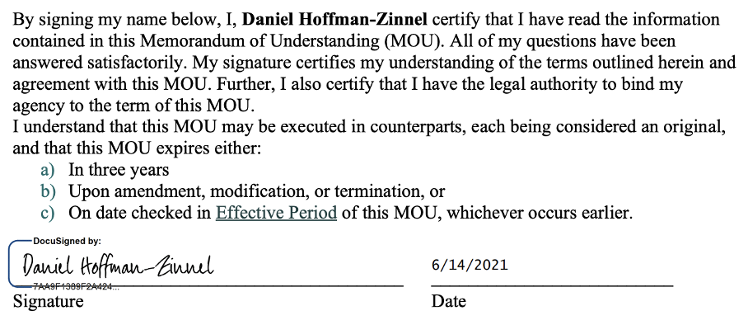
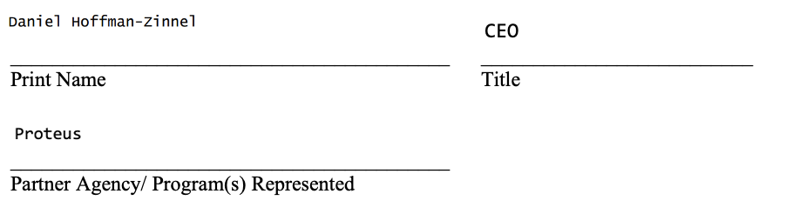

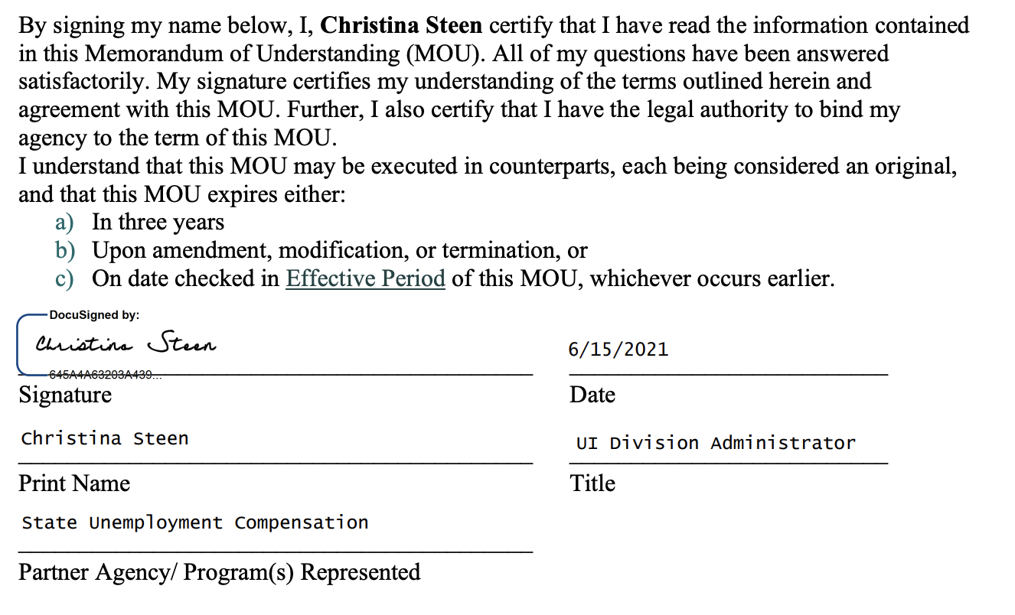

Definitions
Affiliate Site – see IWD Policy 1.4.9- Characteristics of the One Stop Delivery System
Additional Partner – Per WIOA 121(b)(2), an entity that carries out a program not identified as required under WIOA that is approved by the LWDB and the CLEO may be included as an IowaWORKS partner in a local area.
Chief Lead Elected Official – identified in WIOA Section 3 Definitions (9) as the chief elected officer of a unit of general local government in a local area or the individual designated under a local agreement pursuant to WIOA Section 107(c)(1)(B). IWD Policy 1.2.1 CEO Roles and Responsibilities
Career Services – The services which shall be available, at a minimum, to individuals who are adults or dislocated workers through the IowaWORKS center system in each local area. The career services that must be provided as part of the IowaWORKS center system are listed in WIOA Section 134(c)(2).
Comprehensive One Stop Center – see IWD Policy 1.4.9- Characteristics of the One Stop Delivery System
Direct Linkage – a direct connection at the center within a reasonable time by phone or through a real time we based communication to a program staff member who can provide program information or services to the customer. A direct linkage cannot exclusively be providing a phone number or computer website or providing information, pamphlets, or materials.
Fiscal Agent – the entity appointed by the CLEO in accordance with WIOA Section 107(d)(12)(B)(i)(II) and (III) to be responsible for the administration and disbursement of WIOA title I and other funds allocated for workforce development activities in the LWDA. WIOA Section 107(d)(12)(B)(i)(II) provides that designation of a fiscal agent does not relieve the CEOs from liability for any misuse of grant funds. IWD Policy #1.3.1 Local Fiscal Agent Required Functions
Iowa State Workforce Development Board – Established by the Iowa Governor under {Executive Order} to assist the Governor in creating an integrated statewide strategic plan for workforce development which will link workforce policies, education and training programs, and funding streams with the economic needs of Iowa and in complying with the provisions and requirements of WIOA Section 101.
Local Workforce Development Board (LWDB) – The board created by the CLEO pursuant to WIOA Section 107 with responsibility for the development of the local plan and for oversight of the workforce development activities in the local area. No reference to “the Board” or “the local Board” shall be interpreted as any board other than the Local Workforce Development Board.
Memorandum of Understanding (MOU) Agreement Period – the MOU must not be for a period to exceed three years. Additionally, per WIOA 121(c)(2)(v), the MOU must contain:
- the duration of the MOU
- procedures for amending the MOU during the duration of the MOU
- assurance that such memorandum shall be reviewed not less than once every three-year period to ensure appropriate funding and delivery of services.
IowaWORKS One-Stop Delivery System – a collaborative effort among public service agencies, non-profit organizations, and private entities that administer workforce investment, educational, and other human resource programs to make the variety of services available via those programs more accessible to eligible job seeker and employer customers.
IowaWORKS One Stop Operator – an entity or consortium of entities competitively selected in accordance with WIOA section 121(d) to operate an IowaWORKS site and to perform service delivery activities in accordance with all applicable Federal, state, and local laws, regulations, rules, policies, plans, and the terms of this MOU.
Required Partner – an entity that carries out one or more of the programs or activities identified under WIOA Section 121 (b)(1) and is required under that Section to participate in the IowaWORKS delivery system and to make career services under its program or activity available through the IowaWORKS system.
Training Services – services to adults and dislocated workers as described in WIOA section 143 (c)(3). These may include:
- Occupational skills training- including training for nontraditional employment
- On the job training
- Incumbent worker training
- Programs that combine workplace training with related instruction- which may include cooperative education programs
- Private sector training programs
- Skills upgrading and retraining
- Apprenticeships
- Entrepreneurial training
- Transitional jobs
- Job readiness training
- Adult education and literacy activities in combination with a training program
- Customized training
WIOA – The Workforce Innovation and Opportunity Act amends the Workforce Investment Act of 1998 to strengthen the United States’ workforce development system through innovation in, and alignment and improvement of, employment, training, and education programs, and to promote individual and national economic growth, and for other purposes.
WIOA Local Plan – Per WIOA section 108, the local plan is a comprehensive four-year plan developed by each LWDB, in partnership with the CLEO and submitted to the Governor. The plan shall support the strategy described in the State plan. At the end of the first two-year period of the four-year local plan, each LWDB shall review the local plan, and the LWDB, in partnership with the CLEO, shall prepare and submit modifications to the local plan to reflect changes in labor market and economic conditions or in other factors affecting the implementation of the local plan. Plans identify the respective local area’s current and projected workforce investment needs, the IowaWORKS delivery system, performance standards, and strategies to address the workforce investment needs in consideration of performance standards per WIOA Section 116.

WIOA State Plan – the term “state plan,” used without further description, means a unified State plan under section 102 or a combined State plan under section 103.

IWD Policy #1.2.1 CEO Roles and Responsibilities
IWD Policy #1.4.3.1 Local Board Required Functions
IWD Policy #1.4.7.1 Role of the One Stop Operator
20 CFR 678.420

