South Central Iowa Workforce Area Local Plan

BACKGROUND
Section 108 of WIOA and 20 CFR 679.500-560 requires that each Local Workforce Development Board (LWDB) develop and submit to the State, in partnership with the Chief Elected Official(s), a comprehensive plan on the current and projected needs of the local area’s one-stop delivery system. The law emphasizes the importance of collaboration and transparency in the development and submission of the plan.
The Local Plan is an action plan to develop, align, and integrate service delivery strategies and resources across the one-stop delivery system in a Local Workforce Development Area (LWDA). The Local Plan must support achievement of Iowa's vision, goals, and strategies as outlined in the State Plan and is implemented as a business-led, results-oriented, and integrated system.
This document provides a working outline of the local planning requirements included in the Workforce Innovation and Opportunity Act (WIOA), final regulations, and jointly-issued state policy. Further, this guidance will provide clarification on the submission process and timeline. This guidance should be used in conjunction with all state policies, including the Local Planning policy, to develop a comprehensive local plan that meets all requirements. WIOA Administration and Governance and Title I-B state policies can be located in the Iowa ePolicy website.
Outlined below is the State of Iowa’s vision for workforce and WIOA implementation as approved by the Iowa State Workforce Development Board. Please review the state vision and strategies as it is intended to inform the local planning process.

STATE OF IOWA WORKFORCE VISION AND STRATEGIES
Guided by Governor Reynolds’s vision to build a Future Ready Iowa, Iowa’s WIOA Unified State Plan establishes three goals and corresponding strategies for the state workforce system.
Iowa’s Vision:
Iowa’s workforce delivery system partners will collaborate to build a Future Ready Iowa. The system will provide the training and education needed to develop a pipeline of skilled workers who are prepared to meet the workforce needs of Iowa’s current and emerging industries. Iowa employers will have access to the skilled workforce needed to prosper in today’s global economy.
Goals and Strategies:
Goal I: Iowa’s employers will have access to skilled, diverse and Future Ready workers
State Strategy 1.1: Expand and support the framework of sector partnerships that are championed by business and industry to drive career pathways.
State Strategy 1.2: Grow the skilled labor force by advancing the Future Ready Iowa initiatives, resources and programming to all Iowans.
State Strategy 1.3: Collaborate with sector partnerships and Iowa employers to enhance work based learning opportunities for all Iowans.
Goal II: All Iowans will be provided access to a continuum of high quality education, training, and career opportunities.
State Strategy 2.1: Further develop and promote accessible career pathways to all Iowans.
State Strategy 2.2: Educate the system, partners and communities about the programs, initiatives, resources and opportunities available to up-skill the workforce.
State Strategy 2.3: Connect all Iowans with long-term career opportunities from high-growth, in- demand sectors.
Goal III: Iowa’s workforce delivery system will align all programs and services in an accessible, seamless and integrated manner.
State Strategy 3.1: Align workforce programs and initiatives to improve service delivery and outcomes for all Iowans.
State Strategy 3.2: Ensure seamless access to programs and services of the workforce delivery system to all Iowans.
State Strategy 3.3: Continuous improvement of the system to ensure no programmatic or physical barriers exist to accessing programs and services by all Iowans.
Each goal has identified outcomes and measures that will be tracked statewide in order to gauge progress and to better understand our system’s success in working towards this shared vision and shared goals. These goals and strategies should help all Iowa workforce delivery system partners consider how services are delivered, whether the services are reaching in need populations, and where improvements are needed to help address gaps in the system.
As primary contributors to the development of these strategies, LWDBs will be expected to communicate how they will support Iowa’s growth with these strategies. Instructions are provided further in the guidance.

LOCAL PLAN TIMELINE AND SUBMISSION

TIMELINE
WIOA requires each LWDB to submit a comprehensive 4-year plan, with a required review at the end of the first 2-year period of the plan. With the realignment of local workforce development areas and continued WIOA system transformation in Iowa throughout Program Years 2019 and 2020, Iowa will require the following timeline for development of local plans, to ensure all local plans cycles are consistent with the state planning cycle beginning in Program year 2024.

DEADLINES CHART
DEADLINE | KEY TASK
January 15, 2021 | Local Planning Guidance published
August 13, 2021 | Suggested deadline to post local plan for required 30-day public comment period
September 15, 2021 | Suggested deadline for end of public comment period
October 1, 2021 | Deadline to submit Local Plans to State for review
January 1, 2022 | Effective date of Local Plans for PY21 – PY23
April 1, 2023 | Deadline for submission of PY24 – PY27 4-year Local Plans
Local Plans will be reviewed in the order received by the Iowa State Core Partner Working Group.

SUBMISSION
Each local plan is required to be submitted on or before the deadline of 12:59pm October 1, 2021 within the IowaGrants.gov system. Additional training and guidance on this system will be provided at a later date. The submission of the plan will follow the outline of local plan contents below.

LOCAL PLAN CONTENTS
The following sections are designed to function as an outline of the local plan sections. The required content sections are in outline form, while additional “Notes” are included under some sections to provide additional guidance and suggestions for plan contents. Each section of the outline will be a section within the Iowa Grants system for submission of the plan. With the “Notes” sections removed, the outline can be used to draft your responses to each section and to create a draft plan to post for public comment.

SECTION 1 – INFRASTRUCTURE
A description of the local workforce development system in the local area.
- Describe the local workforce delivery system in the local workforce development area (LWDA), including the following:
  - Name of the LWDA: South Central Iowa Workforce Area
  - Identification of the counties included in the LWDA: Appanoose, Davis, Hardin, Jefferson, Keokuk, Lucas, Mahaska, Marshall, Monroe, Poweshiek, Tama, Van Buren, Wapello, and Wayne
  - A roster of all LWDB members, including the organization representing and title/role and the city/county each is from, and identification of the LWDB Chairperson
South Central Iowa Workforce Board Members
  - Identification of Subcommittees of the LWDB and the chair of each
Executive Committee- Natalie McGee
Operations Committee- Jim Keck
Finance Committee- Teri Bockting
Youth Standing Committee- Mark Cooper
Disability Access Committee Marshalltown- Eric Evans
Disability Access Committee Ottumwa- Kelli Hugo
  - Identification of the Fiscal Agent (entity responsible for disbursal of Title I grant funds) Pathfinders RC&D
  - Identification of all LWDB Staff and brief description of their role(s)
Executive Director- Krista Tedrow
  - Identification of the competitively selected WIOA Title I Adult, Dislocated Worker, and Youth service providers: Indian Hills Community College
  - Identification of the One-Stop Operator for the local area: Not Procured at this time.
  - Identification of the office locations in the local area, including:
    - Comprehensive One-Stop locations
IowaWORKS Ottumwa IowaWORKS Marshalltown
15260 Truman St 101 Iowa Ave W STE 200
Ottumwa, IA 52501 Marshalltown, IA 50158
    - Affiliated sites: None
    - Specialized Centers: None

  - A description of the process used to draft the local plan
Core partners collaborated on the Local Service Plan while using the Unified State Plan to provide guidance and direction. We set up the Local Service Plan in One Drive to be able to collaboratively work on it together. Once a draft was completed, it was presented to the Local Workforce Development Board for review.

SECTION 2 – STRATEGIC PLANNING ELEMENTS
Questions in this section are designed to address the aspects of the local area’s labor force, such as its composition and the determination of skills gaps between the talent needed by employers in the local area and the knowledge and skills held by workers and job seekers. It is recommended that these plans include data samples and streamlined graphics and tables that support the narrative provided. The local board must cite the source(s) used to collect all or part of the local area labor market
- Economic Analysis: Include a local area analysis of the local area:

Local Workforce Development Area Executive Summary
As of 2020, the South Central Iowa LWDA’s population according to the U.S. Census is 227,441 and largest private industry was Manufacturing, representing 20.6 percent (17,832) of the region’s total covered employment of 86,448. The region’s total employment decreased by 4.3 percent since 2019, while the average annual wage increased by 7.9 percent to $46,323 for all industries. All industries in the region recorded losses in employment. The smallest loss in employment was posted in the Transportation & Utilities industry with 0.5 percent, while the Leisure & Hospitality industry posted the largest loss in employment with 15.6 percent during 2020. The South Central Iowa LWDA average weekly wage for all industries was $891 for 2020. This was an increase of 7.9 percent since 2019. The highest average weekly wage for a private sector industry was in Financial Services averaging $1,175. Between 2019 and 2020, the Professional & Business Services sector reported the largest percentage increase in average weekly wage of 12.5 percent.
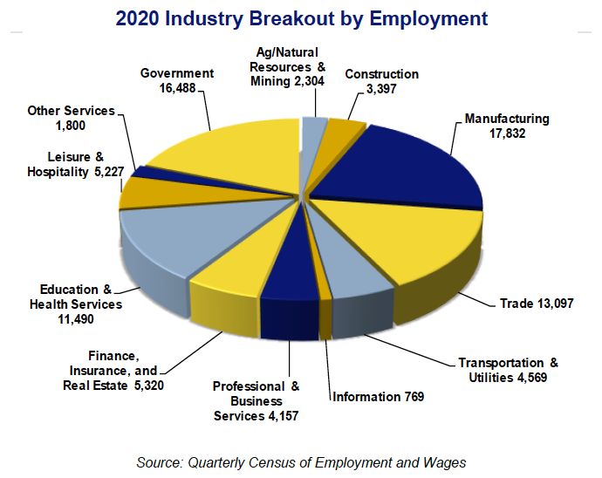

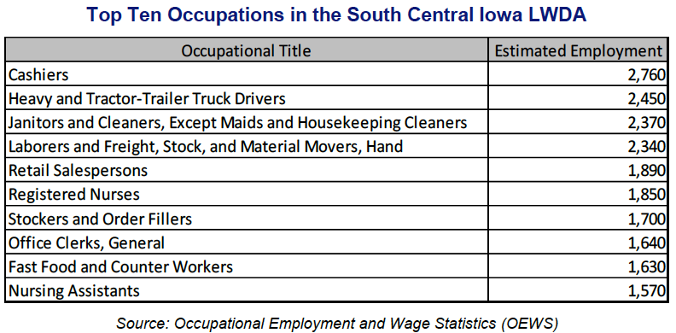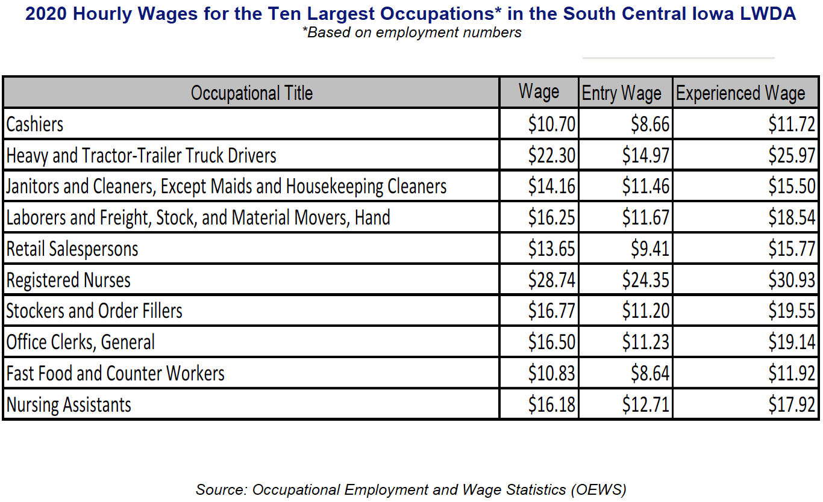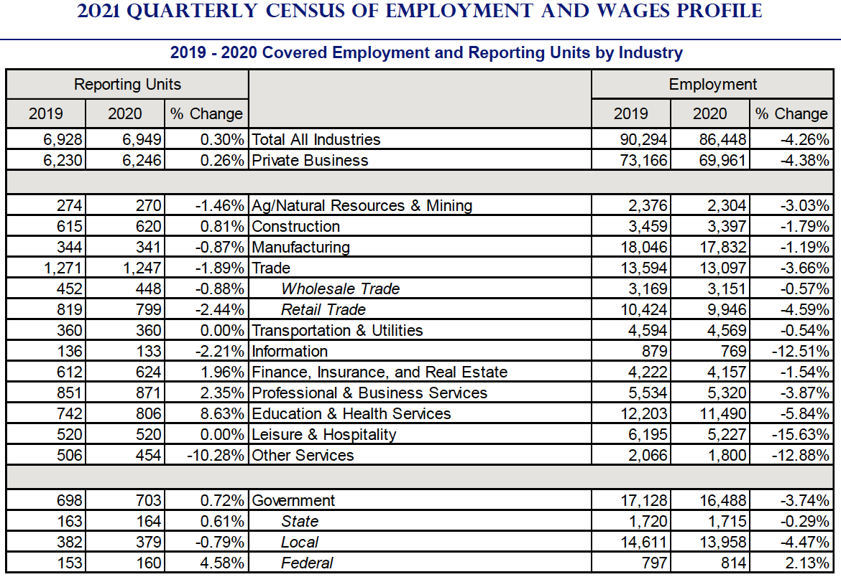Source: Labor Market and Workforce Information Division, Iowa Workforce Development
a. Economic conditions including existing and emerging in-demand industry sectors and occupations

2016-2026 Occupational Projection Summary for the northern counties of the LWDA - Marshall, Tama, Hardin, and Poweshiek.
The occupational employment is expected to increase by 6% from 2016 to 2026 (or .6% annually). Job growth will vary across major occupational groups depending on the industry. Service-providing occupations are generally expected to outperform goods-producing occupations. This is reflected in both employment change and growth rates. Major occupational groups expected to grow at or faster than the regional annual average are Business/Financial (.6%); Computer/Mathematical (1%); Architecture/Engineering (.8%); Life, Physical, and Social Science (.9%); Community and Social Service (1.8%); Education (.8%); Arts, Design, Entertainment, Sports, and Media (.6%); Healthcare Practitioner (1%); Healthcare Support (1.2%); Food Prep (.8%); Building/Grounds Cleaning and Maintenance (1.1%); Personal Care (.9%); Construction (1%); Installation, Maintenance, and Repair (1%); and Transportation/Material Moving (.7%). Growing less than the regional average are Management (.4%); Legal (.5%); Protective Service (.2%); Sales (.4%); Office/Administrative (-.1%); Farming, Fishing, and Forestry (0%); and Production (.4%) major occupational groups.
2016-2026 Occupational Projection Summary for the southern counties of the LWDA - Appanoose, Davis, Jefferson, Keokuk, Lucas, Mahaska, Monroe, Van Buren, Wapello, Wayne
The occupational employment is expected to increase by 5% from 2016 to 2026 (or .5% annually). Job growth will vary across major occupational groups depending on the industry. Service-providing occupations are generally expected to outperform goods-producing occupations. This is reflected in both employment change and growth rates. Major occupational groups expected to grow at or faster than the regional annual average are Business/Financial (.9%); Computer/Mathematical (1.1%); Architecture/Engineering (.6%); Community and Social Service (1.7%); Legal (.6%); Education (.8%); Arts, Design, Entertainment, Sports, and Media (.7%); Healthcare Practitioner (1%); Healthcare Support (.8%); Food Prep (.6%); Building/Grounds Cleaning and Maintenance (1%); Personal Care (1.6%); Sales (.5%); Construction (.8%); Installation, Maintenance, and Repair (.7%); and Transportation/Material Moving (.9%). Growing less than the regional average are Management (.3%); Life, Physical, and Social Science (.3%); Protective Services (.3%); Office/Administrative (.1%); Farming, Fishing, and Forestry (-.3%) and Production (-.1%) major occupational groups.
b. Employment needs of employers in existing and emerging in-demand industry sectors and occupations.
Marshall, Tama, Hardin, and Poweshiek Largest Projected Job Growth, 2016-2026
The ten occupations expected to have the largest employment growth for 2016 to 2026 will account for 910 (or 30%) of the projected 3,010 new jobs. The major occupational groups of Healthcare; Food Prep; Production; Building/Grounds Maintenance and Transportation/Material Moving will account for the bulk of the new jobs as shown below.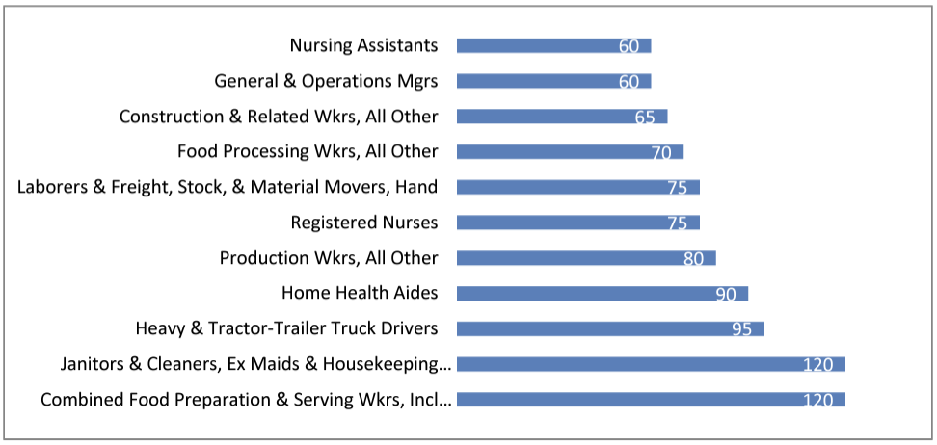
Source: Labor Market and Workforce Information Division, Iowa Workforce Development
Appanoose, Davis, Jefferson, Keokuk, Lucas, Mahaska, Monroe, Van Buren, Wapello, Wayne Largest Projected Job Growth, 2016-2026
The top eleven occupations expected to have the largest employment growth for 2016 - 2026 will account for 1,245 (or 35%) of the projected 3,565 new jobs. The major occupational groups of Personal Care; Food Prep; Office/Administrative; Building/Grounds Maintenance; and Transportation/Material Moving will account for the bulk of new jobs as shown below.
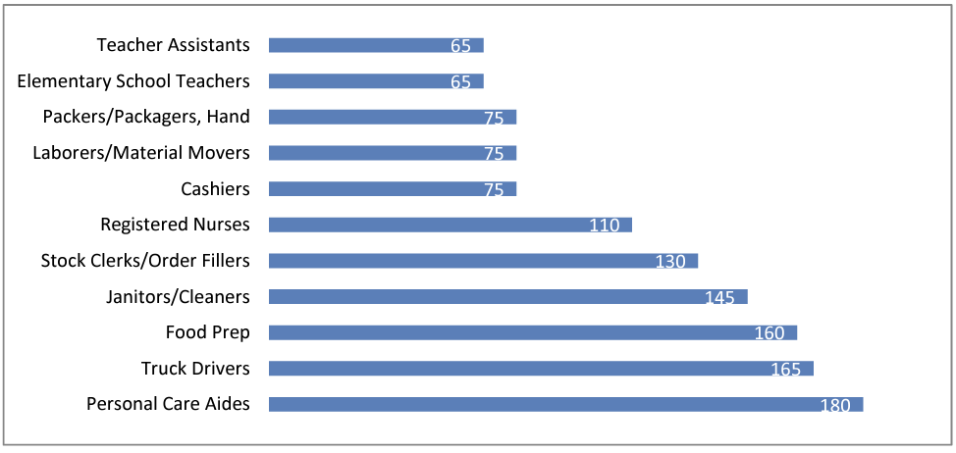
Source: Labor Market and Workforce Information Division, Iowa Workforce Development
Marshall, Tama, Hardin, and Poweshiek Largest Projected Job Decline, 2016-2026
The top eleven occupations expected to have the largest employment decline for 2016 to 2026 will account for 230 (92%) of the projected 250 lost jobs as shown below.
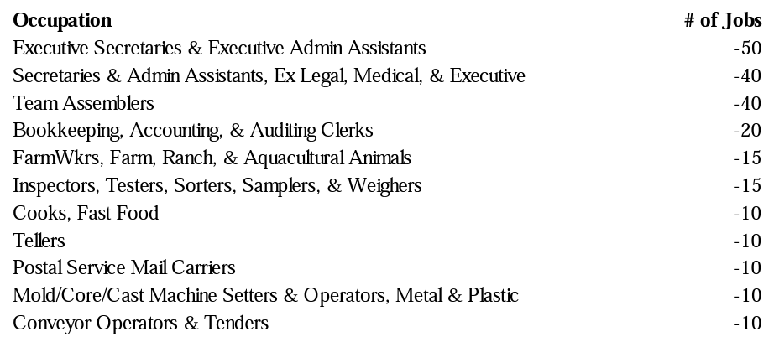
Source: Labor Market and Workforce Information Division, Iowa Workforce Development
Appanoose, Davis, Jefferson, Keokuk, Lucas, Mahaska, Monroe, Van Buren, Wapello, Wayne Largest Projected Job Decline, 2016 - 2026
Office/Administrative and Production occupational groups to have the largest percentage of employment decline for 2016 to 2026 as shown below. Employment costs, competition, technological change and other economic factors may contribute to deteriorating industry employment. While such occupations may be considered a source for employment, careful thought should be given to training time and costs.
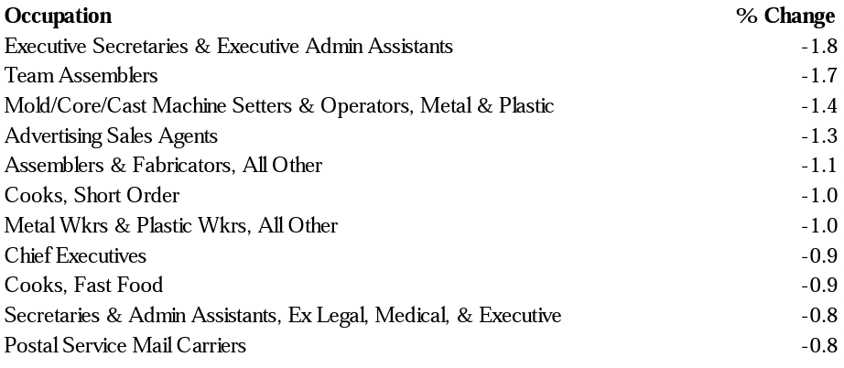
Source: Labor Market and Workforce Information Division, Iowa Workforce Development
Marshall, Tama, Hardin, and Poweshiek Occupations with the Most Annual Openings, 2016 – 2026
The top ten occupations expected to have the most annual openings for 2016-2026 will account for 1,525 (or 26%) of the projected 5,835 openings. The major occupational groups of Management; Sales; Food Prep; Production, and Transportation/Material Moving will account for most of the openings as shown below.
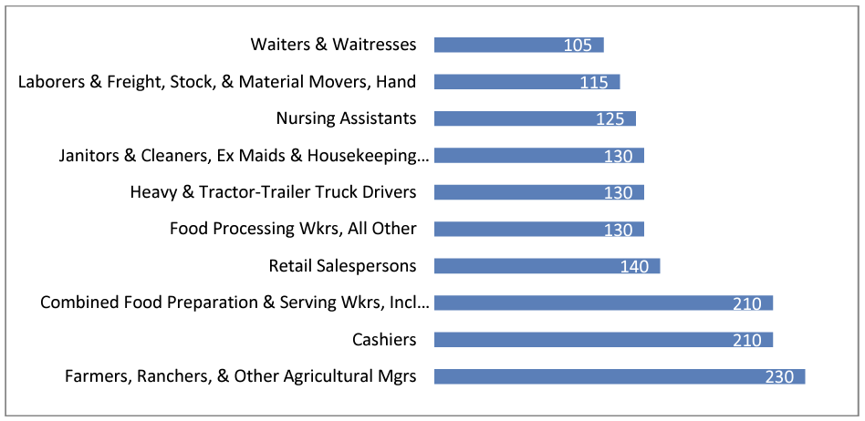
Source: Labor Market and Workforce Information Division, Iowa Workforce Development
Appanoose, Davis, Jefferson, Keokuk, Lucas, Mahaska, Monroe, Van Buren, Wapello, Wayne Occupations with the Most Annual Openings, 2016 - 2026
The top eleven occupations expected to have the most annual openings for 2016-2026 will account for 2,320 (or 30%) of the projected 7,810 openings. The major occupational groups of Sales; Management; Food Prep; Office/Administrative; and Transportation/Material Moving will account for the majority of openings as shown below.
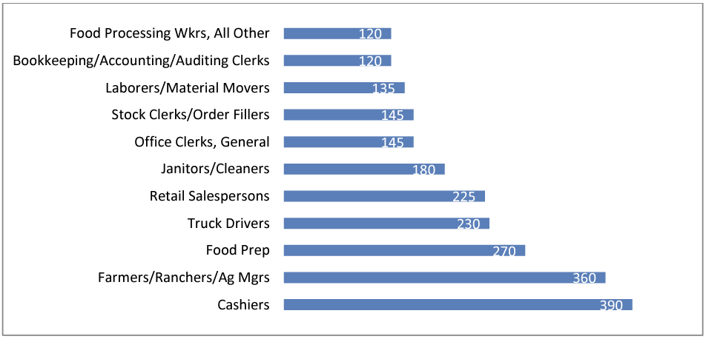
Source: Labor Market and Workforce Information Division, Iowa Workforce Development

South Central Iowa Workforce Area Emerging and In-Demand Occupational Sectors are as follows:

Emerging and in-demand industries are entirely new or restructured industrial sectors, growing at a rate faster than the overall economy. Such industries usually come into being when customers need change, new technologies replace older ones, or when new socio-economic conditions emerge. South Central Iowa Workforce Area projections (2018-2022) by total growth identify the above industries to have the highest % of growth in our 14 county area. Followed by the below list of occupations with the highest growth.
South Central Iowa Occupational Needs
South Central Iowa Workforce Area:__________
Ottumwa AJC Area:_________
Marshalltown AJC Area:_________
Bright Outlook throughout the United States

11-0000 Management Occupations
11-1021.00 General and Operations Managers
11-2021.00 Marketing Managers
11-2022.00 Sales Managers
11-3031.00 Financial Managers
11-3051.00 Industrial Production Managers
11-9021.00 Construction Managers
11-9033.00 Education Administrators, Postsecondary
11-9051.00 Food Service Managers
11-9111.00 Medical and Health Services Managers
11-9151.00 Social and Community Service Managers
11-9179.00 Personal Service Managers, All Other

13-0000 Business and Financial Operations Occupations
13-1031.00 Claims Adjusters, Examiners, and Investigators
13-1041.00 Compliance Officers
13-1051.00 Cost Estimators
13-1071.00 Human Resources Specialists
13-1111.00 Management Analysts
13-1151.00 Training and Development Specialists
13-1161.00 Market Research Analysts and Marketing Specialists
13-1199.00 Business Operations Specialists, All Other
13-2011.00 Accountants and Auditors
13-2072.00 Loan Officers
13-2099.00 Financial Specialists, All Other

15-0000 Computer and Mathematical Occupations
15-1211.00 Computer Systems Analysts
15-1232.00 Computer User Support Specialists
15-1252.00 Software Developers

17-0000 Architecture and Engineering Occupations
17-2112.00 Industrial Engineers

19-0000 Life, Physical, and Social Science Occupations
19-1012.00 Food Scientists and Technologists
19-4012.00 Agricultural Technicians
19-4013.00 Food Science Technicians
19-4071.00 Forest and Conservation Technicians

21-0000 Community and Social Service Occupations
21-1011.00 Substance Abuse and Behavioral Disorder Counselors
21-1012.00 Educational, Guidance, and Career Counselors and Advisors
21-1015.00 Rehabilitation Counselors
21-1019.00 Counselors, All Other
21-1021.00 Child, Family, and School Social Workers
21-1093.00 Social and Human Service Assistants
21-1099.00 Community and Social Service Specialists, All Other

25-0000 Educational Instruction and Library Occupations
25-1199.00 Postsecondary Teachers, All Other
25-2011.00 Preschool Teachers, Except Special Education
25-2021.00 Elementary School Teachers, Except Special Education
25-2022.00 Middle School Teachers, Except Special and Career/Technical Education
25-2031.00 Secondary School Teachers, Except Special and Career/Technical Education
25-2059.00 Special Education Teachers, All Other
25-3021.00 Self-Enrichment Teachers
25-3031.00 Substitute Teachers, Short-Term
25-3099.00 Teachers and Instructors, All Other
25-9042.00 Teaching Assistants, Preschool, Elementary, Middle, and Secondary School, Except Special Education
25-9099.00 Educational Instruction and Library Workers, All Other

27-0000 Arts, Design, Entertainment, Sports, and Media Occupations
27-1024.00 Graphic Designers
27-2022.00 Coaches and Scouts
27-3031.00 Public Relations Specialists

29-0000 Healthcare Practitioners and Technical Occupations
29-1141.00 Registered Nurses
29-2042.00 Emergency Medical Technicians
29-2043.00 Paramedics
29-2052.00 Pharmacy Technicians
29-2061.00 Licensed Practical and Licensed Vocational Nurses

31-0000 Healthcare Support Occupations
31-1121.00 Home Health Aides
31-1131.00 Nursing Assistants
31-2021.00 Physical Therapist Assistants
31-9091.00 Dental Assistants
31-9092.00 Medical Assistants
31-9096.00 Veterinary Assistants and Laboratory Animal Caretakers
31-9099.00 Healthcare Support Workers, All Other

33-0000 Protective Service Occupations
33-3012.00 Correctional Officers and Jailers
33-3051.00 Police and Sheriff's Patrol Officers
33-9032.00 Security Guards
33-9092.00 Lifeguards, Ski Patrol, and Other Recreational Protective Service Workers

35-0000 Food Preparation and Serving Related Occupations
35-1012.00 First-Line Supervisors of Food Preparation and Serving Workers
35-2012.00 Cooks, Institution and Cafeteria
35-2014.00 Cooks, Restaurant
35-2015.00 Cooks, Short Order
35-2021.00 Food Preparation Workers
35-3011.00 Bartenders
35-3023.00 Fast Food and Counter Workers
35-3031.00 Waiters and Waitresses
35-3041.00 Food Servers, Nonrestaurant
35-9011.00 Dining Room and Cafeteria Attendants and Bartender Helpers
35-9031.00 Hosts and Hostesses, Restaurant, Lounge, and Coffee Shop
35-9099.00 Food Preparation and Serving Related Workers, All Other

37-0000 Building and Grounds Cleaning and Maintenance Occupations
37-1011.00 First-Line Supervisors of Housekeeping and Janitorial Workers
37-2011.00 Janitors and Cleaners, Except Maids and Housekeeping Cleaners
37-2012.00 Maids and Housekeeping Cleaners
37-2019.00 Building Cleaning Workers, All Other
37-3011.00 Landscaping and Groundskeeping Workers

39-0000 Personal Care and Service Occupations
39-1014.00 First-Line Supervisors of Entertainment and Recreation Workers, Except Gambling Services
39-1022.00 First-Line Supervisors of Personal Service Workers
39-2021.00 Animal Caretakers
39-3091.00 Amusement and Recreation Attendants
39-4012.00 Crematory Operators
39-5012.00 Hairdressers, Hairstylists, and Cosmetologists
39-9011.00 Childcare Workers
39-9031.00 Exercise Trainers and Group Fitness Instructors
39-9032.00 Recreation Workers
39-9099.00 Personal Care and Service Workers, All Other

41-0000 Sales and Related Occupations
41-1011.00 First-Line Supervisors of Retail Sales Workers
41-2011.00 Cashiers
41-2021.00 Counter and Rental Clerks
41-2022.00 Parts Salespersons
41-2031.00 Retail Salespersons
41-3021.00 Insurance Sales Agents
41-3091.00 Sales Representatives of Services, Except Advertising, Insurance, Financial Services, and Travel
41-4012.00 Sales Representatives, Wholesale and Manufacturing, Except Technical and Scientific Products
41-9099.00 Sales and Related Workers, All Other

43-0000 Office and Administrative Support Occupations
43-1011.00 First-Line Supervisors of Office and Administrative Support Workers
43-3021.00 Billing and Posting Clerks
43-3099.00 Financial Clerks, All Other
43-4031.00 Court, Municipal, and License Clerks
43-4051.00 Customer Service Representatives
43-4081.00 Hotel, Motel, and Resort Desk Clerks
43-4131.00 Loan Interviewers and Clerks
43-4171.00 Receptionists and Information Clerks
43-4199.00 Information and Record Clerks, All Other
43-5061.00 Production, Planning, and Expediting Clerks
43-5071.00 Shipping, Receiving, and Inventory Clerks
43-6013.00 Medical Secretaries and Administrative Assistants
43-9041.00 Insurance Claims and Policy Processing Clerks
43-9061.00 Office Clerks, General
43-9199.00 Office and Administrative Support Workers, All Other

45-0000 Farming, Fishing, and Forestry Occupations
45-2091.00 Agricultural Equipment Operators
45-2092.00 Farmworkers and Laborers, Crop, Nursery, and Greenhouse
45-2099.00 Agricultural Workers, All Other

47-0000 Construction and Extraction Occupations
47-1011.00 First-Line Supervisors of Construction Trades and Extraction Workers
47-2031.00 Carpenters
47-2051.00 Cement Masons and Concrete Finishers
47-2061.00 Construction Laborers
47-2073.00 Operating Engineers and Other Construction Equipment Operators
47-2111.00 Electricians
47-2141.00 Painters, Construction and Maintenance
47-2152.00 Plumbers, Pipefitters, and Steamfitters
47-2181.00 Roofers
47-2211.00 Sheet Metal Workers
47-3015.00 Helpers--Pipelayers, Plumbers, Pipefitters, and Steamfitters
47-4051.00 Highway Maintenance Workers

49-0000 Installation, Maintenance, and Repair Occupations
49-1011.00 First-Line Supervisors of Mechanics, Installers, and Repairers
49-2022.00 Telecommunications Equipment Installers and Repairers, Except Line Installers
49-3023.00 Automotive Service Technicians and Mechanics
49-3031.00 Bus and Truck Mechanics and Diesel Engine Specialists
49-3041.00 Farm Equipment Mechanics and Service Technicians
49-3042.00 Mobile Heavy Equipment Mechanics, Except Engines
49-9021.00 Heating, Air Conditioning, and Refrigeration Mechanics and Installers
49-9041.00 Industrial Machinery Mechanics
49-9071.00 Maintenance and Repair Workers, General
49-9098.00 Helpers--Installation, Maintenance, and Repair Workers
49-9099.00 Installation, Maintenance, and Repair Workers, All Other

51-0000 Production Occupations
51-1011.00 First-Line Supervisors of Production and Operating Workers
51-3021.00 Butchers and Meat Cutters
51-3022.00 Meat, Poultry, and Fish Cutters and Trimmers
51-3023.00 Slaughterers and Meat Packers
51-3092.00 Food Batchmakers
51-3099.00 Food Processing Workers, All Other
51-4041.00 Machinists
51-4081.00 Multiple Machine Tool Setters, Operators, and Tenders, Metal and Plastic
51-4121.00 Welders, Cutters, Solderers, and Brazers
51-6011.00 Laundry and Dry-Cleaning Workers
51-7042.00 Woodworking Machine Setters, Operators, and Tenders, Except Sawing
51-9023.00 Mixing and Blending Machine Setters, Operators, and Tenders
51-9032.00 Cutting and Slicing Machine Setters, Operators, and Tenders
51-9111.00 Packaging and Filling Machine Operators and Tenders
51-9123.00 Painting, Coating, and Decorating Workers
51-9124.00 Coating, Painting, and Spraying Machine Setters, Operators, and Tenders
51-9196.00 Paper Goods Machine Setters, Operators, and Tenders
51-9198.00 Helpers--Production Workers
51-9199.00 Production Workers, All Other

53-0000 Transportation and Material Moving Occupations
53-1043.00 First-Line Supervisors of Material-Moving Machine and Vehicle Operators
53-1049.00 First-Line Supervisors of Transportation Workers, All Other
53-3031.00 Driver/Sales Workers
53-3032.00 Heavy and Tractor-Trailer Truck Drivers
53-3033.00 Light Truck Drivers
53-3051.00 Bus Drivers, School
53-3052.00 Bus Drivers, Transit and Intercity
53-3053.00 Shuttle Drivers and Chauffeurs
53-3054.00 Taxi Drivers
53-7051.00 Industrial Truck and Tractor Operators
53-7061.00 Cleaners of Vehicles and Equipment
53-7062.00 Laborers and Freight, Stock, and Material Movers, Hand
53-7063.00 Machine Feeders and Offbearers
53-7064.00 Packers and Packagers, Hand
53-7081.00 Refuse and Recyclable Material Collectors

- Workforce Analysis: Include a current analysis of:
  - The knowledge and skills needed to meet the employment needs of employers in the local area, including employment needs in in-demand industry sectors and occupations.
Population

Total estimated workforce between the ages of 18-64 is 465,725 individuals. One of the reports generated from ‘On the Map’ displays total primary jobs of 69,597 in the South Central Iowa LWDA and the distribution of age, monthly earnings and race of the workers. 35.4 percent of South Central Iowa LWDA workers earn from $1,251 to $3,333 per month. 25.5 percent of the region’s workers are age 55 and older. Source: Local Employment Dynamics, On the Map: http://onthemap.ces.census.gov/.
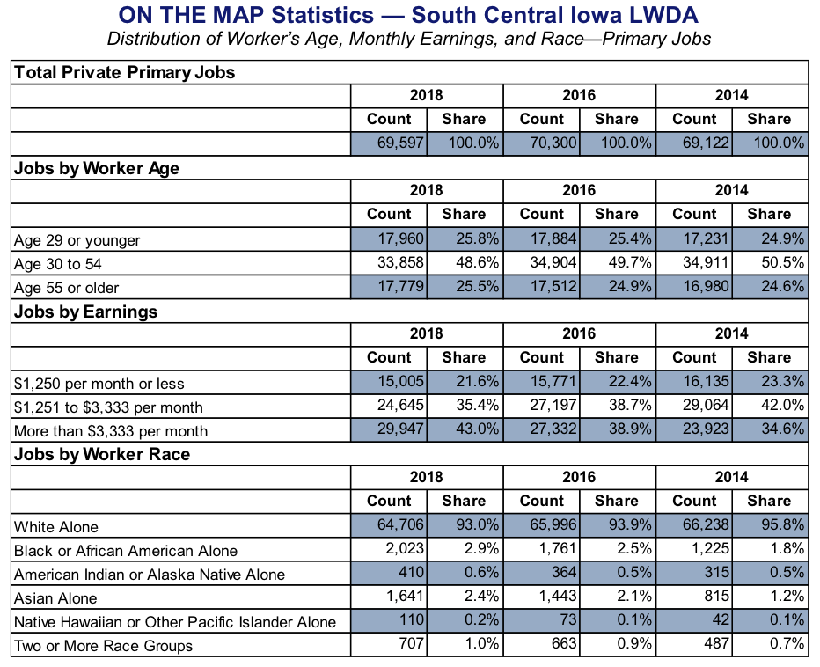
One of the reports generated from ‘On the Map’ Displays 69,597 total primary jobs in the South Central Iowa LWDA and the distribution of educational attainment and sex of the workers.25.8 percent of South Central Iowa LWDA jobs were filled by workers who held some college or Associate degrees 54.8 percent of the region’s workers are male.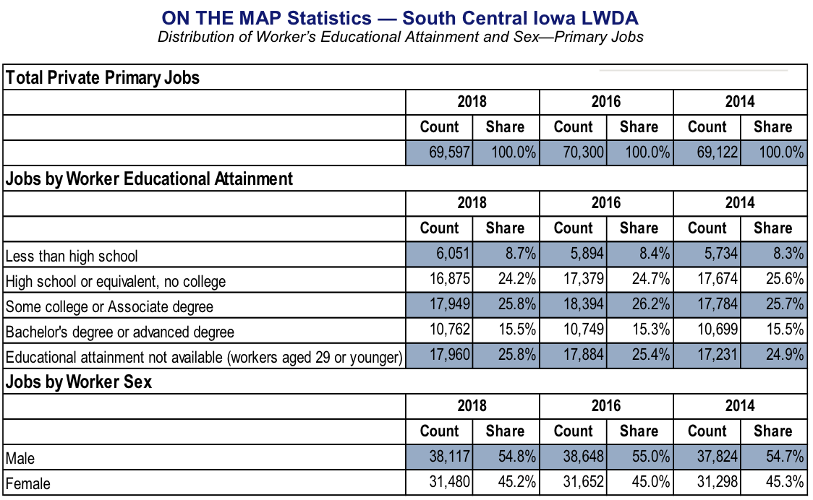
Marshalltown AJC Area
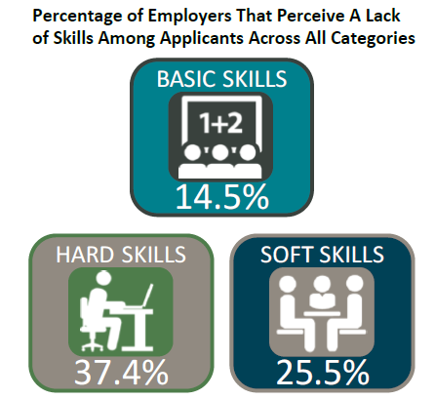
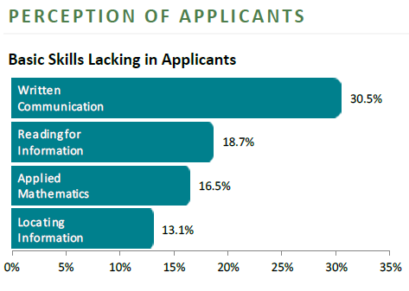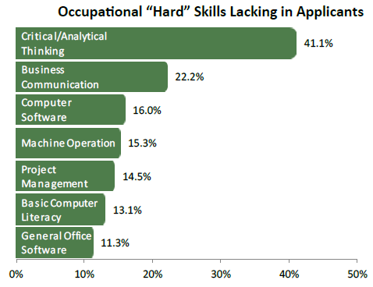

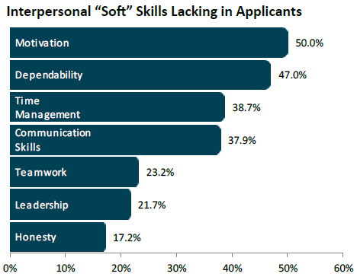

Ottumwa AJC Area
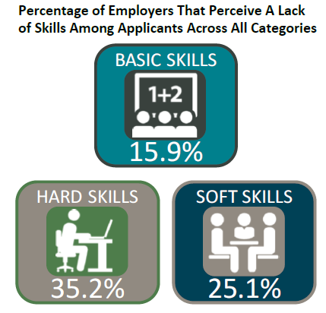
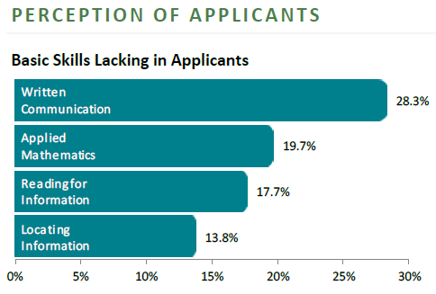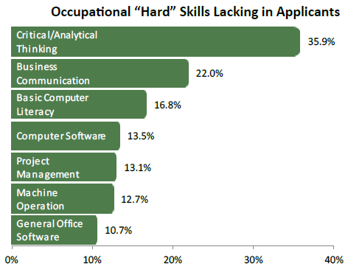
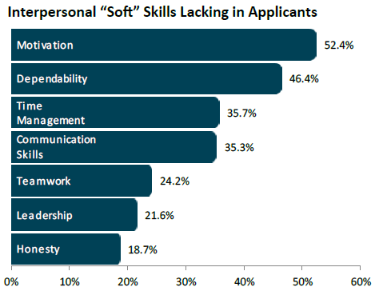

Marshalltown AJC Training Requirements
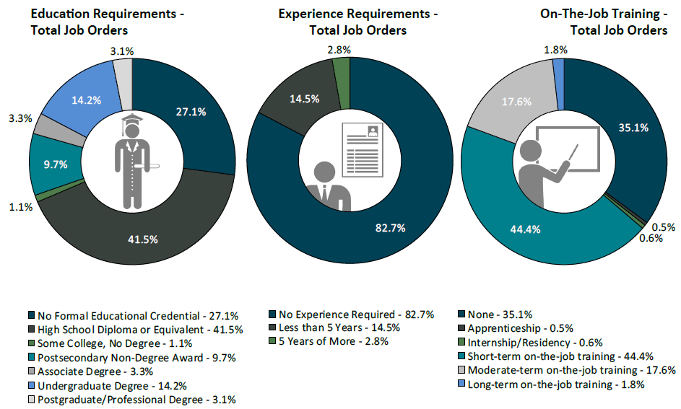
Ottumwa AJC Training Requirements
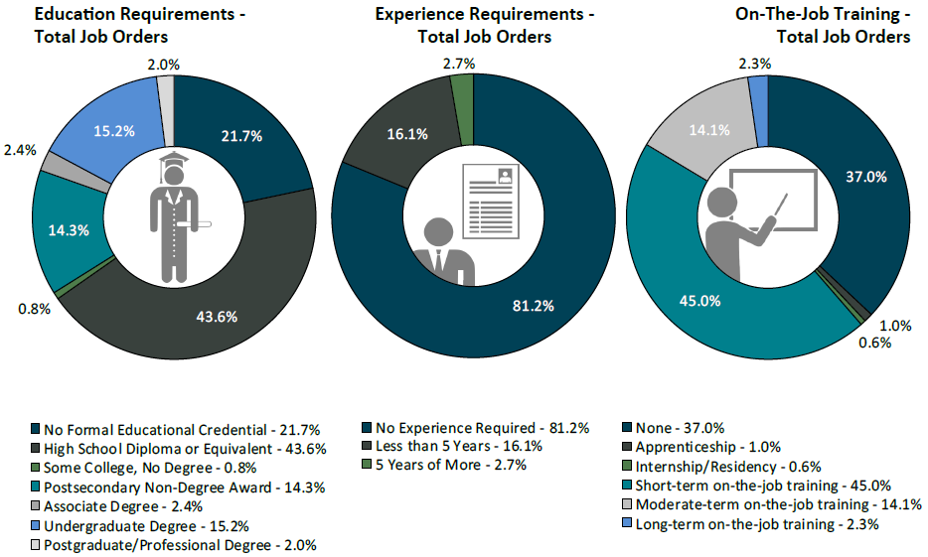

  - An analysis of the local workforce, including current labor force employment and unemployment data, information on labor market trends, and education and skill levels of the workforce, including individuals with barriers to employment.
Analysis of the available workforce in South Central Iowa Workforce Area:
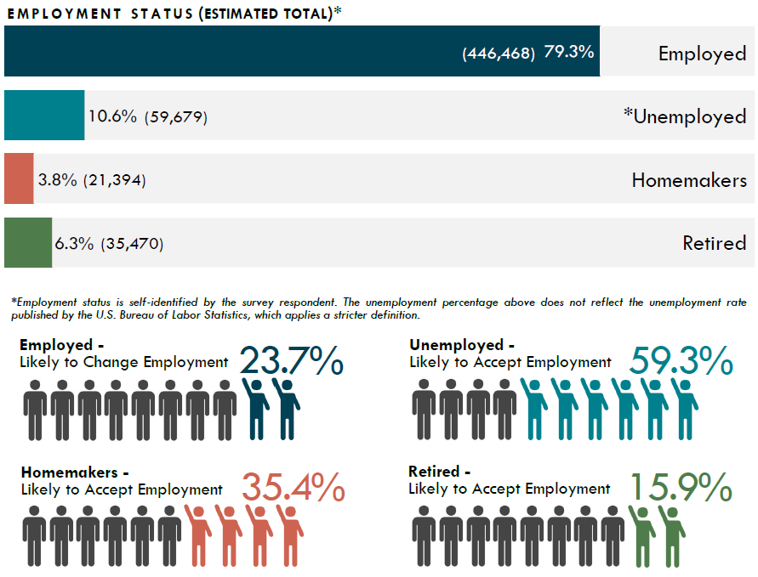

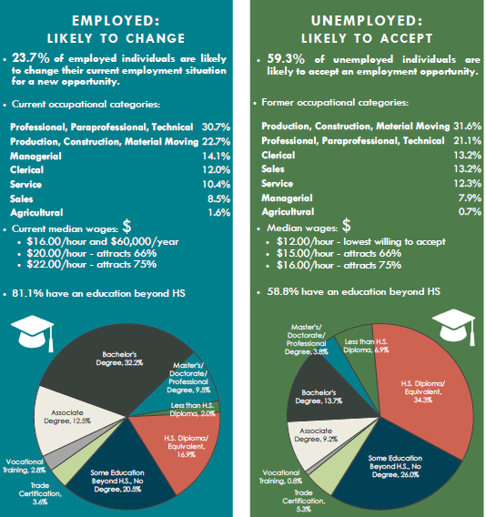

Unemployment Data Analysis of the South Central Iowa Workforce Area:
Unemployment averaged 5.4 percent in the South Central Iowa LWDA for 2020. The region’s jobless rate translated into 6,100 unemployed persons. The 2020 unemployment rate for the South Central Iowa LWDA was higher than the statewide average of 5.3 percent.
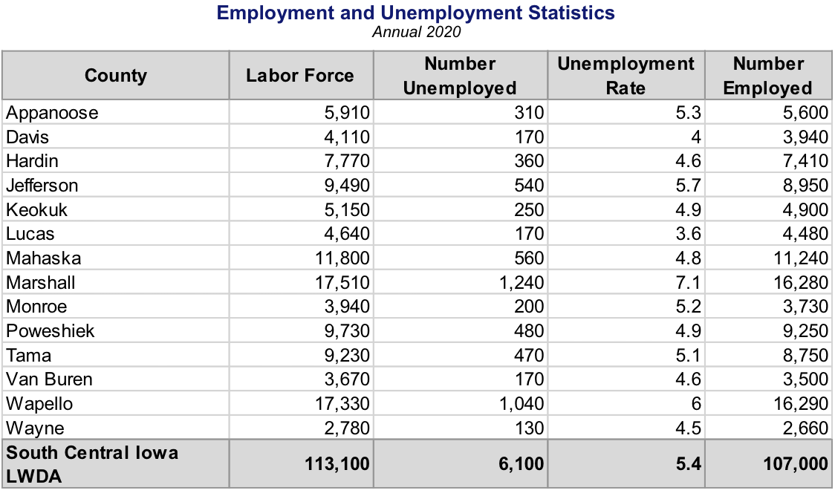

Source: Local Area Unemployment Statistics (LAUS)Note: Total employed and unemployed may not reflect total labor force, due to rounding.
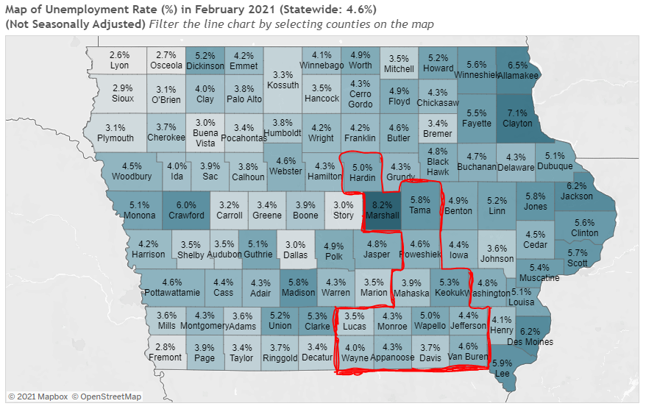
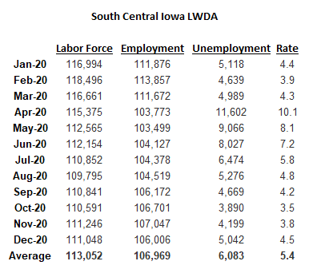
- Workforce Development, Education and Training Analysis: Include an analysis of:

- The strengths and weaknesses of workforce development activities.
South Central Iowa Workforce Area's analysis of our strengths and weaknesses of workforce development activities.

Strengths:
Accessibility: Accessibility to job seekers, businesses, stakeholders, and partners. We strive to ensure that all individuals can access our services and to collaborate with us on additional needs.

Innovation: Collaboratively we strive to provide opportunities for the communities in which we serve. We work together to be innovative in our approaches to meeting the needs of job seekers and employers.

Responsive: We strive to be able to meet all requests that we receive for assistance. Whether it be from employers, community, partners, or job seekers. The core partners work quickly to respond to Business Closings and layoffs to provide Rapid Response and Worker Information Meetings. We continuously analyze data and develop solutions to meet the Local Area needs.

Training: Increasing the availability of needed training programs on the Eligible Training Provider List (ETPL). Providing employer needed Stackable Credentials and employer driven staff training through the Employer’s Council of Iowa (ECI). Accessibility to Soft Skill and Hard Skill improvement workshops. Providing opportunities for Staff Cross-Training among the core partners, community, employers, and partners.

Weaknesses:
Rural Iowa: South Central Iowa has diverse counties and a dispersed population that present barriers to the efficient delivery of services. Delivering services to these rural areas is a challenge. Moreover, limited public transportation networks make it difficult for many, including those with barriers to access employment opportunities.

Gaps: Gaps in coordination, communication, and alignment within the workforce development system. Even though progress has been made, gaps continue in the areas of coordination, communication, and alignment within the system. We are striving to become “One Workforce” and continue to make strides in seamless integration.

Data sharing: Workforce partners recognize the importance of using valid and reliable information to drive services and to support policy initiatives. The core partners are working on methods to improve data sharing through the alignment of data systems and the sharing of data in a transparent manner to determine effectiveness and opportunities for improvement.

- Capacity to provide the workforce development activities to address the education and skill needs of the workforce, including individuals with barriers to employment.

South Central Iowa Workforce Area will deliver a demand driven system that focuses on building a workforce of high skilled, high wage jobs that will enable the employers of the Area to remain competitive. The one-stop system is a comprehensive, integrated service delivery system that is responsive to the employment and training needs of the customers, including those with barriers to employment, that we serve and incorporates the products and services of our workforce system partners in order to assure that customers needs are met without duplication of services and are delivered efficiently and effectively. The values governing South Central Iowa Workforce Area are as follows: Effective partnerships are maintained, expanded and strengthened Ongoing commitment to intertwining various funding sources in service management through partnership ensuring that workers within the Area possess a solid work ethic along with the necessary skill sets.

Soft Skills: Work readiness skills continue to surface as a critical need as expressed by employers, schools, and other stakeholders who struggle to deal with those who do not practice positive work ethic. IowaWORKS has long term experience in accessing and presenting work readiness curriculum which assists to address this issue. Workshops are offered each month to increase soft skills needed by employers. PROMISE JOBS and RESEA programs require workshop participation as part of their programs. GAP/PACE and HSED provide Journey’s curriculum. Each AJC will publish a scheduled list of workshops each month. Potential workshops provided include:
- American Job Center Orientation
- Maximize Your Potential Series
  - Step 1– Maintain a Positive Attitude
  - Step 2– Design Your Future
  - Step 3– Research Industry Trends
  - Step 4– Create a Great Resume
  - Step 5– Conduct Job Search
  - Step 6– Interview and Negotiate
- Basic Computers
- Essential Tools for Job Seekers
- Money Management/Financial Fitness
- National Career Readiness Certificate
- Workin’ it Out
- “A” Game
- Social Media
- Registered Apprenticeship 101
- True Colors
- Careers over Coffee/Networking
- Using IowaWORKS Effectively
- Elephant in the Living Room
- Excellence in Customer Service
The skills new workers (youth) are lacking, including basic work ethics, interviewing skills, basic academic skills, responsibility, organizational skills, and self-­esteem can be addressed in paid work experiences. Additional service providers, including area schools, expand the ability to provide needed training for youth through the referral process and providing Pre­-employment Training (PET). Those referrals will be made on an individual basis, meeting the needs of each person.

Iowa Vocational Rehabilitation hosts an annual Limelight event which provides soft skills training to participants. They also host Students in the Workplace events to develop soft skills.

Hard Skills: We offer Basic Computer Training to individuals lacking digital literacy skills. IVRS also provides Customer Service Certificate Training. Services available to address Hard Skills include Occupational Skills Training, Skills Upgrade, Internships, On-the-Job Training, Registered Apprenticeship, Quality Pre-Apprenticeship, Customized Training, and Incumbent Worker Training.

The National Career Readiness Certificate is a portable credential and a tool employers can utilize to assess the Hard Skills of individuals in Applied Math, Workplace Documents, and Graphic Literacy. This testing is also available in Spanish.

Due to Advanced Manufacturing need, the Production Specialist Course has been created. Upon completion the individual is a Certified Production Technician. We are currently adding this course to the Eligible Training Provider List.

Language Barriers: English Language Learners will be referred to Adult Education and Literacy. We offer English Language Learners (ELL) classes for beginners, intermediate, and advanced students. The lessons cover speaking, reading, listening, and writing. In addition, we offer Citizenship classes and tutoring services. All classes, tutoring services, and instructional materials are free of charge. Also, we offer ELL classes in Fairfield, Oskaloosa, Grinnell, Iowa Falls, Marshalltown, Tama, and at JBS for employees. A few of the workshops are provided in Spanish to include “A” Game and AJC Orientation. Each One-Stop Center is equipped with the use of a Language Line to provide interpretation services.

Employment Gaps: This mostly affects Displaced Homemakers, Long Term Unemployed, and Ex-Offenders. Objective Basic Assessments and Career Planning services help the individuals address this issue. Also, Transitional Jobs is a service we will provide to give them some work experience.

Basic Skills Deficiency: We do a variety of assessments to determine basic skills deficiency. We assess utilizing TABE 9/10 and CASAS testing. Title II will work closely with core and required partners under WIOA to re-examine the use of IET programs for those individuals who lack basic skills as a way of connecting with Title I and Title III for training opportunities, and with Title IV and Integrated Resource Teams (IRTs) will ensure participants have access to needed supportive services, while preventing duplication of services. Joint staffing, cross-training and consultations ensure the participants get the services they need. IVRS only looks at skill deficiencies in relation to the vocational goal requirements, aligning supports as applicable to the individual when the vocational goal is determined as attainable.
Each individual assessment of skills would be different. If they are in high school or recent graduates, we can utilize information from that old IEP to get a picture of areas of weakness in say reading comprehension or math, yet we would also look at areas of strength to build off of for vocational planning. If they are in a college program, we will review their transcripts with the Job Candidate to see again areas of struggle and resources that might not be utilized. If not in any training institution, we would work with the Job Candidate to identify and explore areas of struggle in knowledge, skills, and abilities.
Job candidates that do not have their HSED. We would discuss the value of this, and provide linkages for how to move forward if they so choose, however IVRS wouldn't fund this if the vocational goal of record does not require the acquisition of a HSED.
IVRS has had job candidates with a supported goal of CNA. Some have really struggled in passing the exam. In those cases, we have supported through exploration of supports provided by the local community college such as tutors and study materials that align with learning needs. In cases where this has been unsuccessful, we step back to reanalyze the vocational goal and look at building experience as a Nursing Assistant.

Individuals with disabilities: We work with the individual and the employer to provide accommodations. Title I, III, and IV provide Ticket to Work services to those receiving SSI or SSDI to ease them back into the workforce.

Partners can maximize services and funding levels and the participants benefit by having a more complete, comprehensive service plan to reach self-sufficiency. Workforce delivery systems will collaborate to build a Future Ready Iowa pipeline of skilled workers who are prepared to meet the workforce needs of Iowa's current and emerging industries without duplication of services. Future Ready Iowa will help more Iowans attain the new minimum of high-quality education, training, and work readiness by bringing together education, workforce, and economic development resources and ensuring that all Iowans have access to an integrated and efficient workforce delivery system. Future Ready Iowans will be ready to meet the employment challenges of today and into the future.

- The employment needs of employers.
Employment Needs by Education Level from 2018-2028:

No Education:
Occupational Title
Annual Growth Rate (%)

Taxi Drivers & Chauffeurs | 2.9

Refuse & Recyclable Material Collectors | 1.7
Cooks, Restaurant | 1.5
Maids & Housekeeping Cleaners | 1.4
Cement Masons & Concrete Finishers | 1.3
Janitors & Cleaners, Ex Maids & Housekeeping Cleaners | 1.3

High School Diploma:
Occupational Title
 | Annual Growth Rate (%)
Home Health Aides | 3.1
Personal Care Aides | 2.7
Medical Secretaries | 1.9
Social & Human Service Assistants | 1.9
Shipping, Receiving, & Traffic Clerks | 1.6
Insurance Sales Agents | 1.5
Helpers--Pipelayers, Plumbers, Pipefitters, & Steamfitters | 1.5
Stock Clerks & Order Fillers | 1.5
Bus & Truck Mechanics & Diesel Engine Specialists | 1.5

Post Secondary:
Occupational Title
 | Annual Growth Rate (%)
Medical Assistants | 2.0
Heating, AC, & Refrigeration Mechanics & Installers | 1.4
Licensed Practical & Licensed Vocational Nurses | 1.0
Heavy & Tractor-Trailer Truck Drivers | 0.8

Automotive Service Technicians & Mechanics | 0.7
Nursing Assistants | 0.6

Associates Degree:
Occupational Title
 | Annual Growth Rate (%)
Physical Therapist Assistants | 3.3
Preschool Teachers, Ex Special Educ | 1.2
Agricultural & Food Science Techs | 1.1

Bachelor’s Degree:
Occupational Title
 | Annual Growth Rate (%)
Software Developers, Applications | 2.7
Substance Abuse & Behavioral/Mental Health Counselors | 2.2
Market Research Analysts & Marketing Specialists | 1.9
Medical & Health Services Mgrs | 1.6
Financial Mgrs | 1.6
Social & Community Service Mgrs | 1.6
Child, Family, & School Social Wkrs | 1.4
Coaches & Scouts | 1.4
Registered Nurses | 1.3

Master’s Degree:
Occupational Title
 | Annual Growth Rate (%)
Rehabilitation Counselors | 1.4
Educal, Guidance, School, & Vocational Counselors | 1.1

Source: Labor Market and Workforce Information Division, Iowa Workforce Development
- Vision - Include a description of:
  - The LWDB’s strategic vision to support the economic growth and economic self-sufficiency of the local area, including:
South Central Iowa Workforce Development Board will deliver a demand driven system that focuses on building a workforce of skilled individuals that will enable the employers of our local area to remain competitive in a global environment. Utilizing a “One Workforce” approach to invest in our local area human capital. We will do this by addressing barriers to employment and increasing their employability level until they are self-sufficient.

    - Goals for preparing an educated and skilled workforce, including youth and individuals with barriers to employment.
Goal I: South Central Iowa employers will have access to skilled, diverse, resilient, and Future Ready workers.

Goal II: All Iowans will be provided access to a continuum of high-quality education, training, and career opportunities.

Goal III: South Central Iowa’s workforce delivery system will advance a One Workforce vision and strategy to modernize and develop a customer centered workforce system.

    - Goals relating to performance accountability measures based on the performance indicators.
Performance measurements are negotiated annually with the U.S. Departments of Labor and Education. Iowa has developed proposed targets for the applicable performance measurements for PY20 and PY21. These proposed targets are included below and are subject to change in each program year based on the negotiation process with the federal departments. The CEO and LWDB will negotiate the next levels of performance in June of 2022.
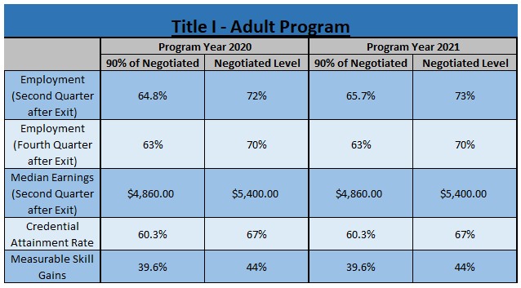

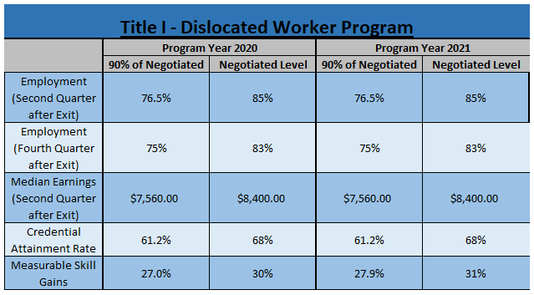

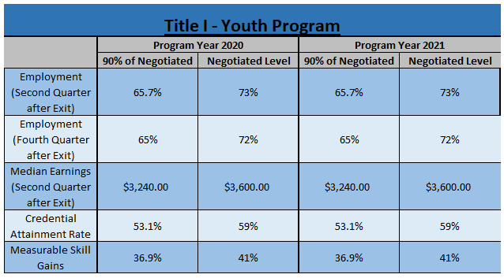

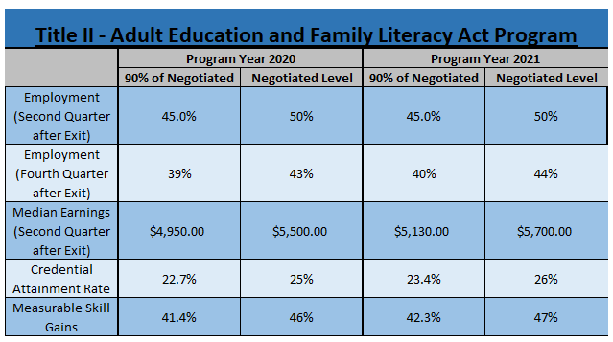

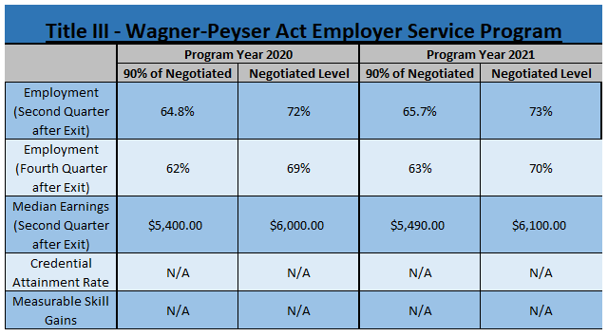

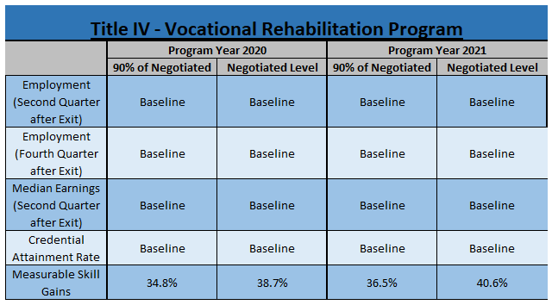

  - The LWDB’s strategic vision to align local resources, required partners, and entities that carry out core programs to achieve the strategic vision and goals.
South Central Iowa’s workforce system partners will work to advance a One Workforce vision. This One Workforce vision will include systemic collaboration, integrated service delivery, data-informed services, and improved outcomes for Business and Job Seeker Customers.

- Strategies – Taking into account the analyses described in sections 1-3 above:
  - Describe the strategy to work with the entities that carryout the core programs and required partners to align resources available in the local area to achieve the strategic vision and goals described in section 4 above.
Systemic Collaboration
While each of our One-Stop partners administer separately funded programs, we must deliver them as a set of aligned streamlined services to customers. We all serve a relatively common customer base, many of whom are low income or face barriers to employment. One-Stop Centers and partners provide job seekers, including individuals with barriers to employment with skills and credentials necessary to secure and advance in employment with family-sustaining wages. The LWDB, as strategic leaders, we will facilitate public- private partnerships; support sector strategies and career pathways that advance opportunities for all workers and job seekers; foster innovation; and ensure streamlined operations and service delivery excellence. We will work to ensure that workforce and economic development goals are aligned. The Core partners will work to develop a crosswalk of services available to individuals and specifically to individuals with barriers to employment.
Iowa has partnered with the Workforce Innovation Technical Assistance Center (WINTAC) to explore service integration and the implementation of the requirements of WIOA. Aligning and developing integrated education and training (IET) programs for low-literacy and low-skilled adults to concurrently address foundational skills with workforce training. The IET programs prepare adults with limited academic or limited English skills to enter and succeed in post-secondary education and training leading to career path employment in demand occupations. The core partners will focus on expanding access and success in sector-based education and training programs that provide opportunities for low-skilled and low-literate youth and adults. The state will support new initiatives that promote sector-based pre-IET, and IET models that expand access and success of low-skilled youth and adults in career pathways. These programs are designed to introduce individuals to career pathway programs of interest. South Central has also worked with WINTAC to develop a current model of the integration continuum assessment. This model assists us in determining where we are at in the different levels of integration.

Expand ability of all partners in the network to inform clients of workforce system services. This will be the result of extensive cross-training. Assess the ability to increase access. The core partners will work with local boards and the future one-stop operators to assess the ability to increase access to the system. For example, several adult education programs may be made available as itinerant sites to provide basic career services. This action can greatly expand the number and proximity of access points of contact for both employers and clients. Expand the use of technology. Given Iowa’s diverse regional needs, it cannot be assumed that all who need to travel to the current comprehensive sites will be able to do so. To address the barriers of distance, childcare, transportation, and schedules that many people face, services will be available digitally. These services will include up-to-date and comprehensive employment and training websites with links to partner websites. In addition, resources will be accessible using videoconferencing and live chat.

Integrated Service Delivery
All populations will receive the necessary services regardless of where they enter the system, whether it be through the AJC or connection with a partner program or agency. This approach supports an integrated workforce staff, so that any customer who walks into any AJC can be served seamlessly by any staff member.
Co-enrollment is another important strategy to provide services to a customer that a specific program might not be able to fund themselves. This is where the crosswalk of services available will be needed to address customer needs. Co-enrollment provides the ability to use multiple funding sources and share accountability for an individual.
The Clearinghouse for Work-Based Learning connects students and employers through shared projects that give students professional experience. This virtual platform is available to all Iowa schools, K-12 classrooms, and businesses for project involvement through a system where both classes and businesses can enter themselves as an interested party and browse for a good match for a project. Students work on the projects primarily in the classroom, making this distinctly different from work-study or internship formats.

Data-Informed Services
We will focus on continuous improvement. Continuous evaluations support continuous improvement of the American Job Centers by identifying which strategies work better for different populations. The Local Workforce Development Board will hold training providers accountable for the performance measures listed in 4 (ii). Reports provided from the Core Partners provide high-quality, integrated data to inform the Local Workforce Development Board for policy decision making. It also drives how we need to change, innovate, or align services to meet the needs of job seekers and business customers.

Leveraged Resources
Effectively and strategically leveraging and braiding an array of public and private financial and in-kind resources to ensure sufficient broad support to meet the service and training needs of all participants. This includes sources from businesses, industry associations, labor organizations, community-based organizations, education and training providers. No one program can address all the needs of the individuals we serve. Aligning and coordinating WIOA Title I services with efforts that currently address justice-involved and returning citizens. South Central Iowa is exploring a range of career pathway models for justice-involved participants that examines best practices and ways to braid and blend funding for maximum impact. We are currently working on a pilot project with 8th Judicial District.

Improved Outcomes for Business and Job Seeker Customers
We will go beyond the performance indicators that are negotiated, we will look at the customer experience and we will look at economic mobility of the individuals we have served. We will continuously evaluate the needs of participants and businesses to ensure we are providing services that meet the needs and removes barriers.

SECTION 3 – IowaWORKS SYSTEM COORDINATION
Questions in this section are designed to address collaboration and coordination across workforce system partners to ensure the LWDB is administering an effective and efficient local workforce system.
- The workforce development system in the local area, including the identification of:
  - The programs that are included in the system
 | SCIWA Workforce Partners
Partner |  | Program | Center Location
Indian Hills CC |  | Title I Adult | Ottumwa & Marshalltown
Indian Hills CC |  | Title I Dislocated Worker
Indian Hills CC |  | Title I Youth
Iowa DOE |  | Title II AEL – Indian Hills Community College | Ottumwa & Marshalltown
Iowa DOE |  | Title II AEL - Iowa Valley Community College
IWD |  | Title III Wager-Peyser | Ottumwa & Marshalltown
IDB |  | Title IV Rehabilitation Act 1973 | Ottumwa & Marshalltown
IVRS |  | Title IV Rehabilitation Act 1973 | Ottumwa & Marshalltown
Iowa DOE CTE |  | Career and Technical Education – Indian Hills CC | Ottumwa & Marshalltown
Iowa DOE CTE |  | Career and Technical Education - Iowa Valley CC
IWD |  | Trade Adjustment Assistance | Ottumwa & Marshalltown
AARP Foundation |  | Senior Community Services Employment Program (SCSEP) | Ottumwa & Marshalltown
National Able |  | Senior Community Services Employment Program (SCSEP) | Ottumwa & Marshalltown
Career Systems Development |  | Job Corps | Ottumwa
American Indian Council |  | Native American Programs | Marshalltown
Proteus |  | National Farmworker Jobs Program (NFJG) | Ottumwa & Marshalltown
IWD |  | Temporary Assistance for needy Families (TANF) - PROMISE Jobs | Ottumwa & Marshalltown
IWD |  | Unemployment Compensation | Ottumwa & Marshalltown
IWD |  | Jobs for Veterans State Grant (JVSG) | Ottumwa & Marshalltown
IWD |  | Reentry Employment Opportunities (REO)
IWD |  | Ticket to Work

  - Describe the steps the LWDB will take to locally implement and support the state strategies identified in the State Plan and work with the entities carrying out core programs and other workforce development programs, including programs of study authorized under the Carl D. Perkins Career and Technical Education Act of 2006, to support service alignment.
State Goal I: Iowa’s employers will have access to skilled, diverse and Future Ready workers
State Strategy 1.1: Expand and support the framework of sector partnerships that are championed by business and industry to drive career pathways.
All core programs will collaborate with local workforce development boards to provide and gather information from local employers by developing effective relationships between the local workforce system and sector partnerships as a means to engage directly with industry across traditional barriers. Championed by Workforce Development Boards, but “driven” by employers, Sector Strategies are regional in scope and industry specific. The goal of Sector Strategies goes beyond immediately placing workers in jobs; rather, the goal is to build regional talent pipelines, address skill shortages, and create meaningful “Career Pathways” for a range of workers in specific industry sectors.
Building Capacity: Providing professional development and technical assistance to state administrators and regional stakeholders on how to expand and strengthen regional collaboration, industry-training programs, and other aspects of designing and implementing sector strategies. Provide technical assistance for state policy makers and administrators: Offer learning opportunities to enhance decision makers’ understanding of both the benefits and the mechanics of implementing a sector partnership. Support efforts in making available and promoting such technical assistance services such as mini-academies and peer learning forums across states. Publish best practice guides and ‘How to’ manuals for state administrators and policy makers. Furthermore, provide direct technical assistance and consulting to regions that are ready to launch a sector strategy. Creating institutional seamlessness: Create seamless and easily accessible workforce systems that respond to the needs of industry Sector initiatives. Support seamlessness by bringing about collaboration across agencies and jurisdictional boundaries. The coordination of activities among key stakeholders and multiple-employer focus allows sector initiatives to capitalize on economies of scale by spreading the costs and risks of new program development across multiple partners. Aligning Activities: Increase collaboration between public and private institutions that oversee and conduct workforce, economic development, education and social services.
Local Strategy 1.1.1: Facilitate the training of Business Marketing Specialists or partner staff as trained Sector Partnership Facilitators.
Local Strategy 1.1.2: Development of at least one sector partnership in Advanced Manufacturing and Healthcare in the Ottumwa Office Area.

State Strategy 1.2: Grow the skilled labor force by advancing the Future Ready Iowa initiatives, resources and programming to all Iowans.
Further expand Iowa’s sector workforce and economic development priorities like Future Ready Iowa: Educate on the results produced by sector initiatives and the potential to strengthen workforce and economic development infrastructures to target and support key industries. Enhance communications strategies that convey the value and effectiveness of sector strategies. Tap into underutilized human capital: Fully utilize all potential sources of workers and identify and develop underutilized sources of workers and talent. Sector initiatives help regions identify and tap underutilized and underemployed workers, addressing the barriers faced by workers in securing employment and advancing in high-wage, high-growth industries. Sector initiatives also utilize the expertise of education and workforce partners in coordinating training and support services to guide low-wage, low-skill workers on career paths out of poverty. Building a self-directed workforce: Create a workforce with the attitudes, learning habits, and decision tools necessary for upward mobility within industries. Sector initiatives create a self-directed, demand-driven workforce system due to the high level of employer involvement. They focus on, and succeed in giving individuals the tools needed for economic mobility, and businesses the resources needed to attract and retain skilled workers. Sector initiatives measure the benefits of participation to both industries and workers including pre and post training wages, employee retention, and employer satisfaction rates. Creating Funding Strategies to Support Future Ready Iowa goals: Providing and aligning state funding to support the creation and implementation of regional sector initiatives. This may be done through grants that encourage regional collaboration or by directing workforce resources toward a specific industry.
Local Strategy 1.2.1: Develop collaboration between Title I, Title II, Title IV, Job Corps, Iowa Valley, and Indian Hills Community College to enhance enrollment and completion of credentialled participants based on in-demand occupations and participation of programs on the ETPL.
Local Strategy 1.2.2: Develop partnerships with businesses and partners to increase innovative ideas in utilization of the Employer Innovation Fund.
State Strategy 1.3: Collaborate with sector partnerships and Iowa employers to enhance work based learning opportunities for all Iowans.
Core programs will educate, promote, design and collaborate with Iowa employers to facilitate work-based learning activities.
Strengthen economic growth and industry competitiveness by creating new pathways into targeted industries, and toward good jobs and careers. This approach benefits low-income individuals and sustains and creates middle-class jobs. Utilize the intermediary networks in facilitating the many stakeholders involved to develop and implement industry-based workforce solutions. Develop the interest of philanthropic and other investors to assist in sector initiatives: Engage existing philanthropy as partners in identifying and funding potential states and sites where sector strategies can be implemented. Educate potential funders on sector strategies and opportunities to finance them. Create funding collaboratives, long-term partnerships between philanthropy and the public sector, which will seed and sustain sector initiatives. Building Sector Intelligence: Analyzing labor market changes to produce workforce trend reports and industry occupational projections, conducting workforce surveys and skill gap analyses, identifying and defining boundaries of regional labor markets, charting the skills needed for specific occupations, and creating certification programs that validate workers’ ability to perform effectively in a variety of occupations.

Local Strategy 1.3.1: Educate, promote, design, and collaborate with local area employers to facilitate work-based learning activities.
Local Strategy 1.3.2: In partnership with Sector Initiatives, develop, train, and market available human capital to meet the needs of local industries.
State Goal II: All Iowans will be provided access to a continuum of high quality education, training, and career opportunities.
State Strategy 2.1: Further develop and promote accessible career pathways to all Iowans.
Build upon prior work to expand regional partnerships that are deeply rooted in employer engagement and industry leadership, labor market alignment strategies and seamless career pathways that encompass grades 9-16, including youth and registered apprenticeship opportunities. Strategic emphasis will be placed on seeking solutions to work-based learning barriers at all levels of learning. Iowa will also continue its commitment to refining processes and protocols for validating the state’s most in-demand industry certifications and credentials, ensuring an assessment and accountability system that is fully aligned to the needs of the state’s workforce. Engage Iowa’s students in the career path development process using creative, progressive, and self-directed techniques in the delivery of career services. Access to academic counseling, expansion of guided pathways which are aligned to career pathways.
Local Strategy 2.1.1: Promote the use of the Iowa Department of Education’s Career Pathways guides.

Local Strategy 2.1.2: Utilizing the Youth Standing Committee to develop processes for core partner involvement in ICAPs for all of the Community School Districts in the area.
State Strategy 2.2: Educate the system, partners and communities about the programs, initiatives, resources and opportunities available to up-skill the workforce.
The goal of the state is to clearly communicate available pathways, resources and opportunities to students, adults, academic and work counselors, employers, community workforce partners as well as to those who might be assisting in choosing career pathways through an interactive website. These resources and pathways will also be communicated via printed brochures, flyers and social media by the system as a whole. Education faculty, staff, and administrators also help communicate information through public relations messaging, orientations, one-on-one advising, public meetings, and other methods. Develop a guide for students and parents, as well as another for high school counselors and administrators, which will include information on the various career pathways. The main message for all pathways is to make every credit count. The goal is to help parents, students, advisors and instructors understand that students should enroll in dual credit courses that have value and count towards their postsecondary plans. Standardize messaging across programs, initiatives and resources and focus communication to those Iowan’s who are in most need of enhanced skill development.
Local Strategy 2.2.1: Market our Success Stories, especially with multiple partner involvement, to highlight our services and resources.
Local Strategy 2.2.2: Develop a Career Pathway Guide based on Local Employers and local area specific Labor Market Information.
State Strategy 2.3: Connect all Iowans with long-term career opportunities from high-growth, in- demand sectors.
Iowans will be engaged in the career pathway development process by utilizing innovative approaches in the delivery of career services and offering a variety of career pathway navigation supports to enhance transition into the workforce.
Activities to support career pathways strategies will be the development of an interagency definition of “self-sustaining employment.” Workforce delivery systems will work in concert to provide workers with the skills, work-based learning opportunities, resources, accommodations and supports needed through the systematic development of career pathways for in-demand industries. All Iowans will have access to the occupational and training resources and skills needed to work to their fullest potential and to secure and maintain self-sustaining employment.
Over the next four years, we will encourage sector partnerships to focus on their role in informing career pathway development for youth, adults, and individuals facing barriers to education and employment by promoting a recently developed framework and offering tools, resources, and technical assistance.
Activities to support sector partnership strategies include working with employers to increase opportunities for all Iowans to gain the experience, skills, and credentials needed to obtain and maintain self-sustaining employment, closing skill gaps between Iowa’s workforce and employers by expanding and supporting sector strategies for in-demand industries. Identifying and quantifying employers’ education, training, and workforce needs will be a priority.
Local Strategy 2.3.1: Improve degree and credential completion and target resources to support attainment of high demand credentials, degrees, and certifications valued by employers, including for those individuals with barriers to employment.
Local Strategy 2.3.2: Increase the availability of short term stackable and portable credentials needed by local employers on the Eligible Training Provider List.
State Goal III: Iowa’s workforce delivery system will align all programs and services in an accessible, seamless and integrated manner.
State Strategy 3.1: Align workforce programs and initiatives to improve service delivery and outcomes for all Iowans.
Alignment of programs across the workforce system will greatly improve seamless delivery of services and outcomes for Iowans engaged in those activities. Core partners realize that alignment of policy, resources, programs and staffing will result in a system integrated to drive success. All core programs will work to blend and braid resources to the extent possible to maximize benefits to Iowans, reducing duplication of services and enhancing the customer experience. Core partners will assess policies, both joint and individual, that can align to performance outcomes. They will assess programs for duplication and work to align those programs across the partners for a more streamlined integrated approach. Partners will also inventory resources to look for cohesive ways in balancing those resources across the system to better impact outcomes for customers.
Local Strategy 3.1.1: Develop a service/resource crosswalk to identify duplication of resources and gaps in services.
Local Strategy 3.1.2: Develop a two promotional videos or guides of the South Central Iowa Services, one for employer’s and one for job seekers.
State Strategy 3.2: Ensure seamless access to programs and services of the workforce delivery system to all Iowans.
The quality of workforce development services is dependent upon the provision of consistent, integrated, and non-duplicative services across education, rehabilitation, economic and workforce activities.
All core partners will employ an integrated service delivery model, giving customers seamless access to all programs and services needed, while reducing duplication of effort amongst programs. All core programs will promote a concurrent and contextual approach to their service delivery activities.
Cross training will be a major focus between partners, programs, communities and employers to ensure Iowan’s have access to services no matter which door they step into.
Continued expansion of accessible technology resources, alignment of case management and program delivery systems and a seamless referral system that promotes program accountability and ultimately success for the individual.

Local Strategy 3.2.1.: Develop a service/resource crosswalk to identify duplication of resources and gaps in services. SCIWA will meet with all partners and thoroughly document services/resources provided.
Local Strategy 3.2.2: Core partners will develop a cross-training plan to include all partners, community agencies, and employers.
Local Strategy 3.2.3: Development of an interactive referral and follow-up system among all partners.
State Strategy 3.3: Continuous improvement of the system to ensure no programmatic or physical barriers exist to accessing programs and services by all Iowans.
Implement continuous professional development for staff from all programs to elevate internal expertise and professionalism and to equip them with the tools necessary to operate a comprehensive, holistic approach to talent development. Core partners will participate in and support state and local area Disability Access Committees work in improving physical, technology and program accessibility for Iowan’s.
Local Strategy 3.3.1: Continuous monitoring of the Disability Access Committees’ Physical Accessibility Report findings and corrections to ensure physical accessibility.
Local Strategy 3.3.2: Improve programmatic accessibility by improving the use of technology and assistive technologies available in each One-Stop

- Describe how the LWDB will work with the entities carrying out the core programs to:
  - Expand access to employment, training, education, and supportive services for eligible individuals, particularly individuals with barriers to employment.
Workforce Development system can be accessed through any core partner program within the Area
Multiple points of access will be established, both physical and through electronic means, throughout the Area. Area­ developed referral and verification forms will assist to document access to services. Orientation sessions that describe the workforce development system will be developed and available at any partner location within the Area. All core partners are focused on ensuring services are delivered and available to all eligible individuals, including eligible individuals with barriers to employment.
Dependent on the needs of the customer, between the Core Partners and Required partners, we have the ability to address all needs of the customer to become employable. In combination of all of our resources and knowledge, customers remain engaged and participate fully in all of the services and opportunities available through WIOA. Our integrated service delivery system provides our customers assistance with employment applications, resume assistance, assessments, skills development and employment services programs. Career Planners provide information to participants on community resources, Labor Market Information, HiSET (high school equivalency program), occupational training, on–the–job training and support services. Additionally, Career Planners share the ETPL with participants so they may make an informed decision on training providers. They also provide information on GAP/PACE, Title I programs, Future Ready Iowa Last-Dollar Scholarship, and other grants and scholarships that they may be eligible for. Career Planners identify participants’ needs, assist with unemployment insurance, employment and reemployment assistance, trade services, workshops and training. When Career Planners identify that a customer may benefit from a referral, they facilitate a “warm handoff” to our core partners.

Employment Services:
With the development of an Integrated Employer Outreach toolkit and communication from the Integrated Business Services Teams, we can increase access to employer services which in turn will increase access to employment services such as job development and recruitment and placement. We will work to improve opportunities for individuals with a disability to obtain Competitive Integrated Employment.

Training Services:
South Central Iowa will develop one-pagers and policies to increase awareness of and the use of Incumbent Worker Training and Customized Training. IVRS has prioritized business engagement to expand access to the trades industry and apprenticeships. The Iowa Workforce Center is a leader in the country with their emphasis on quality apprenticeship programs and IVRS collaborated with IWC during the past two years in training and outreach to apprenticeship programs attempting to identify opportunities to improve access for individuals with disabilities.

Education Services:
We will work with Eligible Training Providers to increase the availability and access to training and education programs that align with our in demand occupations. We will also work to increase the availability of stackable and portable credentials throughout the 14 county area. Through partnerships between the core and required partners, South Central Iowa’s career pathways support local programs that empower students and participants of all ages to explore their academic and career interests. We will leverage the work of statewide and local, public-private partnerships to better coordinate investments, resources and planning for those career pathways to expand access along with interactive delivery with the goal of providing more opportunities for targeted individuals.

Aligning and developing integrated education and training (IET) programs for low-literacy and low-skilled adults to concurrently address foundational skills with workforce training. IET programs prepare adults with limited academic or limited English skills to enter and succeed in post-secondary education and training leading to career path employment in demand occupations. The core partners will focus on expanding access and success in sector-based education and training programs that provide opportunities for low-skilled and low-literate youth and adults. The Core partners will work to develop new initiatives that promote sector-based pre-IET, and IET models that expand access and success of low-skilled youth and adults in career pathways.

Supportive Services:
Supportive services are available to all eligible individuals to assist them in removing barriers and help them participate in Career and Training Services. We will expand access by working with the Core and Required partners to facilitate the expansion of access and funding of Support Services, while avoiding duplication.

  - Facilitate the development of career pathways and co-enrollment, as appropriate, in core programs.
Core and required partners will be engaged in the career pathway development process by utilizing innovative approaches in the delivery of career services and offering a variety of career pathway navigation supports to enhance transition into the workforce.
Activities to support career pathways strategies will be the development of an interagency definition of “self-sustaining employment.” Workforce delivery systems will work in concert to provide workers with the skills, work-based learning opportunities, resources, accommodations and supports needed through the systematic development of career pathways for in-demand industries. South Central Iowans will have access to the occupational and training resources and skills needed to work to their fullest potential and to secure and maintain self-sustaining employment.
Over the next four years, we will encourage sector partnerships to focus on their role in informing career pathway development for youth, adults, and individuals facing barriers to education and employment by promoting a recently developed framework and offering tools, resources, and technical assistance.
Co­-enrollment is completed for all eligible and appropriate individuals across core programs and required partners. Co-enrollment is completed as follows:

- Title I: 100% Co-Enrollment with Trade for Dislocated Workers who are Trade Certified. Co-enroll with other programs when it is beneficial to the customer.
- Title III: Co-Enrollment with Title I (Adult/Dislocated Worker/Youth) should be completed when it is beneficial to the customer.
- Ticket to Work: 100% Co-Enrollment with Title III Wagner-Peyser. Co-Enrollment with Title I when it is beneficial to the customer.
- MSFW: 100% enrollment with Title III Wagner-Peyser when providing services in the field and/or entering an IowaWORKS Center. Co-Enrollment with Title I when it is beneficial to the customer.
- Returning Citizens: 100% enrollment with Title III Wagner-Peyser. A case manager should be assigned.
- Trade: 100% co-enrollment with Title I Dislocated Worker. 100% Co-enrollment with Title III Wagner-Peyser if individualized Unemployment Insurance or TRA benefit assistance is necessary.
- PROMISE JOBS: 100% co-enrollment with Title III Wagner-Peyser for Veterans participating in PJ (DVOP case manager must be assigned). 100% co-enrollment with Title III Wagner-Peyser when PJ participant is job ready. Co-enrollment with Title I (A/DW/Y) should be completed when it is beneficial to the customer (i.e. if supportive services are needed that cannot be provided by PJ).
- Registered Apprenticeship: 100% enrollment with Title III Wagner-Peyser. A statewide RA Career Planner must be assigned as the case manager. Co-enrollment with Title I (A/DW/Y) should be completed when it is beneficial to the customer. Co-enrollment must occur prior to a participant being hired into an RA program. Co-enrollment with Trade (TAA) should be completed when it is beneficial to the customer. Co-enrollment must occur prior to a participant being hired into an RA program.

Staff will ensure meaningful referrals are made to partners with a follow through process. This verifies that participants' needs are being met and reduces the duplication of services. Collaboration of services will occur when co-enrollment is appropriate. The use of Integrated Resource Teams is encouraged to maximize the benefits of co-enrollment without burdening the customer and to ensure all programs have met their individual program policy requirements.

  - Improve access to activities leading to a recognized postsecondary credential, including a credential that is an industry-recognized certificate or certification, portable, and stackable.
South Central Iowa Workforce Area will work closely with Eligible Training Providers to ensure that individuals are receiving quality training. The Local Workforce Development Board will review Eligible Training providers within the Area to ensure providers of high demand careers participate in the Eligible Training Provider list. Individuals should be receiving an Industry-Recognized Credential. An Industry-Recognized Credential is defined as “a documented award by a responsible and authorized body that attests that an individual has achieved specific learning outcomes or attained a defined level of knowledge or skill relative to a given standard needed for an occupation. Credential, in this context, is an umbrella term that includes degrees, diplomas, licenses, certificates, badges, and professional/industry certifications.” Sector strategies will also assist education providers and the workforce system in providing quality training services to participants. Labor Market Information is reviewed annually by the core partners to determine industry clusters in high demand.

We will promote the Future Ready Iowa Initiative which aims at getting 70% of Iowans with a recognized credential by 2025. We will create an inventory list of stackable and portable credentials needed by businesses in our area and work to get them added to the ETPL. We will work to expand our Registered Apprenticeship sponsors throughout the 14 county area. Registered Apprenticeship programs are automatically approved on the Eligible Training Provider List.

The Production Specialist Course is one program that was created due to the demand for manufacturing workers. It provides instruction on math, manufacturing processes, computer skills, measurement, problem solving, and critical thinking skills.

The above strategies will ensure that training programs meet the needs of employers and job seekers and that we are providing quality assistance to ensure creation of Future Ready Iowans. By collaborating with all of our partner agencies we can better streamline the process for the client and be effective and efficient with our resources. We will communicate to avoid duplication of effort.

Sector strategies will enable the Area to receive feedback from employers on their needs and with cross communication between partners, they will be able to develop their programs to meet those needs effectively and efficiently. Registered Apprenticeships have over 1400 occupations that are open to apprenticeship.

In the South Central Iowa Workforce Area, the one-stop centers have partnered with Iowa Valley and Indian Hills in multiple initiatives. One-stop Center Business services teams are constantly involved in groups with all Core Partners to enhance service delivery and avoid duplication. One-stop business services participate in Career Fairs at postsecondary educational institutions throughout the Area to create an awareness of services provided by the WIOA System. They are involved in serving all public and private schools in the Area to inform them about career pathways and training opportunities available. Each One-stop Center has also partnered with all schools to allow them to be a National Career Readiness Certificate proctor and have the service available at each school location. These partners, along with staff from IowaWORKS, proctor the National Career Readiness Certificate testing in the high schools.
A partnership with the GAP/PACE programs out of Iowa Valley Community College District and Indian Hills Community College have played a key role in enrolling more individuals into training services. These programs provide financial assistance for short-term training and career pathways. With shrinking funding in the WIOA Title I programs, the GAP/PACE program has picked up the shortage of training dollars and prevented an additional reduction in individuals being trained. In turn this has allowed the One-Stop center to provide other services that would otherwise not have been offered.
Partnership within the Area will be key to leading to recognized post-secondary credentials and Registered Apprenticeships.
- Describe the strategies and services that will be used in the local area to:
        - Facilitate engagement of employers in workforce development programs, including small employers and employers in in-demand industry sectors and occupations.
Through our Ottumwa and Marshalltown One-Stop Centers, one-stop partners will develop, offer, and deliver quality business services that assist businesses and industry sectors in overcoming the challenges of recruiting, retaining, and developing talent for the local area economy. We will achieve this by utilizing the following strategies:
- Ensure all staff have a clear understanding of industry skill needs
- Collaboration, coordination and communication of Business contacts and services provided/offered.
- Establishment and development of relationships with business networks both large and small.
- Development, convening, and implementation of Industry and Sector Partnerships.
- Development of a list of customized business services available beyond the required career services available to employers.
- Development of an event for Small Business Week, which is the first full week in May.
- Assistance with the development of a Talent Attraction Strategy and promotion of Iowa South.

        - Support a local workforce system that meets the needs of employers in the area.
IowaWORKS in Ottumwa and Marshalltown will continually do their utmost to meet the needs of the employers and provide exceptional customer service to business and industry. We will work hard to understand employer needs throughout the 14-county area and will provide employers with qualified job applicants and workshops and professional development that help improve incumbent worker skill sets. The AJCs will also help employers market job vacancies far and wide and will provide hands-on technical assistance with setting up Registered Apprenticeship programs. Other services offered to employers will include organizing job fairs, reverse job fairs, virtual job fairs and hiring sessions that allow employers to meet candidates for job openings.

c. Better coordinate workforce development programs and economic development.

The Integrated Business Services teams help promote Economic Development programs to current Businesses and new start-up businesses. The teams will receive cross training on Economic Development programs. The following programs will be promoted:
      - High Quality Jobs: The High Quality Jobs (HQJ) program provides qualifying businesses assistance to off-set some of the costs incurred to locate, expand or modernize an Iowa facility. This flexible program includes loans, forgivable loans, tax credits, exemptions and/or refunds. The Iowa Economic Development Authority (IEDA) offers this program to promote growth in businesses, which employ Iowans in jobs defined as high-quality by state statute.
      - Economic Development Set Aside (EDSA): The Economic Development Set Aside (EDSA) program provides financial assistance to businesses and industries requiring assistance to create or retain job opportunities in Iowa. EDSA develops viable communities that provide economic opportunities for people, especially those with low- and moderate incomes.
Priority is given to projects that create manufacturing jobs, add value to Iowa resources and/or increase exports. Preference is given to businesses that create or retain the greatest number of jobs with the least amount of program dollars. Projects must demonstrate a need for assistance. The only three valid criteria to determine need are: a financing gap, insufficient return on investment or location disadvantage.
      - Workforce Training
- Industrial New Jobs Training Program - 260E - Creating new jobs with employee training.
- Iowa Jobs Training Program - 260F - Providing job training to current employees.
- Community College Consortium - 260F - Funding assistance for training projects in which two or more businesses participate.
- Accelerated Career Education Program - 260G - Partnering with community colleges to train workforce.
- Career Link - Funding for workforce training for low-income individuals.
      - Apprenticeships & Internships
- Registered Apprenticeship Program - There are more than 1,000 occupations eligible for apprenticeship training grants.
- Student Internship Program - Grants to small and medium-sized companies in targeted industries to support internship programs.
- STEM Internship Program - Grants to Iowa companies for internship programs in STEM fields.
      - Targeted Small Business Program
Program is designed to help small businesses owned by women, individuals with minority status, service-connected disabled veterans and/or individuals with disabilities.

  - Strengthen linkages between the one-stop delivery system and unemployment insurance programs.
Unemployment Insurance services are incorporated in the Ottumwa and Marshalltown One-Stop Centers. Iowa’s Unemployment Insurance Division regularly provides UI training at basic and advanced levels. The training is conducted in person with occasional virtual sessions. Team members from the Ottumwa and Marshalltown AJC attend these classes as determined necessary and in-service training is provided to IowaWORKS Center staff when needed. Additionally, online policy and procedure documents are available for any team member or partner staff to access if needed. The library of documents is in a keyword searchable format. This process has been very beneficial to ensure the most recent version of a procedure is available when handling UI issues. Each of the IowaWORKS Centers have staff trained in recognizing and referring UI eligibility issues for adjudication. Local staff are encouraged to proactively identify and provide assistance to identified individuals on a case by case basis. If a local office team member has a question about a claimants’ situation, IWD has a direct messaging system the team member can contact a UI expert in the main IWD office in Des Moines for assistance. In addition, Iowa participates in the RESEA program which provides additional opportunities for addressing UI concerns while connecting customers with employment services.

Integrated Service Delivery
South Central Iowa will provide reemployment services to UI claimants and other unemployed individuals using an integrated service delivery.

Integrated data systems -
RESEA, Rapid Response, TAA and WIOA Title I Dislocated Workers program use a common data system. This data system displays services, case notes, workshop attendance and the overall progression of the UI claimant/unemployed individual.

Streamlining case management and assessments -
Each program is able to see case notes and services provided to the UI claimant/unemployed individual. eliminates duplication of services and assessments.

Job Search and Training Services -
The One-Stop provides a variety of job search activities including but not limited to job search workshops (resume building, interviewing, career planning, mock interviews, application assistance and a variety of other workshops), hosting job fairs, employer meet and greets and assistance in filling out online/paper employment applications. The One-Stop has a direct referral process to training programs to provide short term training for high demand occupations through a variety of partner programs including but not limited to Adult Basic Education, Vocational Rehabilitation and WIOA Title I. These services are available to all UI claimants/unemployed individuals.

Helping UI claimants access the full range of on-line and in person services delivered through the American Job Centers - All UI claimants that come in person to the American Job Center are provided information on the range of services offered by the One-Stop.

Ensuring Claimants Meet Eligibility Requirements-
All customers that are selected to participate in an initial or sub RESEA program will complete a UI Eligibility Review to ensure the claimant is conducting appropriate work search contacts and is registered for work in the database system. The RESEA program staff have been fully trained in UI and are able to issue immediate decisions if an eligibility issue arises. There is an immediate feedback loop between UI program staff and the American Job Center for potential eligibility issues. The issue is reported via technology and then the UI program can establish a fact finding if necessary.
Ensuring all Claimants are notified of all deadlines and eligibility requirements associated with the TAA program/seamless communication with case managers

Working with rapid response teams
Providing effective services for Veterans that file for UCX - Veterans that file for UCX will be profiled for the RESEA program to ensure services are offered early in the Veteran UI claim and are connected to the menu of services in the American Job Center. If these Veterans are identified as having a significant barrier, a referral to a local DVOP will be made to provide additional services.

The Reemployment Services and Eligibility Assessments (RESEA) program is a program to assist individuals receiving Unemployment Insurance (UI) benefits. The program connects participants with in-person assessments and reemployment services through local American Job Centers (AJC). Activities include, but are not limited to, developing an individual re-employment plan, providing labor market information, identifying job skills and prospects, and reviewing claimant’s continued UI benefit eligibility.

  - Implement initiatives such as incumbent worker training programs, on-the-job training programs, customized training programs, other work-based learning opportunities, registered apprenticeships, industry and sector strategies, career pathway initiatives, utilization of effective business intermediaries, and other business services and strategies designed to meet the needs of local employers. These initiatives must support the strategies described in a.-c. above.
IowaWORKS will also work with partners to support the development of industry based, employer-driven sector initiatives. Sector partnerships are industries with shared needs, as well as various education, workforce, economic, and community organizations in supportive roles. These partnerships develop and continuously evaluate goals, policies, and service-delivery strategies to meet the needs of employers in a given sector. In doing so, they operate within labor market regions and are not confined to municipal, county, educational, or state boundaries. Effective sector partnerships are industry-driven, meaning industries identify needs and assume the lead role in developing strategies which address their identified needs.
Career pathways are one strategy utilized by sector partnerships to address industry-identified labor market needs. Career pathways organize education and training into a coherent, stackable sequence aligned within specific occupations within a given industry. In that way, career pathways support an individual in developing the personal, technical, and employability skills required for advancement within an industry and transitioning from training and education into the workforce. Colleges, primary and secondary schools, economic development agencies, workforce service providers, employers, labor groups, and social service providers all play a vital role in the successful development of career pathways. As a partner to employers involved in Sector partnerships, we can assist with strategies for some of their workforce issues, including Incumbent Worker Training and Customized Training.
Some individuals with multiple barriers to employment may need to begin with a less intensive activity such as transitional jobs, where they learn or become accustomed to the basic expectations of a workplace. Whereas, other individuals may present as job ready and can be placed in a more intensive OJT arrangement. Conversely, it is important to place individuals with the right fit, and ensure business partners are aware of their obligations as well. Business service teams are integral in engaging participating businesses and ensuring they are educated about the benefits and responsibilities of a business partner. Like job seekers, businesses must be screened to identify what type of placement they are equipped to manage, and the business service teams serve an important role in ensuring a suitable placement exists for both customers.
OJT is beneficial to participants who are prepared to enter the workforce long-term. OJTs are used to teach a participant specialized skills and competencies needed to perform a specific job at a worksite where there may be a chance for advancement. The participating business has a major investment in the OJT process as they assist to complete a training plan, and are the employer of record. Incumbent worker training is designed to assist employers in upgrading the skills of their current workforce. These efforts have shown to increase the competitiveness of employers in their designated markets while creating an internal workforce whose skills are assisting the employer to remain competitive with a skilled workforce and increased worker tenure. Employees benefit by receiving training to upgrade their skills, wages, and increased experiences within an organization.
Incumbent worker training is designed to assist employers in upgrading the skills of their current workforce. These efforts have shown to increase the competitiveness of employers in their designated markets while creating an internal workforce whose skills are assisting the employer to remain competitive with a skilled workforce and increased worker tenure. Employees benefit by receiving training to upgrade their skills, wages, and increased experiences within an organization.
Transitional jobs are a time-limited work experience that is combined with comprehensive employment and supportive services. This work-based learning activity is for individuals with barriers to employment, are chronically unemployed, or have an inconsistent work history. The purpose is to support individuals to establish a work history, demonstrate success in a work environment and develop skills to obtain and retain unsubsidized employment.
Customized training provides training that is specific to an employer (or group of employers) specific requirements so that individuals will be hired by the employer after successful completion of the training. Customized training is designed to provide local areas with flexibility to ensure that training meets the unique needs of the job seekers and employers or groups of employers. These types of activities are very effective training models for both youth and adult populations. Gaining hands-on training in a work environment allows individuals to gain not only the transferable skills needed in employment, but the soft skills employers require.
Registered Apprenticeship provides an earn and learn opportunity for both job seekers and employers. It brings together On-the-job training with Related Training Instruction to receive a Nationally recognized credential. IowaWORKS works with employers to become registered sponsors with the Department of Labor Office of Apprenticeship. They also work with job seekers to match them to Registered Apprenticeship opportunities.
The South Central Iowa Workforce Area will utilize the Training Contract Policy in regards to these services.
- Describe how the LWDB will coordinate local workforce investment activities with economic development activities that are carried out in the local area and how the LWDB will promote entrepreneurial skills training and microenterprise services.
In partnership with the Continuing Education and Workforce Solutions (CEWS) Division at Indian Hills Community College and the Iowa Valley Continuing Education Division, whose mission is to improve the economic conditions of the South Central Iowa Area through continuous learning, innovation, creativity, entrepreneurship, collaboration, and visionary leadership. CEWS and Iowa Valley meet regularly with Economic Developers to identify and address needs of employers. Economic Developers will also be an integral part of Sector Strategies within the Area. Also under the respective Continuing Education Divisions is the New Jobs Training Program (260E) and the Iowa Job Training Program (260F) which assists businesses in remaining economically competitive. These funds are administered through Iowa Economic Development Authority (IEDA) Our Business Services team partners with Economic Developers to address employer needs in their area. IowaWORKS also provides assistance to employers thru the Iowa Apprenticeship Training Program (15B) which provides training grants to businesses for eligible apprenticeship programs. Each of these programs increases economic development within our fourteen county area.
Poweshiek county economic development is leading its own sector partnership, which core partners participate in. Economic development is partnered with, in the Area, during times of layoffs and is also partnered with in hosting events such as career fairs or employee trainings.
Indian Hills Community College has a Regional Entrepreneurial Center next door to the One-­Stop to provide training and incubation to new businesses. The small business development center provides ongoing entrepreneurial training and assistance throughout the area.

Additionally, Iowa Department for the Blind has an Iowa Self­-Employment Program. A program for self-employment has been developed under an agreement between Iowa Vocational Rehabilitation Services (IVRS) and Iowa Department for the Blind (IDB). It is available to active candidates of IVRS or IDB who are able to become self-sufficient establishing, expanding or acquiring a small business. Self-Employment is a vocational option that must be agreed upon by the individual and IVRS/IDB, and is available only to for-profit businesses intended for operation within the State of Iowa. The intent of self-employment services is to support an employment outcome that will significantly contribute to a candidate's financial self-sufficiency. The program is one that is designed to encourage and assist individuals to become entrepreneurs where the team works to enhance the entrepreneurial skills and knowledge of the candidate. The small business development center provides ongoing entrepreneurial training and assistance throughout the Area. IowaWORKS promotes and explores opportunities for center customers to establish self­-employment and refers individuals to the Small Business Development Center.

The Department for the Blind and Vocational Rehabilitation can also assist in funding for start up costs.

- Describe the one-stop delivery system in the local area, including:
  - How the LWDB will ensure the continuous improvement of eligible providers through the system and that such providers will meet the employment needs of local employers, workers, and job seekers.
The South Central Iowa Workforce Area LWDB will conduct ongoing analysis of the Area's economy and workforce needs to ensure continuous improvement of eligible providers of services and to ensure that such providers meet the employment needs of local employers, workers and job seekers.
This analysis will be completed as part of the LWDB's regularly scheduled meetings with needs assessments being completed as necessary. Local labor market information will be utilized with this review.
Elements potentially included in the analysis:
* A review of the local area data gathered from customers of the One-­Stop
* An assessment of the current economic situation and projected trends of the local area economy, industries and occupations, including major economic Areas and industrial and occupational sectors as determined through LMI data;
* An assessment of the required workforce skills and knowledge individuals need in order to find employment.
* An analysis of the skill and education gaps for individuals within the local area.
All partners will participate in a process of continuous improvement to offer the best possible services and seize opportunities for further integration. To assure that services are responsive to the needs of the community, partners will survey customers to obtain feedback on customer satisfaction. All partners will participate in the ongoing development and improvement of the South Central Iowa Workforce Area one-­stop center procedures, policies and operational management. All partners will be part of a joint planning process that will continuously review the needs of the South Central Iowa Workforce Area workforce and business community and refine the services of the one-­stop system based upon those needs.
In addition, the partners will encourage, accommodate staff, and/or provide training and cross training, as deemed appropriate, to ensure that all partner staff are familiar with all programs represented within the South Central Iowa Workforce Area One-­Stop System in order to integrate services, reduce duplication, and improve overall service delivery.

  - How the LWDB will facilitate access to the services provided through the one-stop delivery system, including in remote areas, through the use of technology and other means.
* The Disability Access Committees will help to ensure each one-stop has physical and programmatic accessibility.
* Multiple points of access are available through partner sites within the Area
* IowaWORKS staff provides outreach and enrollment in all outlying counties within the area on an itinerant basis
* Partners provide services through the One-­Stop physical center on an as needed basis
* Partners provide one­-stop system services ongoing through various partner locations
* Partners participate in ongoing referral, co­-enrollment and performance management
* Utilizing Zoom, Teams, Facetime electronic video conferencing for appointments, orientations, and workshops.
* Basic Career Services can be accessed online utilizing the iowaworks.gov website or mobile app.
* ELL Instruction is provided remotely using Burlington English and ESL Library.
* HSED Instruction is provided remotely using HiSET Academy by Essential Education or Essential Education and Learning Upgrade.

Social Media
IowaWORKS One-Stop Centers will utilize social media to engage with job seekers in the local area in accordance with State Communications policy to highlight services that are being provided by the IowaWORKS One-Stop Centers, including but not limited to workshops, hiring events, career fairs, job postings, and programs available. Teams will also share relevant posts from media sources or community partners when it is informative to job seekers of the local area.

  - How entities within the one-stop delivery system, including one-stop operators and the one-stop partners, will comply with section 188 of WIOA, if applicable, and applicable provisions of the Americans with Disabilities Act of 1990 regarding the physical and programmatic accessibility of facilities, including providing staff training and support for addressing the needs of individuals with disabilities.
    - Include how the LWDB will utilize Disability Access Committees (DACs) as a strategy.
Each local office has a disability access committee (DAC) with a chair and co-chair from IVRS/IDB. The DACs are composed of various core partner and outside partner members who work together under the direction of the Statewide DAC. They have conducted physical accessibility and ADA accessibility surveys and continue to work on program accessibility. Both groups have conducted disability focus groups to gather information about the various needs of customers with disabilities in accessing Center programs. In addition to this, the groups have completed local assessments of the assistive technology options that would be available to the community, the level of comfort of Center staff in offering those accommodations, and as well, the appropriate process for working with requests for accommodations from customers. The DACs also drive the Integration Continuum process.

The South Central Iowa Workforce Development Board is committed to providing programs and services in a readily-accessible format and delivery method to any individual who is seeking services from the workforce system. Accessibility as referenced throughout this plan refers to the direct and indirect ideas, actions, philosophies and physical and emotional supports used by an individual or employer to support employment for all Iowans. Core partners have legal obligations under federal and state anti-discrimination laws when providing workforce services. Federal and state antidiscrimination laws prohibit discrimination in the provision of services on the basis of an individual’s race, color, creed, sex, sexual orientation, gender identity, national origin, religion, age, or disability. Meeting the partners’ legal obligations under federal and state anti-discrimination laws must be a focus when they develop and implement policies, procedures, guidance, and proven and promising practices with respect to increasing and maximizing access to workforce services, and when assessing the physical and programmatic access of one-stop system partners, physical office spaces, websites, etc.

Individuals with disabilities constitute a population that has traditionally been underserved or unserved by the workforce development system. Partners recognize that state and federal anti-discrimination laws impose legal obligations with respect to workforce services delivery to individuals with disabilities. Further, WIOA singles out individuals with disabilities as a group with a barrier to employment that the partners must target for increased and maximized access to workforce services. As such, the partners will develop policies, procedures, guidance, and proven and promising practices to create maximized physical and programmatic access and opportunity for individuals with disabilities. Implementation of policies, procedures, guidance, and proven and promising practices to increase and maximize physical and programmatic access for individuals with disabilities must be an element of One-Stop Certification that is strictly applied. SCIA Workforce Board has worked very closely with and has relied upon the expertise provided by the Iowa Vocational Rehabilitation Services (IVRS) and the Iowa Department for the Blind (IDB). As core partners, IVRS and IDB provide ongoing technical assistance and support regarding development of policies, procedures, and system design and evaluation protocols to ensure that all Iowans have full and welcoming access. The Iowa Department for the Blind will also be utilized to consider all forms of accessibility impacting the field of vision. Their Assistive Technology services will ensure accommodations are in place to support access for needed services and supports for all Iowans.

    - Describe the process that an individual would use to request an accommodation as well as how an individual will know what accommodations/assistive technology equipment are available.

The Disability Access Committee will address program accessibility through identifying existing assistive technology resources at the One-Stop Centers and how it relates to reasonable accommodations for job seekers who need assistance. Auxiliary aids and services are available upon request for individuals with disabilities.

The individual or his/her representative must let the associated agency know that s/he needs an accommodation. Requests for reasonable accommodation do not have to be in writing and can be requested in a face-to-face conversation or using any other method of communication.
A list of accommodations/Assistive Technology equipment will be posted at the main entrance of each One-Stop Center.

    - Describe how partners/operator will ensure individuals with disabilities can participate in workshops and services offered throughout the center.
All buildings follow the ADA requirements. The One-Stop Center is evaluated for physical accessibility using the following criteria:
- Approach and Entrance: Parking, passenger, loading zones, public sidewalks, and public transportation stops.
- Access to Goods and Services: The layout of the building should allow people with
disabilities to obtain goods and services and to participate in activities without assistance.
- Toilet Rooms:
- Additional Access: Amenities such as drinking fountains and public telephones should be accessible to people with disabilities.
The checklist can be accessed here: ADA Checklist for Existing Facilities

  - The roles and resource contributions of the one-stop partners, pending completion of the Memorandum of Understanding and Infrastructure Funding Agreement.
The management of the one-stop system is the shared responsibility of the LWDB, CLEO, WIOA core program Partners, required one-stop Partners, one-stop operators, service providers, and any non-mandatory Partners added to the local system by the LWDB and CLEO. In other words, the system is a total collaborative for the planning, operations, and management of local workforce services.
All Partners should be aware of their responsibility under the law. All Partners must:
- Provide access to their programs through the IowaWORKS system.
- Use their program’s funds to:
  - Provide career services.
  - Maintain the one-stop system and jointly fund it.
- Sign the Memorandum of Understanding (MOU) with the LWDB.
- Participate in the operation of the system.
- Provide representation on the LWDB, as required, and participate on committees of the LWDB, as needed.
Required Partner Services
The Parties to the Memorandum of Understanding will collaborate to ensure all required and needed services are available to Iowans and Iowa businesses and will work to ensure each IowaWORKS location offers integrated services and have staff who work to ensure quality service delivery.
Acceptable methods and options for providing access to each of the required services:
- Having a program staff member physically present at the American Job Center.
- Having a staff member from a different partner program physically present at the American Job Center and appropriately trained to provide information to customers about the programs, services, and activities available through all partner programs.
- Making available a direct linkage through technology to a program staff member who can provide meaningful information or services.
Services delivered within the system are outlined in the Partners Services section in the Memorandum of Understanding, Attachment D: Matrix of MOU Partners Shared Service and Delivery Methods. The current MOU is hosted on the LWDB’s website here: South Central Iowa Workforce Area Memorandum of Understanding
- A description and assessment of the type and availability of adult and dislocated worker employment and training activities in the local area.
Title I Adult and Dislocated Worker:
Basic Career Services are offered in the fourteen counties (Appanoose, Davis, Hardin, Jefferson, Keokuk, Lucas, Mahaska, Marshall, Monroe, Poweshiek, Tama, Van Buren, Wapello, and Wayne) and include:
1. Determinations of whether the individual is eligible to receive assistance from the adult, dislocated worker, or youth programs;
2. Outreach, intake (including identification through the state’s Worker Profiling and Reemployment Services system of unemployment insurance (UI) claimants likely to exhaust benefits), and orientation to information and other services available through the one-stop delivery system;
3. Initial assessment of skill levels including literacy, numeracy, and English language proficiency, as well as aptitudes, abilities (including skills gaps), and supportive service needs;
4. Labor exchange services, including— Job search and placement assistance, and, when needed by an individual, career counseling, including—
a. Provision of information on in-demand industry sectors and occupations (as defined in sec. 3(23) of WIOA); and,
b. Provision of information on nontraditional employment (as defined in sec. 3(37) of WIOA);
5. Provision of referrals to and coordination of activities with other programs and services, including those within the one-stop delivery system and, when appropriate, other workforce development programs;
6. Provision of workforce and labor market employment statistics information, including the provision of accurate information relating to local, local area, and national labor market areas, including— Job vacancy listings in labor market areas; Information on job skills necessary to obtain the vacant jobs listed; and Information relating to local occupations in demand and the earnings, skill requirements, and opportunities for advancement for those jobs;
7. Provision of performance information and program cost information on eligible providers of training services by program and type of providers;
8. Provision of information about how the local area is performing on local performance accountability measures, as well as any additional performance information relating to the area’s one-stop delivery system;
9. Provision of information relating to the availability of supportive services or assistance, and appropriate referrals to those services and assistance, including: child care; child support; medical or child health assistance available through the State’s Medicaid program and Children’s Health Insurance Program; benefits under the Supplemental Nutrition Assistance Program (SNAP); assistance through the earned income tax credit; housing counseling and assistance services sponsored through the U.S. Department of Housing and Urban Development (HUD) ; and assistance under a State program for Temporary Assistance for Needy Families (TANF), and other supportive services and transportation provided through that program;
10. Assistance in establishing eligibility for programs of financial aid assistance for training and education programs not provided under WIOA; and
11. Provision of information and assistance regarding filing claims under UI programs, including meaningful assistance to individuals seeking assistance in filing a claim—
a. Meaningful assistance means providing assistance:
i. On-site using staff who are properly trained in UI claims, filing, and/or the acceptance of information necessary to file a claim , or By phone or via other technology, as long as the assistance is provided by trained and available staff and within a reasonable time.
12. Provide these services also on the Exploratory Floor.
Provide the following Individualized Career Services
1. Comprehensive and specialized assessments of the skill levels and service needs of adults and dislocated workers, which may include—
a. Diagnostic testing and use of other assessment tools; and
b. In-depth interviewing and evaluation to identify employment barriers and appropriate employment goals;
2. Development of an individual employment plan, to identify the employment goals, appropriate achievement objectives, and appropriate combination of services for the participant to achieve his or her employment goals, including the list of, and information about, eligible training providers;
3. Group and/or individual counseling and mentoring;
4. Short-term pre-vocational services, including development of learning skills, communication skills, interviewing skills, punctuality, personal maintenance skills, and professional conduct to prepare individuals for unsubsidized employment or training, in some instances pre-apprenticeship programs may be considered as short-term prevocational services;
5. Internships and work experiences that are linked to careers;
6. Workforce preparation activities that help an individual acquire a combination of basic academic skills, critical thinking skills, digital literacy skills, and self-management skills, including competencies in utilizing resources, using information, working with others, understanding systems, and obtaining skills necessary for successful transition into and completion of postsecondary education, or training, or employment;
7. Financial literacy services;
8. Out-of-area job search assistance and relocation assistance; and
9. English language acquisition and integrated education and training programs.
10. Provide opportunities for Work Based Learning that lead to careers.
11. Provide the 14 Required Youth Services.
12. Conduct Integrated Resource Team meetings with participants and partners when meeting with dual-enrolled clients to coordinate services.
Provide the following Training Services:
(a) Occupational skills training, including training for nontraditional employment;
(b) On-the-job training (OJT);
(c) Incumbent worker training;
(d) Programs that combine workplace training with related instruction, which may include cooperative education programs;
(e) Training programs operated by the private sector;
(f) Skills upgrading and retraining;
(g) Entrepreneurial training;
(h) Transitional jobs;
(i) Job readiness training provided in combination with services listed in paragraphs (a) through (h) of this section;
(j) Adult education and literacy activities, including activities of English language acquisition and integrated education and training programs, provided concurrently or in combination with training services listed in paragraphs (a) through (g) of this section; and
(k) Customized training conducted with a commitment by an employer or group of employers to employ an individual upon successful completion of the training .
Provide Follow-up Services
1. Follow-up services must be provided as appropriate for participants who are placed in unsubsidized employment, for up to 12 months after the first day of employment. Counseling about the workplace is an appropriate type of follow-up service.

- How the LWDB will coordinate workforce investment activities in the local area with statewide rapid response activities.
The following individual will be the primary contact who will work with the State Dislocated Worker Unit and the State Trade Adjustment Act Unit to provide Layoff Aversion and Rapid Response services in the South Central Iowa Workforce Area.

Krista Tedrow
South Central Iowa Workforce Development Board
Executive Director
641-814-3563
sciaworkforceboard@gmail.com
Rapid Response is a proactive, business­-focused, and flexible strategy designed for two major purposes: to help growing companies access an available pool of skilled workers from other companies that are downsizing or who have been trained in the skills Iowa companies need to be competitive, and to respond to layoffs and plant closings by quickly coordinating services and providing immediate aid to companies and the affected workers.

Rapid Response provides early intervention to worker groups who have received a notice of layoff or closure. South Central Iowa Workforce Area has a Rapid Response Team consisting of staff from various partners within the Area. Whenever possible, the team conducts on­site presentations at the business location. Every effort is made to provide information sessions prior to the commencement of the lay­offs and/or plant closure. The presentation consists of an overview of the benefits and services that can be expected from each of the partner groups. During these sessions, the emphasis is how the partner agency staff will be working together as a team to offer the customer individualized comprehensive re­employment benefits and services. Afterwards, customers begin to engage in further orientation and intake sessions.

The Dislocated Worker program provides retraining and re­employment services to individuals who have been dislocated from their jobs. Job seekers have access to computerized resources centers for career exploration, resume preparation, skill assessment and testing, job search, on­line work registration and on­line unemployment insurance claim filing. Job seekers also have access to a variety of skill building workshops, job search assistance and individualized career services.

Trade Adjustment Assistance (TAA) provides early intervention to worker groups on whose behalf a Trade Adjustment Act petition has been filed: South Central Iowa Workforce Area has a Rapid Response Team consisting of staff from Title I, Wagner-­Peyser, and Trade Adjustment Assistance (once the petition has been certified). Whenever possible, the team conducts on­site presentations at the business location. Every effort is made to provide information sessions prior to the commencement of the lay­offs and/or plant closure. The presentation consists of an overview of the benefits and services that can be expected from each of the partner groups. During these sessions, the emphasis is how the partner agency staff will be working together as a team to offer the customer individualized comprehensive re­employment benefits and services.

Furthermore, as appropriate at such sessions or after layoffs occur, the joint Trade Adjustment Act/Workforce Innovation and Opportunity Act applications are completed. Afterwards, customers begin to engage in further orientation and intake sessions.

- The type and availability of youth workforce investment activities in the local area, including activities for youth who are individuals with disabilities, which must include an identification of successful models of such activities.
Youth Services: WIOA Title I Youth program is focused on ensuring services are delivered and available to all eligible youth, including those with barriers to education and employment. Title I Career Planners persistently provide guidance and counseling to assist youth with the next steps toward successful, self­ sustaining employment. The program design focuses on utilizing the 14 Youth Required Elements to help participants meet their educational and employment goals. These elements are:
1. Adult Mentoring for Youth: Career Planners act as adult mentors for every youth participant they serve. For youth in need of more intensive Adult Mentoring Services, those services are contracted out to agencies able to provide background checks. Mentoring is a formal relationship between a youth participant and an adult mentor that includes structured activities where the mentor offers guidance, support, and encouragement to develop the competence and character of the mentee.
2. Alternative Secondary School Offerings: Career Planners provide participants with information on alternative solutions to complete a secondary school diploma. These solutions include alternative schools, career academies, and High School Equivalency Diploma (HSED) programs.
3. Comprehensive Guidance and Counseling: Career Planners provides participants with connections to a wide array of counseling services provided by health agencies. Participants struggling with drug and alcohol abuse are referred to agencies that provide treatment, counseling, and support to help them resolve these issues. Career Planners also provide participants with mental and behavioral issues with referrals to area counseling programs offered and personally assist them with enrolling in the respective agency’s services.
4. Follow­-up Services: Career Planners provide follow-­up services to youth participants for no less than 12 months after program exit.
5. Leadership Development Opportunities: Career Planners provide community service and peer centered activities that encourage responsibility, employability, and other positive social and civic behaviors to participants and other in­-school youth.
6. Occupational Skills Training: Participants may be eligible to take part in training that teaches them the technical skills and information needed for a specific occupation. Training is related to the participant’s career pathway goal and often leads to postsecondary or industry recognized credential.
7. Paid and Unpaid Work Experience: Career Planners coordinate with area employers and community agencies to provide short term work experiences to participants. These experiences may include job shadowing, quality pre­-apprenticeship programs, internships, work experiences, and On­-the­-Job Training.
8. Summer Employment Opportunities: Summer employment opportunities are offered in the same manner as the paid and unpaid work experiences above.
9. Supportive Services: Career Planners work with youth to eliminate barriers to participating in WIOA activities such as issues with transportation, child care, counseling, financial need, lack of proper clothing, and healthcare.
10. Tutoring and Study Skills Training: Career Planners refer participants to partner agencies and programs to receive tutoring services that will assist them with completing secondary or postsecondary credentials.
11. Financial Literacy Education: Career Planners provide financial literacy education to youth participants via classroom instruction and referrals to partner agencies and online financial literacy resources.
12. Entrepreneurial Skills Training: Participants are exposed to entrepreneurial skills training at the IHCC Regional Entrepreneurial Center (REC), which is located next door to the IowaWORKS One­-Stop Center in Ottumwa on the IHCC North Campus.
13. Services that Provide Labor Market Information (LMI): As youth participants develop their career pathway goals during the ISS development process, Career Planners provide them LMI that shows them what jobs are in­-demand locally, are anticipated to have a growth in available positions, and offer self-­sufficiency wages.

14. Activities that Prepare Youth for Transition to College/Training: In an effort to help prepare participants for the transition to postsecondary education or training, Career Planners take participants on in-­depth college campus visits to IHCC and other colleges in the Area and surrounding area.

  - Include how the LWDB will utilize the Youth Standing Committee as a strategy.
The South Central Iowa Workforce Area Youth Standing Committee performs the following duties and other functions as necessary and proper to carry out its responsibilities.
1) Providing information to the LWDB on the provision of services to youth;
2) To assist with planning, operational, and other issues relating to the provision of services to youth;
3) Coordinating programs, services, and activities that address the employment, training, or education needs of eligible youth, including out-of-school youth, in SCIWA; and
4) Coordinating with the State Workforce Development Board Youth Standing Committee on statewide initiatives
The South Central Iowa Workforce Area Youth Standing Committee will meet at a minimum on a quarterly basis.
- How the LWDB will coordinate relevant secondary and postsecondary education programs and activities with education and workforce investment activities to coordinate strategies, enhance services, and avoid duplication of services.
Core partners have had years of established working relationships, working collaboratively together. Regular meetings are scheduled monthly, with participation from community college and representation of core partners, to develop ways the partners can coordinate services and avoid duplication. Participants are screened and co-enrolled when necessary. One-Stop staff present work readiness and career choices information in workshop settings in schools, at the community college, within the Adult Literacy program sites and within the community. Workforce System Partner Meetings (i.e. Lunch and Learns) have been established to ensure that all partners receive information on services being rendered within the local area. This will allow for duplication of services to be reduced. Collaboration between the Indian Hills and Iowa Valley Intermediary Network program and the WIOA program, both which serve youth in the local area, in order to enhance services, increase number served and avoid duplication of services. The Adult Literacy program is offered by the local Community Colleges in the South Central Iowa Workforce Area. An additional ABE access points in Iowa Falls, Grinnell, Tama, Fairfield, Centerville, and Oskaloosa allows services for co-enrolled participants to not have to travel to other sites, increases access, and provides recruitment opportunities for career pathway programs. The local area ABE programs have an advisory board made up of community, professional, postsecondary, and K-12 representatives. IVRS has a counselor assigned to every high school and college in the local area providing services to students with disabilities. IVRS works with disability service units on each college campus to make sure students are receiving the accommodations needed to progress in his or her program. The event strategized on the coming together of secondary/post-secondary and employment. These initiatives will be reviewed as the progress and implemented into strategies within the region.
Based on the Comprehensive Local Needs Assessment completed by Region 6 Regional Planning Partnership and Region 15 Regional Planning Partnership in 2021, the following needs were identified:

Region 6 Regional Planning Partnership
- Increase work-based learning experiences.
- Develop or expand middle school/early high school career exploration to help students begin to identify a program of study/pathway for concentration.
- Provide professional development on Labor Market data, performance indicators, special populations, and improved student learning.

Region 15 Regional Planning Partnership
- Recruit, improve, or increase student and employer participation in full continuum of work-based learning (career exploration to work-based learning)
- Curriculum and equipment in CTE programming that emphasizes alignment to industry skills, commercial grade tools, and use of software.
- Career exploration: All students, not later than seventh grade, have exposure to the world of work and districts crafted their own Pre-K through work plan.

The LWDB will encourage, promote, and increase the use of work-based learning opportunities provided by WIOA throughout the South Central Area. Members of the LWDB and Core Partners will volunteer to participate in the Regional Planning Partnerships representing the following areas: Regional Economic and Workforce Development, Business and Industry, or Representatives of Special Populations. The next assessment will occur in 2023.

  - Include the name of the Title II adult education provider grantee(s) in the local area that were included in this coordination.
Indian Hills Community College, Ashleigh Richmond
Iowa Valley Community College District, Patty Mendoza
- How the LWDB will coordinate WIOA Title I workforce investment activities with the provision of transportation and other appropriate supportive services in the local area.
Title I program serves job seekers who face a wide variety of challenges and barriers as they work to meet their career goals. To engage these individuals, Title I career planner and business liaisons will develop meaningful relationships with their clients. Through assessments, interviews, IEP development and the provision of case management services, Title I staff will get to know the individuals they serve and understand what obstacles they may face in progressing down their chosen career pathway. Ongoing, regular contact between Title I staff and participants will help assure that barriers, both old and new, are tackled with additional resources and support.

Title I staff will work closely with partners and other agencies and programs to link participants to supportive services that help them overcome barriers to employment. Once a participant’s barriers have been identified, Title I staff will complete a Financial Needs Determination to determine what the participant's unmet need is. If the needs outweigh the support Title I can provide, Title I staff will look for other possible funding avenues. Supportive service providers we have worked with in the past for the Title I program include: Pathways for Academic Career and Employment (PACE) and the GAP Tuition Assistance Program, IVRS, PROMISE JOBS, County General Relief assistance, Veterans’ Administration, Jobs Corps Scholars and other community resources. The local area has developed a community resource guide for the fourteen-county area that identifies possible resources available in the community.

Expenses that may be covered through Title I supportive service payments include: clothing, counseling, dependent care, emergency financial assistance (auto repair, housing assistance, etc.), healthcare when it affects employment and transportation, among others. The need for supportive service payments, as well as the amount, will be determined for each client during the Objective Assessment process, utilizing the financial needs determination form, and will be documented in the client’s IEP. Payments will only be made while the participant is enrolled in and receiving WIOA individualized career, training or follow-up services, and back-up documentation from the participant will be required.

South Central Iowa Workforce Area Support Service Policy
- Plans, assurances, and strategies for maximizing coordination, improving service delivery, and avoiding duplication of Wagner-Peyser Act services and other services provided through the one-stop delivery system.
The One-Stop focuses on providing a variety of employment related labor exchange services including but not limited to job search assistance, job referral, and placement assistance for job seekers, re-employment services to unemployment insurance claimants, job seeker assessment of skill levels, abilities and aptitudes, career guidance when appropriate, job search workshops, referrals to training and recruitment services to employers with job openings. Services are delivered in one of three modes including self-service, facilitated self-help services and staff assisted service delivery approaches.
Training will be provided to American Job Center staff on a continuous basis to improve the skills and knowledge of the team to provide superior customer service. This will include cross-training between programs to increase the staff’s understanding of their roles and the role of the other core partners to increase the effectiveness of referrals and minimize duplication between programs.
The One-Stop will offer co-location of partner programs when possible so that there are program staff members physically present in the American Job Center. When not possible will have appropriately trained team members from different partner programs that can provide information about services available and how to access those services or the ability to link the customer through technology to that partner.
When beneficial, Wagner-Peyser Career Planners will promote Integrated Resource Teams to work with participants that utilize services from multiple partner programs. These team meetings will identify the needs of the customer and develop a plan for which program can best help the participant with the necessary steps of that plan.
IowaWORKS is the common data-collection process for the following programs:
- Title I, Adult, Dislocated Worker and Youth
- Title III, Wagner-Peyser
- Veterans Employment Training programs
- Migrant and Seasonal Farm Workers
- TANF
- Food Assistance Employment & Training
- Iowa’s State Performance Accountability System

- How the LWDB will coordinate WIOA Title I workforce investment activities with adult education and literacy activities under WIOA Title II, including how the LWDB will carry out the review of local applications submitted under Title II.
AEFLA programs in the South Central Iowa LWDA are based at the Community Education Center on the IHCC North Campus and at the Iowa Valley Education & Training Center in downtown Marshalltown. Services delivered by the AEFLA providers include Adult Basic Education classes, High School Equivalency Diploma instruction, English Language Learning (ELL) Centers for non-native English speakers and computer workshops. Title I participants are referred to AEFLA when they need to increase their basic reading, math or computer skills, attain a high school equivalency diploma or improve proficiency of the English language.
Coordination of Title I Activities with Title II Activities:
· AEFLA staff attend Title I staff meetings to discuss service coordination.
· Title I staff present at AEFLA student orientations and education sessions.
· Staff contact information from Title I and AEFLA is shared amongst partners and clients (including mutual business card distribution).
· A joint in-service training for the core partners, including AEFLA staff. The training will focus on staff cross training, the referral process and developing a system that promotes collaboration and ongoing communication.
· AEFLA staff attend ongoing WIOA training opportunities at the state and regional level.
· AEFLA staff take part in WIOA Integration and Alignment and Career Pathway trainings.
· AEFLA staff attend ongoing meetings of the core partner group within the local area.
· AEFLA staff are represented on the WIOA Compliant Workforce Board.
· AEFLA staff participate in reporting state-developed common performance measures.
· AEFLA provides student progress reports and completion information to Title I.
· AEFLA and Title I partner to provide CASAS testing.
AEFLA Application Review Process
The LWDB will select a review committee to score applications as a group based on the scoring criteria. Upon completion of scoring, will submit the scores to the Iowagrants.gov website.

- Provide copies of executed cooperative agreements which define how all local service providers, including additional providers, will carry out the requirements for integration of and access to the entire set of services available in the local one-stop delivery system. This includes cooperative agreements (as defined in WIOA Sec. 107(d)(11)) between the Local WDB or other local entities described in WIOA Sec. 101(a)(11)(B) of the Rehabilitation Act of 1973 (29 U.S.C. 721(a)(11)(B)) and the local office of a designated State agency or designated State unit administering programs carried out under title I of the Rehabilitation Act (29 U.S.C. 720 et seq.) (other than Sec. 112 or part C of that title (29 U.S.C. 732, 741) and subject to Sec. 121(f)) in accordance with Sec. 101(a)(11) of the Rehabilitation Act (29 U.S.C. 721(a)(11)) with respect to efforts that will enhance the provision of services to individuals with disabilities and to other individuals, such as cross training of staff, technical assistance, use and sharing of information, cooperative efforts with employers, and other efforts of cooperation, collaboration, and coordination.
IVRS has agreements with Easter Seals Iowa Assistive Technology Program, the Iowa Program for Assistive Technology (I-PAT), the Center for Disabilities and Development (CDD) and the University of Iowa Health Care for providing assistive technology and assistive technology services, or administrating staff training to such services found here. Services include referrals, exchange of information, services provided in collaboration, staff development, and strategies for coordination and collaboration.
- The competitive process that will be used to award sub-grants and contracts for WIOA Title I activities.
Awards for contracts are made to service providers who can provide services that are the most advantageous to the South Central Iowa Local Workforce Development Area (LWDA) regarding service, price and other specific factors. It must be understood that any and all services procured are the best available to meet the employment and training needs of eligible individuals that reside in the LWDA.
The South Central Iowa Workforce Area Local Workforce Development Board (LWDB) will adhere to the principles outlined in 29 CFR Part 97 and the procurement procedures required by the State of Iowa. All steps of the procurement process will be documented in accordance with 29 CFR Part 97, including solicitations, selection process, contract negotiations, and award. In addition, all documents developed during the procurement process will be maintained as required by Iowa Workforce Development.

General Provisions
The competitive procurement process for the selection of service providers will occur every 4 years.
All potential providers, who have expressed interest in being considered for awards, will be sent Requests for Proposals for the areas of service for which they wish to be considered when such awards are due to be made.
Awards will be made only to service providers that demonstrate the ability to meet objectives of the proposed procurement. Examples of how the ability to meet the procurement objectives can be demonstrated include, but are not limited to:
financial resources, technical qualifications, experience, organization and facilities adequate to carry out the project
resources to meet the completion schedule contained in the contract
a satisfactory performance record for completion of contracts
cost analysis of proposed budget -accounting and auditing procedures adequate to control property, funds and assets
The LWDB will also ensure that any entity is not debarred, suspended, or otherwise excluded from or ineligible to participate in Federal assistance programs or activities.
Information about the selection of the service provider will be made available to the public on a regular basis through electronic means and open meetings, in accordance with the Sunshine Provision.

Equitable Procedures
Procurement procedures will not restrict or eliminate competition. Activities that may be considered to be restrictive of competition include, but are not limited to:
  - Placing unreasonable requirements on firms in order for them to qualify to do business.
  - Requiring unnecessary experience and excessive bonding.
  - Non-competitive pricing practices between firms or between affiliated companies.
  - Non-competitive contracts to consultants that are on retainer contracts.
  - Organizational conflicts of interest.
  - Specifying only a “brand name” product instead of allowing “an equal” product to be offered and describing the performance or other relevant requirements of the procurement.
  - Any arbitrary action in the procurement process.
  - Cover Sheet
  - Executive Summary
  - Organization Overview
  - Program Narrative
  - Budget & Budget Narrative
  - Attachments

Required Content for RFP
Solicitations for goods and services (requests for proposals or RFPs) should provide for all of the following:
  - Requirements which the bidder/offer must fulfill and all other factors to be used in evaluating bids or proposals.
  - funding level range or an up to amount must be provided in the RFP that ensures the responsibilities in the Statement of Work can be performed.
  - Technical requirements in terms of functions to be performed or performance required, including the range of acceptable characteristics or minimum acceptable standards. (45 CFR Part 75.328(c)(1))
  - The specific features of "brand name or equal" descriptions that bidders are required to meet when appropriate. (45 CFR Part 75.328(c)(1))
  - A description of the format, if any, in which proposals must be submitted, including the name of the person to whom proposals should be sent.
  - The date by which proposals are due.
  - Required delivery or performance dates/schedules.
  - The release of an RFP for services does not obligate the LWDB to accept any or all proposals. The LWDB shall be held harmless from any action resulting from any decision not to accept any or all proposals.

Proposal Process and Evaluation Review
1. The LWDB will meet and select a small committee of at least three Board members to oversee the RFP process.
2. RFP will be open for a minimum of 20 business days and posted on the board website, other outlets, and distributed to bidder’s list when applicable.
3. A pre-set time period will be available for written questions, and answers will be posted to the board website.
4. LWDB staff will perform a technical review of each proposal prior to them being distributed to the review team.
5. The technical review will determine if the proposal is complete and meets all the submission guidelines stated in the RFP.
6. Proposals that are incomplete or fail to meet all submission guidelines stated in the RFP will be rejected.
7. Bidders will be notified regarding the status of their proposal after the technical review.
8. Proposals will be evaluated by the RFP committee and a recommendation will be made to the LWDB for selection.
9. The LWDB will vote on the RFP committee recommendation at a regularly scheduled board meeting, and reserves the right to either accept, reject or make changes to the committee’s recommendation.
10. Bidders may request, in writing, feedback on the proposal submitted after the funding awards are determined.

Sole Source
Sole source must only be pursued after a minimum of two attempts to competitively procure, including one attempt that combines the procurement of the Adult and Dislocated Worker service provider with the selection of the one-stop operator.
Sole source selection of a service provider can only be completed under the criteria outlined in the Workforce Investment and Opportunity Act (WIOA). When the sole source selection process is used the board must prepare and maintain written documentation describing the entire process of making such a selection.
Sole source procurement can only be utilized when:
  - The item or service is available only from a single source.
  - The public exigency or emergency for the item or service will not permit a delay resulting from competitive solicitation.
  - The Federal awarding agency or pass-through entity expressly authorizes noncompetitive proposals in response to a written request from the non-Federal entity.
  - After solicitation of a number of sources, competition is determined to be inadequate, whether for reasons of number or quality of proposals/bids.
Should the LWDBs request to use sole source procurement for service providers it will submit a formal request to Iowa Workforce Development electronically. The request will include justification that all other options were exhausted and identify the reason for sole source. Also, identify the timeline and the activities performed prior to the sole source request, and certify that all appropriate measures consistent with the WIOA and this policy have been taken.
The following documentation should also be included with the request for sole source:
  - Copy of the RFP or IFB
  - Proof of the announcement medium used (newspaper, social media)
  - Documentation showing how long the announcement was posted
  - The name of the entity to which the sole source is to be awarded
  - Documentation showing that the entity has the capacity and ability to perform the functions required to provide career services and/or youth workforce investment activities

Right to File a Grievance
Any organization making an application under this RFP has the right to file a grievance related to the RFP process within five (5) working days of the award announcement. All grievances must be made in writing and must fully identify any contested issues and/or policy or procedural violations. Subjective interpretations by evaluators are not subject to protest or grievance. A bidder may file a grievance in writing, with the LWDB Executive Director, who will then have ten (10) days in which to reach an informal written resolution of the grievance.
Should the grievance not be resolved within ten (10) days, the bidder may submit in writing a protest to the LWDB Executive Committee. The Executive Committee will then have twenty (20) days to reach a formal written decision. A hearing is not a right under this LWDB grievance policy. No further appeals will be allowed. This does not prohibit the bidder from seeking other resolutions in addition to those allowed by the LWDA. Any further resolutions taken by the bidder outside of this policy will be handled by the CEOs of the LWDA.

Standards of Conduct
Any officer, employee or agent of the LWDB who is either:
  - engaged in negotiations with a potential contractor;
  - has arrangements concerning prospective employment with a potential contractor; or,
  - has a financial interest in a potential contractor may not participate in the review, award of administration of a contract for a potential contractor. Such relationships constitute a Conflict of Interest. This prohibition also extends to:
    - an immediate family member of any officer, employer or agent of the grantee/subgrantee;
    - a partner or organization who employs any officer, employee or agent of the grantee/subgrantee.
Additionally:
  - No LWDB member shall participate in the selection or in the awarding of a contract if a conflict of interest is involved. This provision does not prohibit a community-based organization, educational agency, employer, or other service provider represented by a LWDB member from receiving a contract for the provision of training and/or services to participants. However, when such a conflict of interest arises, LWDB members must abstain from voting on the award and disclose all financial/non-financial information of the contractor.
  - No employee, officer or agent of the LWDB shall participate in the selection, in the awarding, or administration of a contract if a conflict of interest exists.
  - No contract will be awarded to any LWDB member or entity with which he/she is affiliated which results in direct personal gain to that LWDB member.
  - LWDB officers, employees or agents shall neither solicit nor accept gratuities, favors, or anything of monetary value from service providers, potential service providers (i.e., persons who perform services of type contracted for), or parties to grants.

Confidentiality and Non-Disclosure
Information will not be disclosed to anyone who is not directly involved in the procurement process relating to the intent to implement a procurement, the amount of funds available, or any related data, until that information is made known to all bidders through a notification of the intent to solicit or dissemination of a Request for Proposal (RFP) or Request for Quote (RFQ). Technical and cost/price information from any proposal must not be disclosed to anyone not officially involved in the procurement process while the procurement is still in progress. Certain technical or proposal information that a bidder has designated as proprietary or trade secret, and with which LWDB concurs, must not be disclosed to other bidders, even after the award is made and publicized. The number or names of bidders will not be disclosed to anyone not officially involved in the procurement process until the contract is awarded and the decision is made public.

- Provide information on the local levels of performance negotiated with the Governor and CLEO and LWDB, to be used to measure the performance of the local area and to be used by the LWDB for measuring the performance of the local fiscal agent (where appropriate), eligible providers under WIOA Title I subtitle B, and the one-stop delivery system in the local area.
NOTE: This section is not required for the PY2021 local plan submission.
- The actions the LWDB will take toward becoming or remaining a high-performing WDB, consistent with the factors developed by the State WDB.
NOTE: This section is not required for the PY2021 local plan submission.
- How training services will be provided through the use of individual training accounts (ITAs), including:
ITAs are the primary method to be used for procuring training services for adults, dislocated workers, and Out-of-School youth participants.
Participants purchase training services from eligible training providers they select in consultation with career planners. This includes discussion of program quality and performance information regarding the available eligible training providers. ITAs allow participants the opportunity to choose the training provider that best meets their needs. To receive funds from an ITA, the training provider must be on the Eligible Training Provider List (ETPL).
In order to enhance consumer choice in education and training plans, as well as to provide flexibility to service providers, youth program-funded ITAs may be used for out-of-school youth (OSY) ages 16-24, when appropriate. In-school youth (ISY) cannot use youth program-funded ITAs. However, ISY between the ages of 18 and 21 may co-enroll in the adult program and receive training services through an adult program-funded ITA.
Payments from Individual Training Accounts
Payments from ITAs may be made in a variety of ways, including the electronic transfer of funds through financial institutions, vouchers, or other appropriate methods. Payments also may be made incrementally, for example, through payment of a portion of the costs at different points in the training course.
The Title I operations manager will be responsible for ensuring ITAs comply with all applicable federal, state and local regulations and policies. To stay abreast of updates in this arena, the Title I operations manager will actively take part in professional groups with other Iowa Title I directors and will take part in compliance-related professional development on an ongoing basis. The Title I operations manager will also monitor the state e-policy website for additional changes.

  - If contracts for training services will be used.
- On-the-job training, which may include paying for the on-the-job training portion of a Registered Apprenticeship program, customized training, incumbent worker training, or transitional jobs/Work Experience. For OJT, Customized Training, and Incumbent Worker Training, contracts may only be written to employers identified as an in-demand industry.
- If the Local WDB determines that there are an insufficient number of Eligible Training Providers in the local area to accomplish the purpose of a system of ITAs. This determination process must include a public comment period of at least 30 days for interested providers and must be described in the local plan.
- To use a training services program of demonstrated effectiveness offered in a local area by a community-based organization or other private organization to serve individuals with barriers to employment. The Local WDB must develop criteria to be used in determining demonstrated effectiveness, particularly as it applies to individuals with barriers to employment to be served. The criteria may include:
  - Financial stability of the organization.
  - Demonstrated performance in the delivery of services to individuals with barriers to employment through such means as program completion rate; attainment of the skills, certificates, or degrees the program is designed to provide; placement after training in unsubsidized employment, and retention in employment.
  - How the specific program relates to the workforce investment needs identified in the local plan.
- If the Local WDB determines that the most appropriate training could be provided by an institution of higher education or other provider of training services in order to facilitate the training of multiple individuals in in-demand industry sectors or occupations. This is true provided that the contract does not limit consumer choice.
- If the Local WDB determines a pay-for-performance contract is suitable. No more than 10 percent of the local funds may be spent on pay-for performance contract strategies.
  - How the use of contracts will be coordinated with the use of ITAs.
South Central Iowa Workforce Area will utilize one or the other for a respective service. Contracts and ITA’s may be used together for Registered Apprenticeship but the Contract would be used for the On-the-Job Training and the ITA would be used for Occupational Skills Training or related support services.

  - How the Local WDB will ensure informed consumer choice in the selection of training
The South Central Iowa Workforce Area will utilize the Eligible Training Provider List (ETPL). The list includes a description of the programs through which the providers may offer the training services, and the performance and cost information about those providers. This list is available on the IowaWORKS website at www.iowaworks.gov.
An individual who has been determined eligible for training services, will review the Eligible Training Provider List and complete the Consumer Choice Worksheet, reviewing at least three Eligible Training Providers with the program that they are interested in. An individual will select a provider after consultation with a career planner based on the outcome of their research into the ETPL and which program meets their needs.

- The process used by the LWDB to provide a 20 business days’ public comment period prior to submission of the plan, including an opportunity to have input into the development of the local plan, particularly representatives of businesses, education, and labor organizations.
South Central Iowa solicited public comments on the Local Service Plan in its entirety for a 30-day period. Other targeted stakeholders were notified of the posting and included all core, required, and optional partners as well as community stakeholders. The plan was also posted (or linked to) on all core partner websites with instructions on how to submit public comments. The draft was publicly available on www.iowawdb.gov website under South Central Iowa and included instructions on how to comment.

- How one-stop centers are implementing and transitioning into an integrated, technology-enabled intake and case management information system for programs carried out under WIOA and by one-stop partners.
The IowaWORKS data management system encompasses case management, data collection, reporting, labor exchange, LMI, etc. and is used in all of the AJCs among several partners to track customers and activities in one common database. IowaWORKS is an intuitive, customer centered, WIOA compliant system which allows customers, both job-seekers and employers, as well as AJC staff enhanced access to workforce services and delivery. The system provides a coordinated method to manage multiple programs, while streamlining services to customers. The communication center allows AJC staff to communicate with job-seekers and employers. Appointments and notifications can be easily shared within the system ensuring continuous accessibility for individuals when accessing programs and services.
Title I, Title III, PROMISE JOBS, DVOP/JVSG, Trade, and Ticket to Work are currently utilizing the IowaWORKS Case Management System.
Additionally, all core programs are currently working on using IowaWORKS as a single reporting system for the Employer Services tracking functionality. This allows all partners to report all Effectiveness in Serving Employer measures jointly. As Iowa continues to develop and refine our data management systems, the exchange of information and common data elements will improve and continue to expand.
Knowing that each individual agency will need the flexibility to conduct analysis, evaluate data, engage service providers and prepare data for internal and state uses, as well as meet their unique reporting requirements of their corresponding federal agencies, core partners are maintaining existing legacy data systems or have been involved in the launch of IowaWORKS. Each system has their respective capability to mark and track co-enrolled participants and is able to produce all the WIOA required reports.
While a common intake through a single data management system isn’t being utilized across the core partners, all Titles are collecting and reporting based on the WIOA required PIRL data elements through their respective system. This process lends itself toward co-enrollment and referrals to core partner programs and/or outside community agencies. Increased collaboration among core partners within local areas with cross training has shown an increase in co-enrolled participants who could benefit from the services provided by core partner programs and community agencies. The improvements to the process allows for direct connection by and between key agency staff, and holds agencies accountable for assisting workers in achieving success and making it easier for jobseekers to navigate the system.
While current field practices have included secure tracking sheets and frequent core partner meetings to track service delivery among shared co-enrolled participants, best practices are still being reviewed. South Central Iowa will continue to pursue the development of a technological solution to integrate data when applicable. This technology could allow core programs to share common data elements at intake and “sit-on-top” of existing technology to maximize the efficient exchange of common data elements and improve service delivery tracking across core programs. Iowa will continue to work to streamline intake across all core programs.
- A description of how the LWDB will ensure priority of service for the WIOA Title I-B Adult career and training services will be given to recipients of public assistance, other low-income individuals, and individuals who are basic skills deficient (20 CFR 680.600).
In regards to WIOA Adult funds, priority must be provided in the following order:
1. To veterans and eligible spouses who are also included in the groups given statutory priority for WIOA Adult formula funding. This means that veterans and eligible spouses who are also recipients of public assistance, other low-income individuals, or individuals who are basic skills deficient would receive first priority for services with WIOA Title I Adult formula funds for individualized career services and training services.
2. To non-covered persons (that is, individuals who are not veterans or eligible spouses) who are included in the groups given priority for WIOA Title I Adult formula funds.
3. To veterans and eligible spouses who are not included in WIOA’s priority groups.
4. To priority populations established by the Governor and/or Local Workforce Development Board (Local WDB).
5. To non-covered persons outside the groups given priority under WIOA.
- Priority of Service for Adult Program Funds
- Recipients of public assistance
- Temporary Assistance to Needy Families (TANF)
- General Assistance (GA)
- Refugee Cash Assistance (RCA)
- Supplemental Security Income (SSI)
- Supplemental Nutrition Assistance Program (SNAP)
- Other income based public assistance
2. Low-Income Individuals
- Receives, or in the past 6 months has received, or is a member of a family that is receiving or in the past 6 months has received, assistance through the SNAP, TANF, SSI under Title XVI of the Social Security Act, or state or local income-based public assistance program; or
- Receives an income or is a member of a family receiving an income that in relation to family size, is not in excess of the current U.S. DOL 70 percent Lower Living Standard Income Level Guidelines and U.S. Department of Health and Human Services Poverty Guidelines, or
- Is a homeless individual, or
- Is an individual with a disability whose own income meets the income requirements above, but who is a member of a family whose income does not meet this requirement.

3. Individuals Who Are Basic-Skills Deficient must meet at least one of the following:
- Lacks a high school diploma or equivalency and is not enrolled in secondary education; or
- Is enrolled in Title II adult education (including enrolled for English Language Acquisition); or
- Has poor English-language skills and would be appropriate for ESL, even if the individual isn’t enrolled at the time of WIOA participation; or
- The career planner makes observations of deficient functioning, and, as justification, records those observations in the data management system; or
- Scores below 9.0 grade level (8.9 or below) on the Test of Adult Basic Education (TABE); Comprehensive Adult Student Assessment Systems (CASAS) or other allowable assessments as per National Reporting System (NRS) developed by the U.S. Department of Education’s Division of Adult Education and Literacy; or
- Individual does not earn the National Career Readiness Certificate (NCRC) (e.g., one or more of the scores are below a Level 3 on the Workplace Documents, Applied Math, or Graphic Literacy assessments).
4. Individuals with Barriers to Employment. Individuals with barriers to employment may include:
- Displaced homemakers
- Indians, Alaska Natives, and Native Hawaiians
- Individuals with disabilities, including youth who are individuals with disabilities
- Older individuals (age 55 and older)
- Ex-offenders
- Youth who are in or have aged out of the foster care system
- Individuals who are:
  - English language learners
  - Individuals who have low levels of literacy (an individual is unable to compute or solve problems, or read, write, or speak English at a level necessary to function on the job, or in the individual’s family, or in society); and
  - Individuals facing substantial cultural barriers
  - Eligible migrant and seasonal farmworkers
  - Individuals within two years of exhausting lifetime TANF eligibility
  - Single parents (including single pregnant women)
  - Long-term unemployed individuals (unemployed for 27 or more consecutive weeks)
  - Underemployed individuals. Underemployed individuals may include:
  - Individuals employed less than full-time who are seeking full-time employment
  - Individuals who are employed in a position that is inadequate with respect to their skills and training
  - Individuals who are employed who meet the definition of a low-income individual
  - Individuals who are employed, but whose current job’s earnings are not sufficient compared to their previous job’s earnings from their previous employment, per state and/or local policy

The above list is used only for applying for the individual to receive individualized career services and training services. Certain individualized career services or training services may require pre- and post-test scores to measure skills gain for the specific activity; in this case the determination is made by administering an acceptable skills assessment or by using scores from any partner’s previous assessment.
When there are multiple applications, a waiting list will be established based on priority categories listed above and based on the date their application was received.
- A description of how the LWDB will provide Veterans priority of service.
South Central Iowa prides itself on providing outstanding services to our veterans. All WIOA team members are trained on veteran services and resources and have a solid understanding of Priority of Service. State policies across Department of Labor funded programs contain requirements for Veterans Priority of Service, which ensures veterans and their eligible spouses receive access to services before or instead of a non-covered person. The IowaWORKS SOP is designed to identify veterans and eligible spouses at their first point of contact. As part of Iowa’s Standard Operating Procedures, each new customer who visits an American Job Center (AJC) is asked by non-JVSG (Jobs for Veterans State Grant) Career Planners, “Have you, or your spouse, ever served in the U.S. Military?” If the customer states that they are a veteran, they are thanked for their service. If the customer is a spouse, the customer is thanked for their support. During an initial “triage” conversation to determine the reason for their visit, the veteran is provided a folder with veteran-related resource information, including information regarding Priority of Service. If it is determined that the veteran or eligible spouse needs assistance beyond self service, priority of service is applied to ensure the veteran or eligible spouse is given precedence in services compared to other job seekers.
All AJCs have Priority of Service posters in several locations throughout the center. Iowa has a 24-hour hold on all job orders so that veterans receive priority over non-veterans. Additionally, when AJCs hosts large job fairs, veterans, service members, and spouses are invited to attend earlier than the general public.
Each AJC has at least one designated computer for veteran customers in the Exploratory (resource) area. This area has a plethora of information displayed regarding veteran programs, Priority of Service, and Home Base Iowa.
To monitor and ensure Veterans are aware of all services, AJC operations managers run a monthly report that displays all registered individuals which allows them to identify Veterans that may have registered outside of the center. Non-JVSG Career Planners then contact those veterans, share information regarding programs and services, and invite them into the Center.
Core partner programs refer customers to JVSG and DVOP services, and DVOP’s often refer customers to core partner programs, ensuring Veterans receive the services they need.
- Assurances
  - By submitting this local plan, the Local Workforce Development Board assures it has established all local policies and procedures required by State WIOA policy and federal legislation and that all local policies are made available on the local area website.

