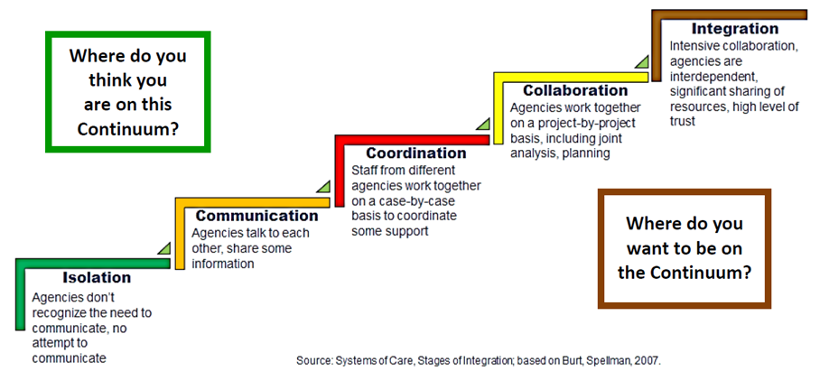

| **OUTREACH AND INTAKE** | **ISOLATION** | | | **COMMUNICATION** | | | **COORDINATION** | | | **COLLABORATION** | | | **INTEGRATION** | | |
| --- | --- | --- | --- | --- | --- | --- | --- | --- | --- | --- | --- | --- | --- | --- | --- |
| **✓ Current Level of Integration** | Low | Mid | High | Low | Mid | High | Low | Mid | High | Low | Mid | High | Low | Mid | High |
|  |  |  |  | x | x | x | x |  |  |  |  |  |  |  |
| **Examples:**  **Title I WIOA: When a new WIOA participant is already working with IVRS, we coordinate meetings and services to help as much as possible, either with funding or with services provided. If WIOA participants may benefit from IVRS services, we refer them and collaborate on services.**  **Title II AEL: – Orientations have changed from or ceased during Covid, more isolated**  **Title IV IVRS: Have received occasional referrals with slip of information for referral, will walk individuals to the office for service support. Further service steps unknown. Sometimes no prior notification of referral.** | | | | | | | | | | | | | | | |
| **Circle Priority Rating: Low = 1 x Low/Medium = 2 x Medium = 3 x Medium/High = 4 High = 5** | | | | | | | | | | | | | | | |
| **Ideas/Opportunities:**  **Title I WIOA: Monthly or every other month meetings to discuss co-enrolled customers or potential customers and how to best serve them.**  **Title II AEL: When safe, resume F2F orientations with collaboration and coordination**  **Title IV IVRS: Continue to utilize referral forms from one stop partners.** | | | | | | | | | | | | | | | |
| **Questions/Concerns/Areas for Assistance?**  **Title IV IVRS: Referral process impacted by Covid 19 and agency response. IWD operations limited.** | | | | | | | | | | | | | | | |
| **ASSESSMENTS** | **ISOLATION** | | | **COMMUNICATION** | | | **COORDINATION** | | | **COLLABORATION** | | | **INTEGRATION** | | |
| **✓ Current Level of Integration** | Low | Mid | High | Low | Mid | High | Low | Mid | High | Low | Mid | High | Low | Mid | High |
|  |  |  | x | X | X | X |  |  |  |  |  |  |  |  |
| **Examples:**  **Title II AEL: AEL provides CASAS assessments for WIOA**  **Title IV IVRS: CAPS, Interest Profiler, Customer Service Academy, NCRC** | | | | | | | | | | | | | | | |
| **Circle Priority Rating: X Low = 1 Low/Medium = 2 Medium = 3 X Medium/High = 4 High = 5** | | | | | | | | | | | | | | | |
| **Ideas/Opportunities:** | | | | | | | | | | | | | | | |
| **Questions/Concerns/Areas for Assistance?** | | | | | | | | | | | | | | | |
| **CAREER SERVICES** | **ISOLATION** | | | **COMMUNICATION** | | | **COORDINATION** | | | **COLLABORATION** | | | **INTEGRATION** | | |
| **✓ Current Level of Integration** | Low | Mid | High | Low | Mid | High | Low | Mid | High | Low | Mid | High | Low | Mid | High |
|  | x |  |  |  |  |  | x |  |  | X |  |  |  |  |
| **Examples:**  **Title I WIOA: Resume and job search assistance, focus on customer strengths and abilities**  **Title II AEL: Pre Covid: representation on Business Services advisory , referrals, COLORS**  **Title IV IVRS: Joint meetings with Job Corps, feedback from job candidates is that there is not a lot of career services being offered. Some staff have not had a lot to do with WIOA in placement activities.** | | | | | | | | | | | | | | | |
| **Circle Priority Rating: Low = 1 Low/Medium = 2 Medium = 3 x Medium/High = 4 X High = 5** | | | | | | | | | | | | | | | |
| **Ideas/Opportunities:**  **Title IV IVRS: Making and strengthening connections with career services with each agency. This will be beneficial in just a warm outreach.** | | | | | | | | | | | | | | | |
| **Questions/Concerns/Areas for Assistance?** | | | | | | | | | | | | | | | |
| **CASE MANAGEMENT** | **ISOLATION** | | | **COMMUNICATION** | | | **COORDINATION** | | | **COLLABORATION** | | | **INTEGRATION** | | |
| **✓ Current Level of Integration** | Low | Mid | High | Low | Mid | High | Low | Mid | High | Low | Mid | High | Low | Mid | High |
|  |  |  | x | x |  |  | x |  |  |  |  |  |  |  |
| **Examples:**  **Title I WIOA: Open communication occurs when we have a shared customer to discuss concerns, areas of need, share services provided**  **Title II AEL: IWD, IVRS, AEL data systems do not connect/communicate**  **Title IV IVRS: Collaborative meetings with providers.** | | | | | | | | | | | | | | | |
| **Circle Priority Rating: Low = 1 Low/Medium = 2 x Medium = 3 x Medium/High = 4 High = 5** | | | | | | | | | | | | | | | |
| **Ideas/Opportunities:**  **Title II AEL: Connected systems would increase ease of referrals and flow of information**  **Title IV IVRS: Increase communication with specific point of contact.**  **WIOA contacts have been strong. Maintain communication!** | | | | | | | | | | | | | | | |
| **Questions/Concerns/Areas for Assistance?** | | | | | | | | | | | | | | | |
| **CAREER PATHWAYS** | **ISOLATION** | | | **COMMUNICATION** | | | **COORDINATION** | | | **COLLABORATION** | | | **INTEGRATION** | | |
| **✓ Current Level of Integration** | Low | Mid | High | Low | Mid | High | Low | Mid | High | Low | Mid | High | Low | Mid | High |
|  |  |  | X | x |  |  | x |  |  |  |  |  |  |  |
| **Examples:**  **Title I WIOA: Invited by IVRS to participate in school events/transition fairs; when customers were coming into our office for job seeker services and disclosed a disability they were referred to IVRS or told about services (not recently due to not having walk-in customers with Covid)**  **Title IV IVRS: Collaborative exploration of career pathways and supports when working with WIOA, IHCC Navigator, IWD classes** | | | | | | | | | | | | | | | |
| **Circle Priority Rating: Low = 1 Low/Medium = 2 x Medium = 3 Medium/High = 4 High = 5** | | | | | | | | | | | | | | | |
| **Ideas/Opportunities:** | | | | | | | | | | | | | | | |
| **Questions/Concerns/Areas for Assistance?**  **Job Corps** | | | | | | | | | | | | | | | |
| **BUSINESS ENGAGEMENT** | **ISOLATION** | | | **COMMUNICATION** | | | **COORDINATION** | | | **COLLABORATION** | | | **INTEGRATION** | | |
| **✓ Current Level of Integration** | Low | Mid | High | Low | Mid | High | Low | Mid | High | Low | Mid | High | Low | Mid | High |
|  |  |  | X x |  |  |  |  |  |  |  |  |  |  |  |
| **Examples:**  **Title IV IVRS: This was strong when information was shared in monthly one stop team business meetings. Staff reach out to IWD Business specialist for contact information, but no collaboration at this time.** | | | | | | | | | | | | | | | |
| **Circle Priority Rating: Low = 1 Low/Medium = 2 Medium = 3 Medium/High = 4 x High = 5** | | | | | | | | | | | | | | | |
| **Ideas/Opportunities:**  **Title IV IVRS: Struggle to see opportunities until work roles are shifted back to “norm” due to agency needs in alternative service delivery for partners. Might even be able to start meetings sooner due to technology once work flow and focus allow. Excited to restart this.** | | | | | | | | | | | | | | | |
| **Questions/Concerns/Areas for Assistance?** | | | | | | | | | | | | | | | |