Draft

Ottumwa, Iowa
INTEGRATION CONTINUUM SELF-ASSESSMENT

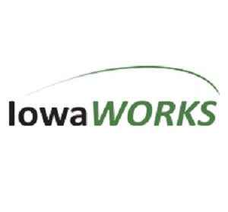
Summary & Recommendations by WINTAC

Table of Contents
Table of Contents Introduction 3
Table 1 – Integration Continuum 3
Table 2 – Current vs. Desired 4
Self-Assessment 4
Ratings 4
Priorities Established for Planning 4
Combined Issues and Activities - Priorities 5
Career Services 5
Case Management 5
Career Pathways 6
Recommendations 7

c
Introduction
The IowaWORKS Center in Ottumwa invited the Workforce Innovation Technical Assistance Center (WINTAC) to assist them in assessing their level of engagement and connectivity between core, required, and other American Job Center (AJC) partners. On October 8, 2018, WINTAC met with representatives in Ottumwa to facilitating the Integration Continuum ^{Table 1} process with the partners to complete a self-assessment of their current level of integration of series and to develop an initial plan of action based on a prioritization of desired outcomes.
Table 1 – Integration Continuum
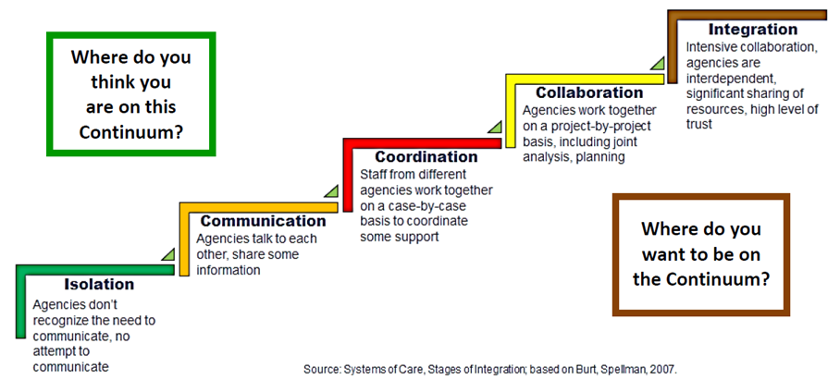
Meeting – Lincoln Land Community College, Springfield, Illinois, February 21, 2018
WINTAC reviewed the WIOA Vision and Requirements related integrated services with the participant's ^{Table 2}. Stimulus questions and information on the Integration Continuum – Major Processes examples had been sent to the participants prior to the meeting and was reviewed in detail prior to each individual doing an assessment of the current levels of alignment followed by a group consensus with those from their area. Subsequently, each group identified 3 priority areas to focus on in the coming year. WINTAC shared information, examples, and resources that teams can utilize for planning priority areas of efforts and assisted the teams with short and long-term planning and the establishment of on-going evaluation for progress made. The results of the three group’s self-assessment and priorities have been compiled in this report.

Ottumwa Self-Assessment
Each of the areas met separately to review and compile their levels in each of the three of the six major process categories (Career Service, Case Management and Career Pathways) to determine their overall level of alignment.
Overall Rating by Office:
Career Services - Collaboration
Case Management – Coordination
Career Pathways – Collaboration
In combining the results of the self-assessment of each of the areas we were able to identify the rating for the entirety of Area I.
Overall Rating (across the 6 activities): Communication
Ratings actual vs. desired:
Integration Continuum | Career Service | Case Management | Career Pathways
Current Level | Coordination | Coordination | Collaboration
Desired Level | Integration | Collaboration | Integration

Priorities Established for Planning
In Ottumwa the group had pre-identified 3 areas they would like to work on locally this year. It soon became evident that each office in this area identified the same 3 areas as their priorities for focus.
- Career Services
- Case Management
- Career Pathways
The group broke into three groups to further explore areas around the priority areas and began to identify issues for planning and then moved in action planning.

Small Group Discussion by Priority Area
Career Services
CAREER SERVICES | ISOLATION |  |  | COMMUNICATION |  |  | COORDINATION |  |  | COLLABORATION |  |  | INTEGRATION
Current Level of Integration  Mark individual ratings for each group member. Discuss any significant differences in participants’ ratings, and determine if there is consensus within the group. Note the results to report out. | Low | Mid | High | Low | Mid | High | Low | Mid | High | Low | Mid | High | Low | Mid | High
Capture any examples shared in the discussion.
- Increase communication | - Coordinating job fairs and event
- Increase team meetings | - High level of collaboration and team work, especially on events, team projects
- Increase collaboration on individuals | - Integrated Resource Team
- Share calendars
- Patty in office once a week

Capture any ideas/opportunities group members share.
- Change school’s perception of our agencies
- Integration goal - Iowa Works:
  - Fine tune referrals Follow up when referral is made
  - Develop plans together
Note any questions, concerns, and/or areas for assistance.
- Identify a day of week to meet and discuss mutual clients
- Schools – workshops – resume
- Increase communication and follow up on individual participants
Case Management
CASE MANAGEMENT | ISOLATION |  |  | COMMUNICATION |  |  | COORDINATION |  |  | COLLABORATION |  |  | INTEGRATION
Current Level of Integration  Mark individual ratings for each group member. Discuss any significant differences in participants’ ratings, and determine if there is consensus within the group. Note the results to report out. | Low | Mid | High | Low | Mid | High | Low | Mid | High | Low | Mid | High | Low | Mid | High
Capture any examples shared in the discussion.
- Information sharing between multiple partners on common customers
- Referrals from PJ to VR
- PJ attending intakes at VR
- Partner referral sheet
Capture any ideas/opportunities group members share.
- Blanket release for all partner programs
- Reminders to staff to make referrals
- FaDDS referral – add partners to it and all utilize it
- PJ – orientation, FaDDS, orientation for partner staff (Cross-training)
Note any questions, concerns, and/or areas for assistance.
- New staff training (each agency)
- Developing universal partner release form
- Aligning Regions – same for all partners
- Shared resource directories
- Barriers – no common case management system for all partners

Action Plan/Next Step with regard to addressing the Priority Areas
The three groups identified their next steps and they are captured below in their short-term action plans.
Career Services
Priority Objective - What do we want to do?

Career Services
Activities & Tactics  How will we do it? | Key Players  Who should be involved? | Expected Outcomes  What is the result? | Timeline  When will we do it? | Questions & Assistance Needed  Where do we need assistance?
Refine referral process so everyone understands it to include follow up. | Collette, Clark and Kim | Synchronized collaborative form, packets.  Better understanding on results of referrals | December 1, 2018 | Submit plan to Kelli, Linda and Jen
Increase Communication  - Cc on emails when appropriate  - Lists of participants – protocol  - IVRS 10 business days application to referral  - Team Meetings | Team | Thursday Morning Monthly Meetings | January 2019 | Kelli, Linda and Jen
Create Desk Aid and Flow Chart | Mike and Jeremy | Increase knowledge process and services | December 1, 2018 | Submit to Jen, Linda and Kelli
Schools – different cultures, needs and goals  - Workshops  - Events (employers)  - Summer events  - STEM – summer externships | Parent Involvement  Increase school’s knowledge of services  IPE planning | Provide Career Services to students  Increase awareness of services  Bridge gap between students and employers |  | Alumni telling about how they became successful
Increase Individual Resource Teams (IRT) across populations | All – Mike to list | Create list of IowaWorks team members’ areas of expertise | October 19, 2018

Career Pathways

Priority Objective - What do we want to do?

Career Pathways

Activities & Tactics  How will we do it? | Key Players  Who should be involved? | Expected Outcomes  What is the result? | Timeline  When will we do it? | Questions & Assistance Needed  Where do we need assistance?
All partners at the table! | Title 1 – Career Services IVRS/IDB. Title IV, Title III, Wagner Peyser, Title II Indian Hills/AEL.  Distribution list Updated by Kim to share Events via monthly email. | All become part of planning, improved Customer Services, Business Client Service, Employer Service | Monthly emails | Managers from different partners on who should be at the table.
Shared Releases  ONET/TAB - Share | Case Managers  Clients  Employers | Shared Communication | TBD
Increase development and use of apprenticeships | Christian Rey Amy Beller  Conference Calls | Knowledge shared. Increase in apprenticeships | November 14th, National Apprenticeship Week | Help Christian share info on apprenticeships
Increase utilization of apprenticeships (Cross training across agencies) | Business Services Teams/BS Reps, Christian, Apprenticeship teams | More options for inclusive apprenticeships  Knowledge of region, availability | 1 year  IDB have l1 apprenticeship  IVRS have I apprenticeship
Future Ready Iowa Certification after HS, Employer outreach expect 70% | Core Partners, Education,  Employer | IPE reflects credential or certification attainment | 1 year | Convince employers to create certificate for industry standards

Case Management
Priority Objective - What do we want to do?

Case Management – Cross Training all partner program field staff
Activities & Tactics  How will we do it? | Key Players  Who should be involved? | Expected Outcomes  What is the result? | Timeline  When will we do it? | Questions & Assistance Needed  Where do we need assistance?
Desk Reference – information on all programs | Form committee | Referrals made, is it being used? | 2 months | Leadership support
Electronic ‘shared’ folders  - Policies and procedures  - Forms  - Business engagement  - Workshop Schedule  - Schools | IT  Committee (formed above) | Better referrals  Awareness and increase in staff confidence | 1 year  2 months | Policy writers
Job shadow partners | Team Leadership | Better understanding and confidence in making referrals  Better relationships | 4 partners in 6 months | Leadership support  Release  Optional vs. mandatory
Eligibility requirements  Funding  Partners training partners  - Customer experience | All case managers | Expedited services  Better referrals  Better relationships | 6 months | Leadership
Monthly ‘staffing’ of hardest-to-serve customers | Case managers | Collaboration  Fresh ideas  Sharing what has worked | Within 6 months | Supervisor support  PJ staff invite partners to existing staffing.

Career Services
CAREER SERVICES | ISOLATION |  |  | COMMUNICATION |  |  | COORDINATION |  |  | COLLABORATION |  |  | INTEGRATION
Current Level of Integration  Mark individual ratings for each group member. Discuss any significant differences in participants’ ratings, and determine if there is consensus within the group. Note the results to report out. | Low | Mid | High | Low | Mid | High | Low | Mid | High | Low | Mid | High | Low | Mid | High
Capture any examples shared in the discussion.
- Increase communication | - Coordinating job fairs and event
- Increase team meetings | - High level of collaboration and team work, especially on events, team projects
- Increase collaboration on individuals | - Integrated Resource Team
- Share calendars
- Patty in office once a week

Capture any ideas/opportunities group members share.
- Change school’s perception of our agencies
- Integration goal - Iowa Works:
  - Fine tune referrals Follow up when referral is made
  - Develop plans together
Note any questions, concerns, and/or areas for assistance.
- Identify a day of week to meet and discuss mutual clients
- Schools – workshops – resume
- Increase communication and follow up on individual participants

Recommendations
WINTAC is making the following recommendations and providing the following resources in support of the work of Ottumwa IowaWorks.
- WINTAC recommends a follow-up meeting in 2019 to assess progress towards priority areas
- WINTAC is available for additional consultation on the areas identified including the priority areas, closing the integration gap for partners which are not co-located.
- The purposeful use of implementation practices can assist in change efforts such as those facing the three groups, these positive practices include:
  - Create readiness for change
  - Examine degree to which the proposed strategies and practices meet the needs of those we are working with and their clients
  - Create a rapid review – rapid action process for problems and barriers which arise
  - Provide the necessary training and coaching to move the activities forward

Resources
WINTAC has developed videos which highlight the integration of services efforts in three areas, they can be accessed through this links:
- Northern Kentucky American Job Center – Covington, Kentucky https://www.youtube.com/watch?v=e7gOhGbTxcU&t=25s

- Prince William American Job Center – Woodbridge, Virginia

https://www.youtube.com/watch?v=VCf_ZvAycTk&t=59s

- IowaWorks: Southern Hills American Job Center – Creston, Iowa

https://www.youtube.com/watch?v=mXDBS555bn0

- Finding Workforce Service Integration in Iowa, Kentucky, and Virginia

https://www.youtube.com/watch?v=GPR9_GFfbFo

